# NPM

## Q) [What is the difference between --save and --save-dev?](https://stackoverflow.com/questions/22891211/what-is-the-difference-between-save-and-save-dev)

* --save-dev is used to save the package for development purpose. Example: unit tests, minification



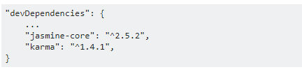

* --save is used to save the package required for the application to run.



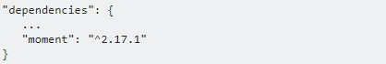

## Q) The Package Version Numbering System

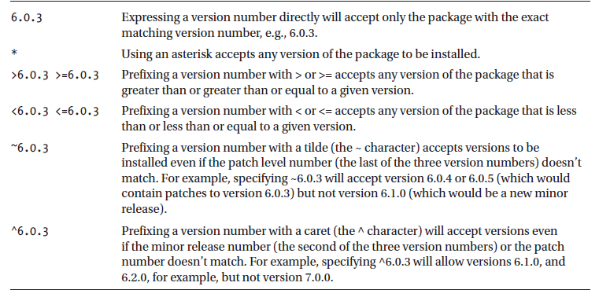

# JavaScript

### Q) What is the 'Strict' mode in JavaScript and how can it be enabled?

Strict Mode adds certain compulsions to JavaScript. Under the strict mode, JavaScript shows errors for a piece of codes, which did not show an error before, but might be problematic and potentially unsafe. Strict mode also solves some mistakes that hamper the JavaScript engines to work efficiently.

Strict mode can be enabled by adding the string literal "use strict" above the file. This can be illustrated by the given example:

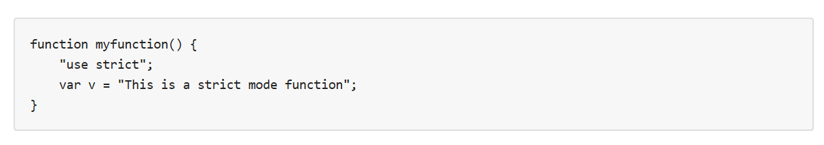

## Q) Data Type

### Q) What are JavaScript Data Types?

Value types

* Number
* String
* Boolean
* Symbol
* Null
* Undefined

Reference Type

Objects are reference types. Objects have a copy-by-value-of-the-reference semantic.

Objects can be declared in two ways:

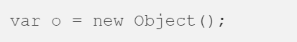

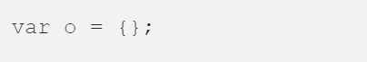

### Q) What is the use of type of operator?

'Typeof' is an operator which is used to return a string description of the type of a variable.

'Typeof' returns seven possible values: number, string, Boolean, object, symbol, function and undefined.

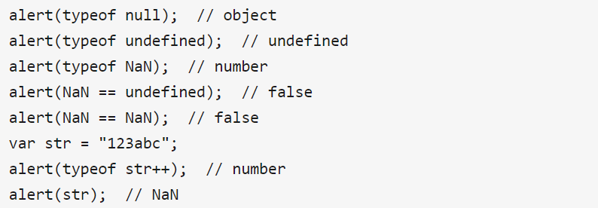

### Q) What are undeclared and undefined variables?

Undeclared variables are those that do not exist in a program and are not declared. If the program tries to read the value of an undeclared variable, then a runtime error is encountered.

Undefined variables are those that are declared in the program but have not been given any value. If the program tries to read the value of an undefined variable, an undefined value is returned.

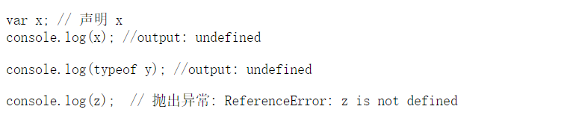

### Q) What do mean by NULL in Javascript?

The NULL value is used to represent no value or no object.

It implies no object or null string, no valid boolean value, no number and no array object.

### Q) What is an undefined value in JavaScript?

Undefined value means the

* Variable used in the code doesn't exist
* Variable is not assigned to any value
* Property doesn't exist

### Q) null vs undefined

In JavaScript, undefined means a variable has been declared but has not yet been assigned a value, such as:

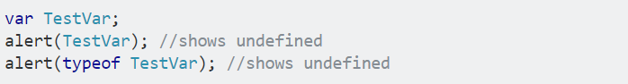

null is an assignment value. It can be assigned to a variable as a representation of no value:

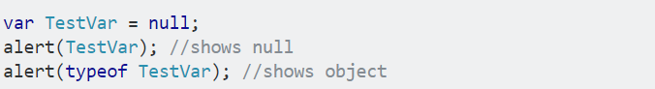

From the preceding examples, it is clear that undefined and null are two distinct types:

undefined is a type itself (undefined) while null is an object.

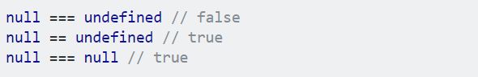

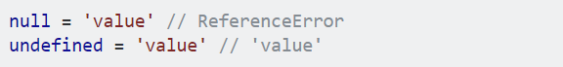

### Q) == vs ===

=== is called as strict equality operator which returns true when the two operands are having the same value without any type conversion.

**"==" checks only for equality in value whereas "===" is a stricter equality test and returns false if either the value or the type of the two variables are different.**

### Q)!!

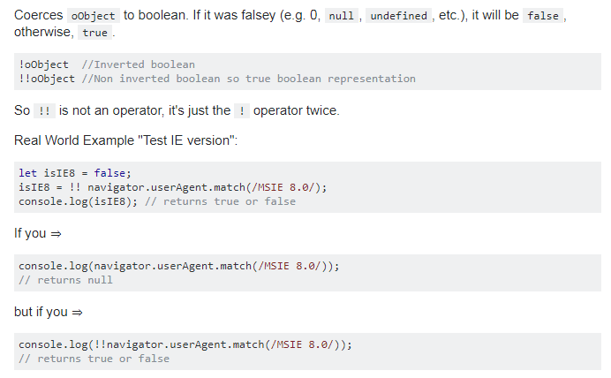

### Q) What is 'this' keyword in JavaScript?

'This' keyword refers to the object from where it was called.

### Q) What is the use of Void(0)?

Void(0) is used to call another method without refreshing the page.

### Q) What is called Variable typing?

Variable typing is used to assign a number to a variable and the same variable can be assigned to a string.

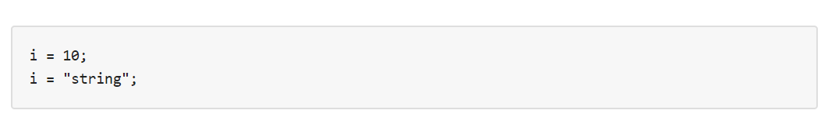

### Q) What is Coercion in JavaScript?

In JavaScript conversion between different two build-in types called coercion. Coercion comes in two forms in JavaScript: *explicit* and *implicit*.

Here's an example of explicit coercion:

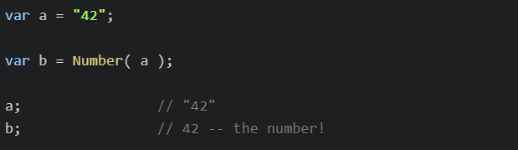

And here's an example of implicit coercion:

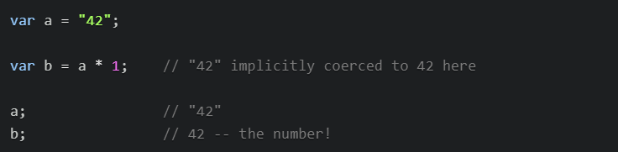

### Q) What would be the result of 3+2+"7"?

Since 3 and 2 are integers, they will be added numerically. And since 7 is a string, its concatenation will be done. So, the result would be 57.

### Q) What would be the result?

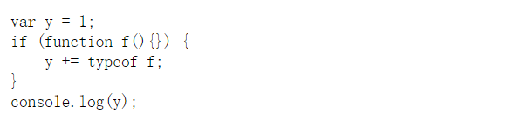

Answer is 1undefined

If statement is using function eval to get condition value，

eval(function f(){}) return function f(){} which is true。

## Event

### Q) Event Object

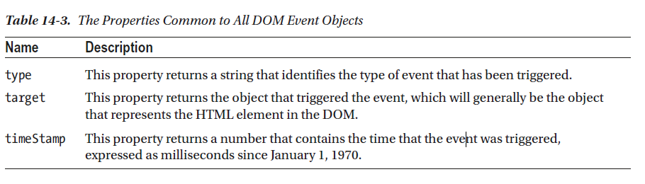

### Q) stopPropagation vs stopImmediatePropagation

stopPropagation will prevent any parent handlers from being executed while stopImmediatePropagation will do the same but also prevent other handlers from executing.

$("p").click(function(event){  
  event.stopImmediatePropagation();  
});

$("p").click(function(event){  
  // This function won't be executed  
  $(this).css("background-color", "#f00");  
});

If event.stopPropagation was used in previous example, then the next click event on p element which changes the css will fire, but in case event.stopImmediatePropagation(), the next p click event will not fire.

## Methods

### Q) What is the function of delete operator?

The delete keyword is used to delete the property as well as its value.

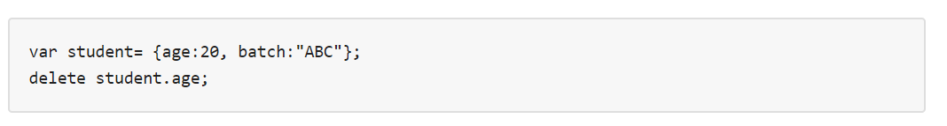

### Q) What is the use of Push method in JavaScript?

The push method is used to add or append one or more elements to the end of an Array. Using this method, we can append multiple elements by passing multiple arguments

### Q) What is unshift method in JavaScript?

Unshift method is like push method which works at the beginning of the array. This method is used to prepend one or more elements to the beginning of the array.

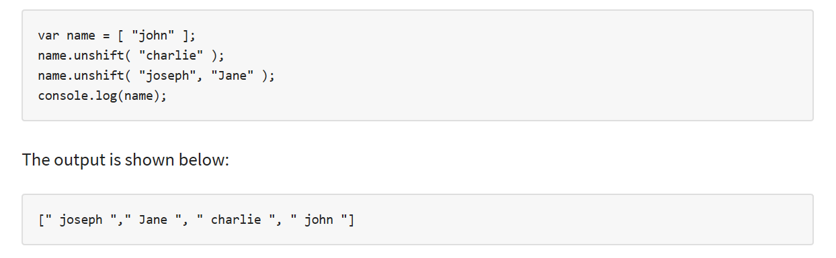

### Q) window.onload vs onDocumentReady?

The onload function is not run until all the information on the page is loaded. This leads to a substantial delay before any code is executed.

onDocumentReady loads the code just after the DOM is loaded. This allows early manipulation of the code.

### Q) The working of timers in JavaScript?

Timers are used to execute a piece of code at a set time or also to repeat the code in a given interval of time. This is done by using the functions **setTimeout, setInterval**and **clearInterval**.

The **setTimeout(function, delay)** function is used to start a timer that calls a particular function after the mentioned delay.

The **setInterval(function, delay)** function is used to repeatedly execute the given function in the mentioned delay and only halts when cancelled.

The **clearInterval(id)** function instructs the timer to stop.

Timers are operated within a single thread, and thus events might queue up, waiting to be executed.

## Object

### Q) Create objects

#### Q) Using Object literal

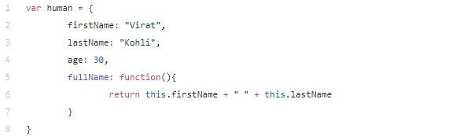

#### Q) Using new Object()



#### Q) Using Object Constructor

Objects can be created using the constructor function syntax using the following two steps:

* Define the object *blueprint* (class) by defining the constructor function. By convention, name of the constructor function should start with capital letter
* Create the object by instantiating the constructor function using *new* operator

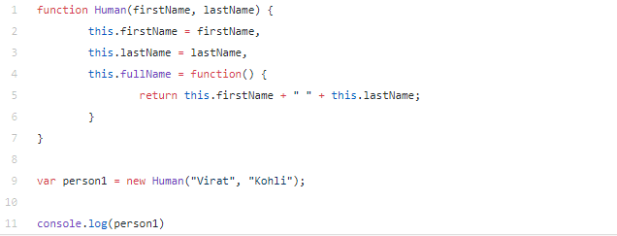

In a constructor function this does not have a value. It is a substitute for the new object. The value of this will become the new object when a new object is created.

### Q) Prototypes

#### **Q) Prototype Object**

When a function is created in JavaScript, the JavaScript engine adds a prototype property to the function. This prototype property is an object (called as prototype object) which has a constructor property by default. The constructor property points back to the function on which prototype object is a property. We can access the function’s prototype property using functionName.prototype.

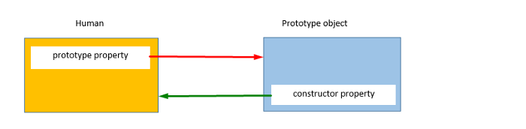

As shown in the above image, Humanconstructor function has a prototype property which points to the prototypeobject. The prototypeobject has a constructor property which points back to the Humanconstructorfunction.

To access the prototype property of the Human constructor function, use the below syntax:



When an object is created in JavaScript, JavaScript engine adds a __proto__property to the newly created object which is called __proto__points to the prototype object of the constructor function.

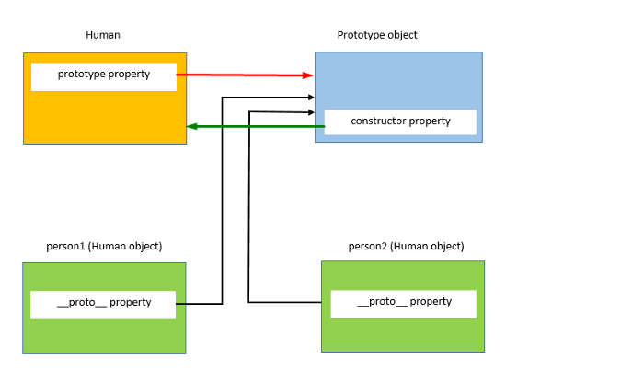

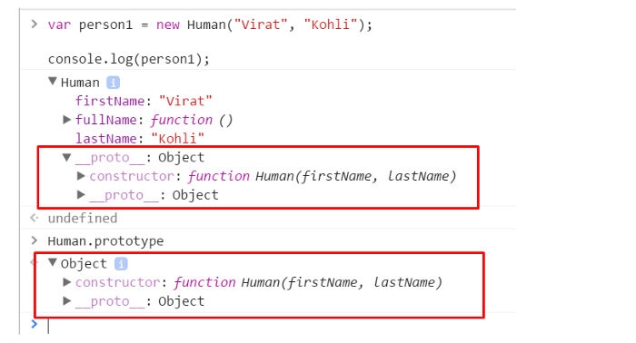



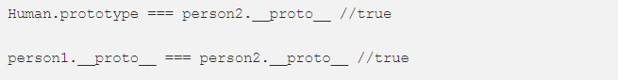

Above statement proves that the person1’s and person2’s __proto__ properties point to Human constructor function’s prototype object. **Prototype object of the constructor function is shared among all the objects created using the constructor function.**

#### **Q) Prototype Object Chain**

As prototype object is an object, we can attach properties and methods to the prototype object. Thus, enabling all the objects created using the constructor function to share those properties and methods.

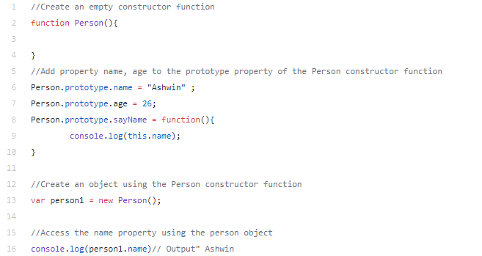

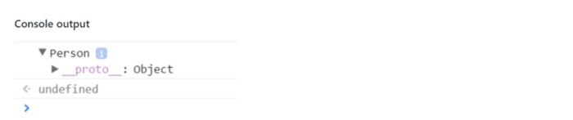

As we can see that person1 object is empty and it does not have any property except its _proto property.

When we try to access a property of an object, JavaScript engines first tries to find the property on the object, if the property is present on the object it outputs its value. But, if the property is not present on the object then it tries to find the property on the _proto of the object. If the property is found the value is returned else JavaScript engine tries to find the property on the _proto of the object. This chain continues until the _proto property is null. In these cases, the output will be undefined.

The Object.prototype is on the top of the prototype inheritance chain:

Date objects, Array objects, and Person objects inherit from Object.prototype.

## Function

### Q) Function Parameters and Arguments

Function parameters are the names listed in the function definition.

Function arguments are the real values passed to (and received by) the function.

**Parameter Rules**

JavaScript function definitions do not specify data types for parameters.

JavaScript functions do not perform type checking on the passed arguments.

JavaScript functions do not check the number of arguments received.

If a function is called with missing arguments (less than declared), the missing values are set to: undefined

**Arguments**

JavaScript functions have a built-in object called the arguments object.

The argument object contains an array of the arguments used when the function was called (invoked).

**JavaScript arguments are passed by value:**

The function only gets to know the values, not the argument's locations.

If a function changes an argument's value, it does not change the parameter's original value.

Changes to arguments are not visible (reflected) outside the function.

**In JavaScript, object references are values.**

Because of this, objects will behave like they are passed by **reference:**

If a function changes an object property, it changes the original value.

**Changes to object properties are visible (reflected) outside the function.**

### Q) Function invocation

#### Q) The Global Object

When a function is called without an owner object, the value of this becomes the global object.

In a web browser the global object is the browser window.

This example returns the window object as the value of this:

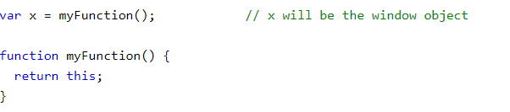

#### Q) The Object

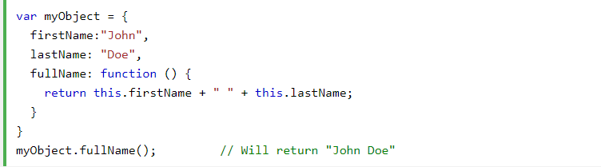

The thing called this, is the object that "owns" the JavaScript code. In this case the value of this is myObject.

#### Q) Invoking a Function with a Function Constructor

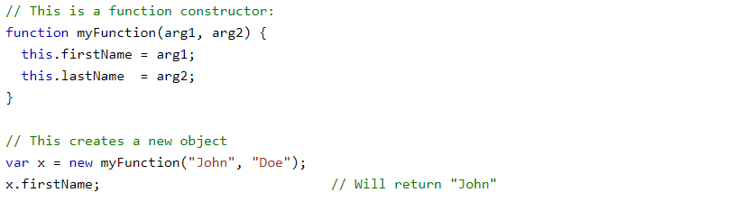

The this keyword in the constructor does not have a value.

The value of this will be the new object created when the function is invoked.

#### Q) .call() vs .apply()?

The function .call() and .apply() are very similar in their usage except a little difference. .call() is used when the number of the function's arguments are known to the programmer, as they have to be mentioned as arguments in the call statement. On the other hand, .apply() is used when the number is not known. The function .apply() expects the argument to be an array.

The basic difference between .call() and .apply() is in the way arguments are passed to the function. Their usage can be illustrated by the given example.

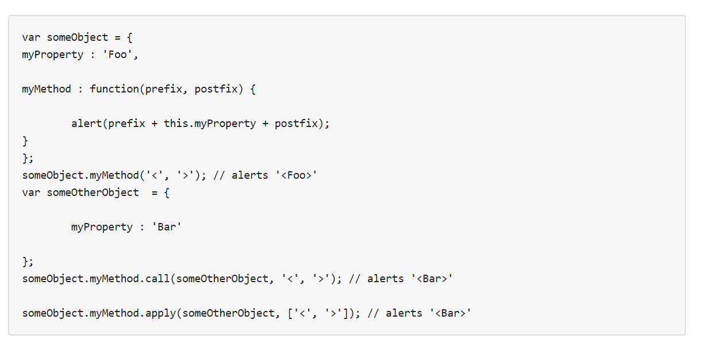

## Scope

### Q) What is scope?

In JavaScript, each function gets its own *scope*. Scope is basically a collection of variables as well as the rules for how those variables are accessed by name. Only code inside that function can access that function's scoped variables.

A variable name has to be unique within the same scope. A scope can be nested inside another scope. If one scope is nested inside another, code inside the innermost scope can access variables from either scope.

### Q) Types of scope

In JavaScript there are three types of scope:

1. Global Scope — variables can be accessed everywhere.
2. Function Scope — variables can be accessed in the boundaries of the function in which they are defined.
3. Block Scope — variables can be accessed in the block in which they are defined. A block is separated by { and }.

### Q) Scopes chain

Scope is where to look for things, or more precisely, scope is where engine will look for things. But what happen in the case of nested scopes? Where will engine look for things? Engine will perform an LHS look-up on the current scope and if he doesn’t find the variable in there it will then perform the LHS look-up on the closest outer scope, and so on, traversing nested scopes until it will get to the outermost scope, the global scope. There his search will terminate. If nothing is found in the global scope two things could happen depending if you are running in strict mode or not:

If you are running in ES5 strict mode: engine would throw a ReferenceError as you would logically imagine, otherwise global scope will just create a variable with that name in the global scope and hand it back to the engine.

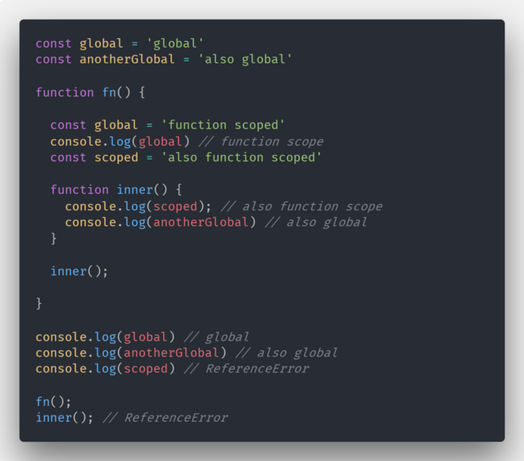

### Q) Hoisting

Hoisting is JavaScript's default behavior of moving declarations to the top of the current scope.

**Javascript engine execute js code in two phases**: the *memory creation phase* and the *execution phase*, and that our code won’t be executed until the second phase.

Hoisting applies to variable declarations and to function declarations.

Because of this, JavaScript functions can be called before they are declared:

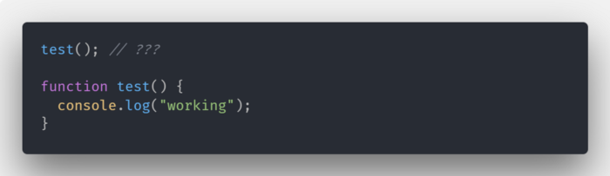

After hoisted,

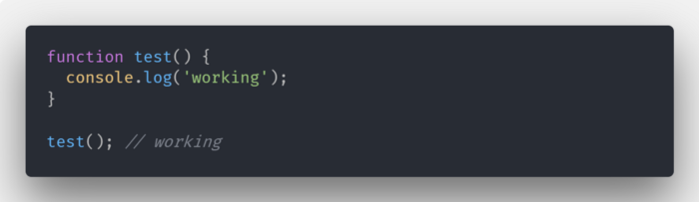

Variables are also hoisted but in a different way. Only the declaration of the variable is “pulled” to the top. The value assignment will stay where it is. In other words, we can’t access the value of a variable the same way we can call functions.

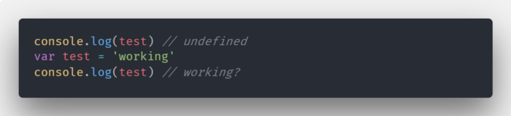

After hoisted,

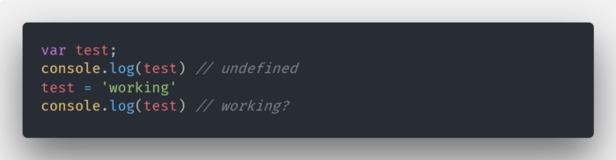

Functions defined using an expression are not hoisted. Again, only the declaration is pulled to the top while the actual assignment of the function as a value will stay where it is. So when we try to call test as a function we will get an error.

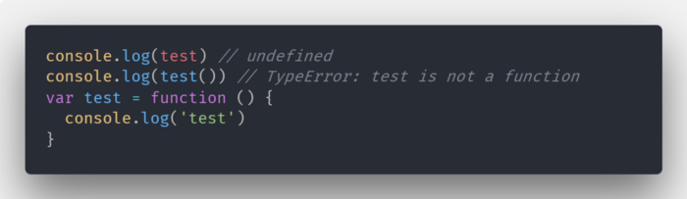

It’s important to note that variables created with let or const are not hoisted. This means that they definition is not pulled to the top like variables declared with var.

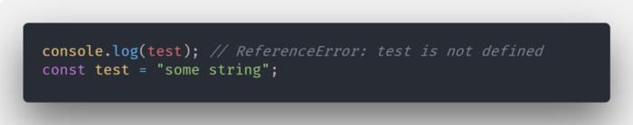

### Q) What is the closure

A **closure** is the combination of a function bundled together (enclosed) with references to its surrounding state (the **lexical environment**). In other words, a closure gives you access to an outer function’s scope from an inner function. In JavaScript, closures are created every time a function is created, at function creation time.

To use a closure, define a function inside another function and expose it. To expose a function, return it or pass it to another function.

The inner function will have access to the variables in the outer function scope, even after the outer function has returned.

### Q) Example of closure

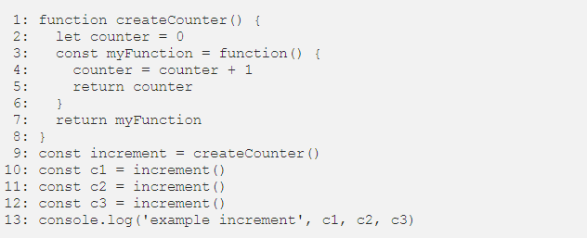

1. Lines 1–8. We create a new variable createCounter in the global execution context and it gets assigned function definition.
2. Line 9. We declare a new variable named increment in the global execution context.
3. Line 9 again. We need call the createCounter function and assign its returned value to the increment variable.
4. Lines 1–8. Calling the function. Creating new local execution context.
5. Line 2. Within the local execution context, declare a new variable named counter. Number 0 is assigned to counter.
6. Line 3–6. Declaring new variable named myFunction. The variable is declared in the local execution context. The content of the variable is yet another function definition. As defined in lines 4 and 5.
7. Line 7. Returning the content of the myFunction variable. Local execution context is deleted. myFunction and counter no longer exist. Control is returned to the calling context.
8. Line 9. In the calling context, the global execution context, the value returned by createCounter is assigned to increment. The variable increment now contains a function definition. The function definition that was returned by createCounter. It is no longer labeled myFunction, but it is the same definition. Within the global context, it is labeledincrement.
9. Line 10. Declare a new variable (c1).
10. Line 10 (continued). Look up the variable increment, it’s a function, call it. It contains the function definition returned from earlier, as defined in lines 4–5.
11. Create a new execution context. There are no parameters. Start execution the function.
12. Line 4. counter = counter + 1. Look up the value counter in the local execution context. We just created that context and never declare any local variables. Let’s look in the global execution context. No variable labeled counter here. Javascript will evaluate this as counter = undefined + 1, declare a new local variable labeled counter and assign it the number 1, as undefined is sort of 0.
13. Line 5. We return the content of counter, or the number 1. We destroy the local execution context, and the counter variable.
14. Back to line 10. The returned value (1) gets assigned to c1.
15. Line 11. We repeat steps 10–14, c2 gets assigned 1 also.
16. Line 12. We repeat steps 10–14, c3 gets assigned 1 also.
17. Line 13. We log the content of variables c1, c2 and c3.

Try this out for yourself and see what happens. You’ll notice that it is not logging 1, 1, and 1 as you may expect from my explanation above. Instead it is logging 1, 2 and 3. So what gives?

The Closure.

Here is how it works. Whenever you declare a new function and assign it to a variable, you store the function definition, *as well as a closure*. The closure contains all the variables that are in scope at the time of creation of the function. It is analogous to a backpack. A function definition comes with a little backpack. And in its pack it stores all the variables that were in scope at the time that the function definition was created.

1. Lines 1–8. We create a new variable createCounter in the global execution context and it get’s assigned function definition. Same as above.
2. Line 9. We declare a new variable named increment in the global execution context. Same as above.
3. Line 9 again. We need call the createCounter function and assign its returned value to the increment variable. Same as above.
4. Lines 1–8 . Calling the function. Creating new local execution context. Same as above.
5. Line 2. Within the local execution context, declare a new variable named counter. Number 0 is assigned to counter. Same as above.
6. Line 3–6. Declaring new variable named myFunction. The variable is declared in the local execution context. The content of the variable is yet another function definition. As defined in lines 4 and 5. Now we also create a closure and include it as part of the function definition. The closure contains the variables that are in scope, in this case the variable counter (with the value of 0).
7. Line 7. Returning the content of the myFunction variable. Local execution context is deleted. myFunction and counter no longer exist. Control is returned to the calling context. So we are returning the function definition and its closure, the backpack with the variables that were in scope when it was created.
8. Line 9. In the calling context, the global execution context, the value returned by createCounter is assigned to increment. The variable increment now contains a function definition (and closure). The function definition that was returned by createCounter. It is no longer labeled myFunction, but it is the same definition. Within the global context, it is called increment.
9. Line 10. Declare a new variable (c1).
10. Line 10 (continued). Look up the variable increment, it’s a function, call it. It contains the function definition returned from earlier, as defined in lines 4–5. (and it also has a backpack with variables)
11. Create a new execution context. There are no parameters. Start execution the function.
12. Line 4. counter = counter + 1. We need to look for the variable counter. Before we look in the local or global execution context, let’s look in our backpack. Let’s check the closure. Lo and behold, the closure contains a variable named counter, its value is 0. After the expression on line 4, its value is set to 1. And it is stored in the backpack again. The closure now contains the variable counter with a value of 1.
13. Line 5. We return the content of counter, or the number 1. We destroy the local execution context.
14. Back to line 10. The returned value (1) gets assigned to c1.
15. Line 11. We repeat steps 10–14. This time, when we look at our closure, we see that the counter variable has a value of 1. It was set in step 12 or line 4 of the program. Its value gets incremented and stored as 2 in the closure of the increment function. And c2 gets assigned 2.
16. Line 12. We repeat steps 10–14, c3 gets assigned 3.
17. Line 13. We log the content of variables c1, c2 and c3.

The key to remember is that when a function gets declared, it contains a function definition and a closure. The closure is a collection of all the variables in scope at the time of creation of the function.

You may ask, does any function has a closure, even functions created in the global scope? The answer is yes. Functions created in the global scope create a closure. But since these functions were created in the global scope, they have access to all the variables in the global scope. And the closure concept is not really relevant.

When a function returns a function that is when the concept of closures becomes more relevant. The returned function has access to variables that are not in the global scope, but they solely exist in its closure.

## Asynchronous

JavaScript is one of the synchronous and single thread language, it means it cannot create multiple threads automatically and execute from top to bottom one by one in parallel. The *Web browser* provides a way to do it by providing a callback function, promise, and Async-Await that can handle this kind of functionality.

### Q) Callback

Callback functions are derived from a programming paradigm known as **functional level programming.**When a function simply accepts another function as an argument, this contained function is known as a **callback function.**

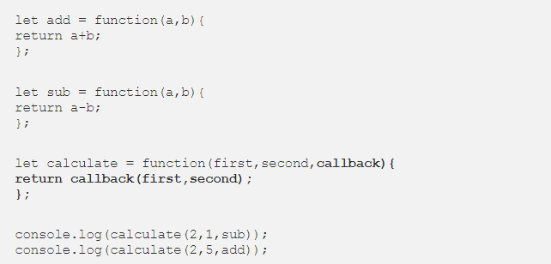

### Q) Promise

In JavaScript, promise represents the result of an asynchronous operation.

A Promise is in one of these states:

* *pending*: initial state, neither fulfilled nor rejected.
* *fulfilled*: meaning that the operation completed successfully.
* *rejected*: meaning that the operation failed.

### Q) Async-Await

*Async/await functions, is a new addition with ES2017 (ES8), help us even more in allowing us to write completely synchronous-looking code while performing asynchronous tasks behind the scenes.*

**Async** declaration defines an **asynchronous function**, which returns an [AsyncFunction](https://developer.mozilla.org/en-US/docs/Web/JavaScript/Reference/Global_Objects/AsyncFunction?source=post_page---------------------------) object.

**Await**declaration causes async function execution to pause until a Promiseis resolved, that is fulfilled or rejected, and to resume execution of the async function after fulfillment.

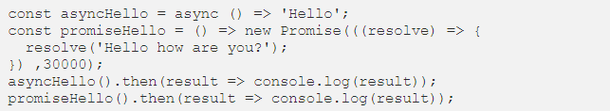

### Q) How Does Synchronous JavaScript Work?

#### Execution Context

An Execution Context is an abstract concept of an environment where the JavaScript code is evaluated and executed. Whenever any code is run in JavaScript, its run inside an execution context.

The function code executes inside the function execution context, and the global code executes inside the global execution context. Each function has its own execution context.

#### Call Stack

The call stack as its name implies is a stack with a LIFO (Last in, First out) structure, which is used to store all the execution context created during the code execution.

JavaScript has a single call stack because it’s a single-threaded programming language. The call stack has a LIFO structure which means that the items can be added or removed from the top of the stack only.

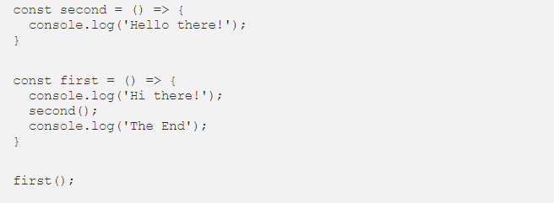

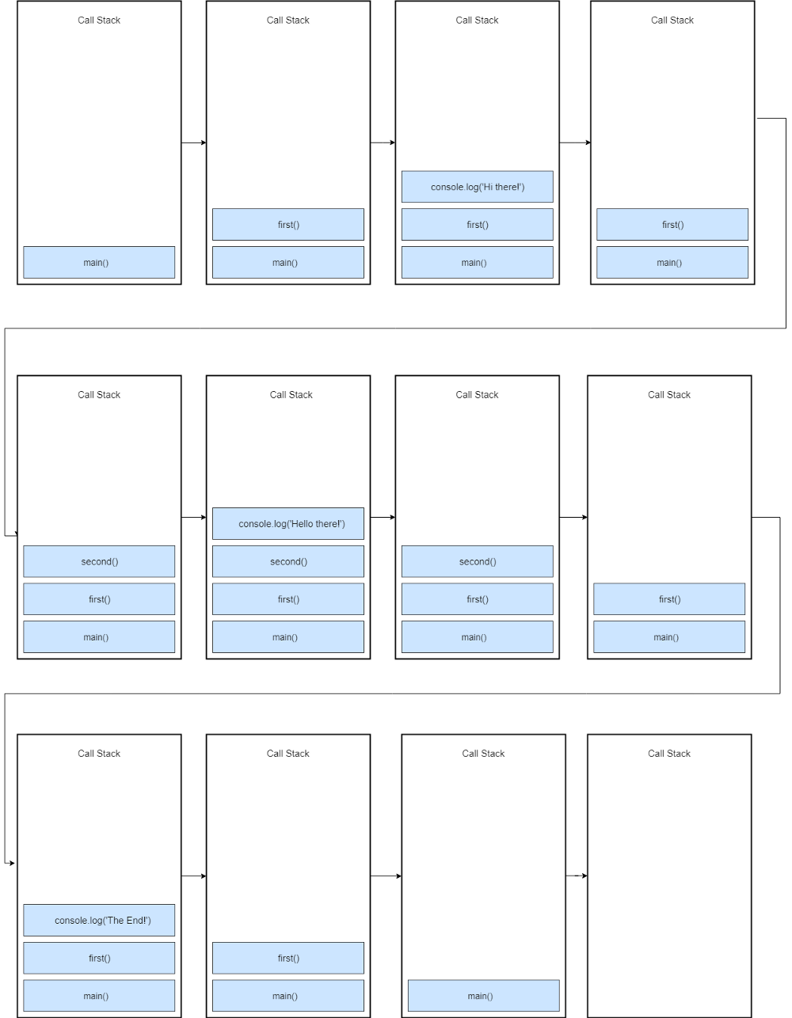

When this code is executed, a global execution context is created (represented by main()) and pushed to the top of the call stack. When a call to first() is encountered, it’s pushed to the top of the stack.

Next, console.log('Hi there!') is pushed to the top of the stack, when it finishes, it’s popped off from the stack. After it, we call second(), so the second() function is pushed to the top of the stack.

console.log('Hello there!') is pushed to the top of the stack and popped off the stack when it finishes. The second() function finishes, so it’s popped off the stack.

console.log(‘The End’) is pushed to the top of the stack and removed when it finishes. After it, the first() function completes, so it’s removed from the stack.

The program completes its execution at this point, so the global execution context(main()) is popped off from the stack.

#### Asynchronous callback

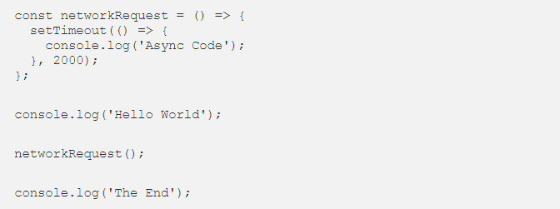

Here I have used setTimeout method to simulate the network request. Please keep in mind that the setTimeout is not a part of the JavaScript engine, it’s a part of something known as web APIs (in browsers) and C/C++ APIs (in node.js).

To understand how this code is executed we have to understand a few more concepts such event loop and the callback queue (also known as task queue or the message queue).



The **event loop**, the **web APIs** and the **message queue**/**task queue** are not part of the JavaScript engine, it’s a part of browser’s JavaScript runtime environment or Nodejs JavaScript runtime environment (in case of Nodejs). In Nodejs, the web APIs are replaced by the C/C++ APIs.

When the above code loads in the browser, the console.log(‘Hello World’)is pushed to the stack and popped off the stack after it’s finished. Next, a call to networkRequest() is encountered, so it’s pushed to the top of the stack.

Next setTimeout() function is called, so it’s pushed to the top of the stack. The setTimeout() has two arguments: 1) callback and 2) time in milliseconds (ms).

The setTimeout() method starts a timer of 2s in the web APIs environment. At this point, the setTimeout() has finished and it’s popped off from the stack.

After it, console.log('The End') is pushed to the stack, executed and removed from the stack after its completion.

Meanwhile, the timer has expired, now the callback is pushed to the **message queue**. But the callback is not immediately executed, and that’s where the event loop kicks in.

#### The Event Loop

**The job of the Event loop is to look into the call stack and determine if the call stack is empty or not. If the call stack is empty, it looks into the message queue to see if there’s any pending callback waiting to be executed.**

In this case, the message queue contains one callback, and the call stack is empty at this point. So the Event loop pushes the callback to the top of the stack.

After that the console.log(‘Async Code’) is pushed to the top of the stack, executed and popped off from the stack.

At this point, the callback has finished so it’s removed from the stack and the program finally finishes.

#### DOM Events

The Message queue also contains the callbacks from the DOM events such as click events and keyboard events. For example:

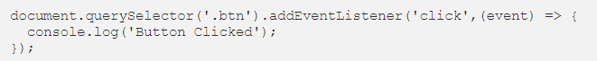

In case of DOM events, the event listener sits in the web APIs environment waiting for a certain event (click event in this case) to happen, and when that event happens, then the callback function is placed in the message queue waiting to be executed.

Again the event loop checks if the call stack is empty and pushes the event callback to the stack if it’s empty and the callback is executed.

#### ES6 Job Queue/ Micro-Task queue

ES6 introduced the concept of job queue/micro-task queue which is used by Promises in JavaScript. The difference between the message queue and the job queue is that the job queue has a higher priority than the message queue, which means that promise jobs inside the job queue/ micro-task queue will be executed before the callbacks inside the message queue.

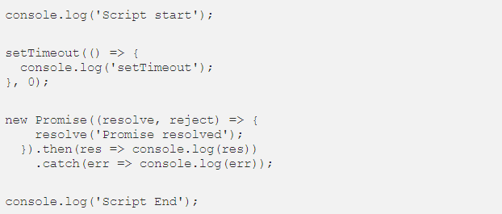

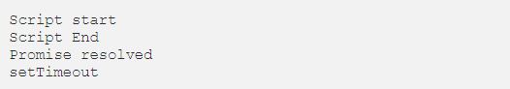

We can see that the promise is executed before the setTimeout, because promise response are stored inside the micro-task queue which has a higher priority than the message queue.

While the event loop is executing the tasks in the micro-task queue and in that time if another promise is resolved, it will be added to the end of the same micro-task queue, and it will be executed before the callbacks inside the message queue no matter for how much time the callback is waiting to be executed.

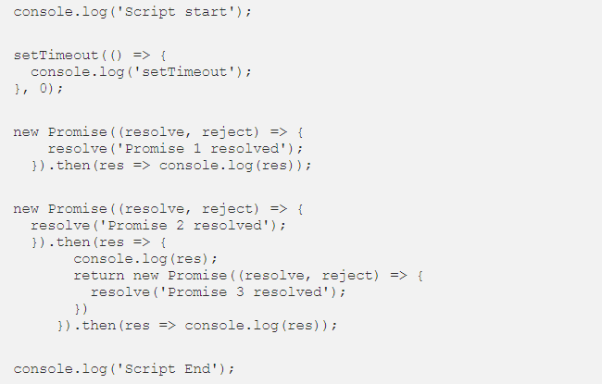

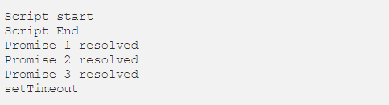

So all the tasks in micro-task queue will be executed before the tasks in message queue. That is, the event loop will first empty the micro-task queue before executing any callback in the message queue.

# TypeScript

## Q) Strict Null checking

TypeScript 2.0 adds support for **non-nullable types**. There's a new **strict null checking** mode that you can opt into by providing the --strictNullChecks flag on the command line. Alternatively, you can enable the strictNullChecks compiler option within your project's *tsconfig.json* file:

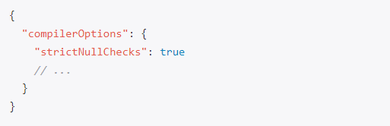

In strict null checking mode, null and undefined are no longer assignable to every type. Both null and undefined now have their own types, each with only one value:

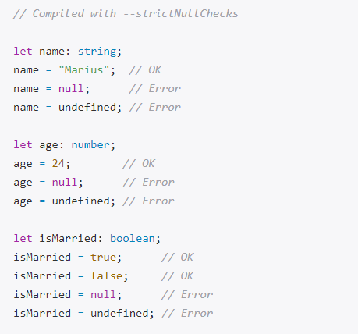

**Modeling Nullability with Union Types**

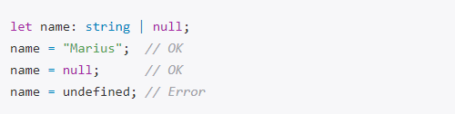

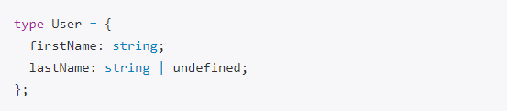

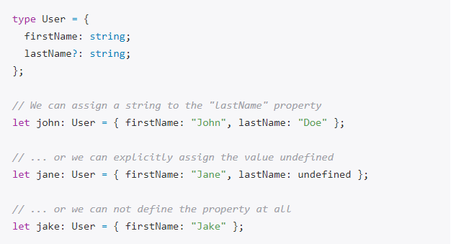

## Q) Control Flow Based Type Analysis

With TypeScript 2.0, the type checker analyses all possible flows of control in statements and expressions to produce the most specific type possible (the *narrowed type*) at any given location for a local variable or parameter that is declared to have a union type.

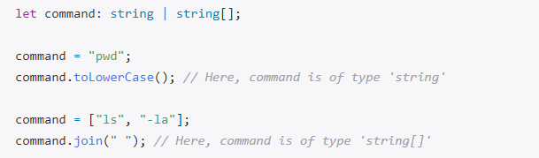

## Q) Definite Assignment Analysis

Definite assignment analysis is another protection measure against nullability bugs. The idea is to make sure that every non-nullable local variable has been initialized properly before it's being used.

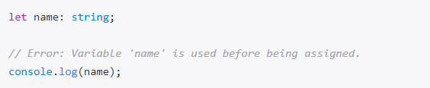

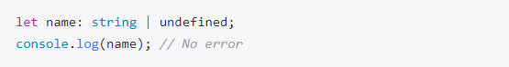

## Q)Three dots

... can be used in two different ways; as a spread operator OR as a rest parameter.

* Rest parameter: collects all remaining elements into an array.
* Spread operator: allows iterables (arrays /objects /strings ) to be expanded into single arguments/elements.

**Rest parameter**

Rest parameters have to be at the **last argument**. This is because it collects all remaining/ excess arguments into an array.

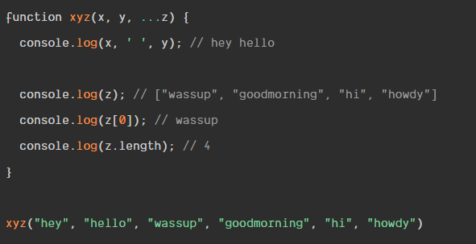

**Arguments keywords**

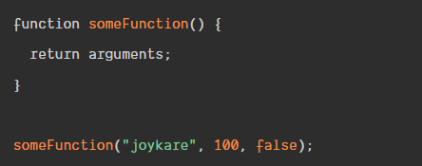

Some Function returns the arguments and their indexes,

[Arguments] { '0': 'joykare', '1': 100, '2': false }.

The downside of using the arguments keyword is that, it returns an array-like **object**; this means you essentially cannot perform any array-methods like; Array.filer, Array.map.

Another pitfall, is that we cannot use arguments in arrow functions. This is because arrow-functions do not have their own this, and hence no arguments object either.

[**Spread operators**](https://scotch.io/bar-talk/javascripts-three-dots-spread-vs-rest-operators543#toc-spread-operators)

The spread operator allows us to expand elements. It let us unpack elements in an array to single/individual arguments.

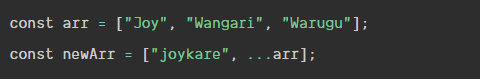

The value of newArr will be [ 'joykare', 'Joy', 'Wangari', 'Warugu' ].

Note: Unlike rest parameters you can use the spread operator as the first argument.

If multiple spread objects define a property with the same key, the type of that property in the resulting object will be the type of the property of the last assignment because it overrides previously assigned values of that property:

Object spread can be used to create a **shallow copy** of an object.

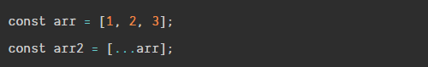

This copies arr into arr2. Now we can do things on arr2 and any changes done to arr2 will not have any effect arr. object spread only copies over property values, which might lead to unintended behavior if a value is a reference to another object.

If you want to create a **deep clone** of a serializable object, consider JSON.parse(JSON.stringify(obj)) or some other approach like [Object.assign()](https://developer.mozilla.org/en-US/docs/Web/JavaScript/Reference/Global_Objects/Object/assign)

## Q) keyof

The new keyof operator. It queries the set of keys for a given type, which is why it's also called an *index type query*. Let's assume we have defined the following Todo interface:

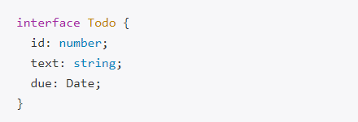

We can apply the keyof operator to the Todo type to get back a type representing all its property keys, which is a union of [string literal types](https://blog.mariusschulz.com/2016/03/31/string-literal-types-in-typescript):



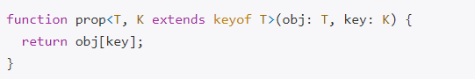

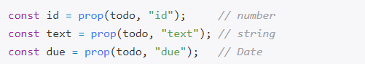

## Q) never type

**The Difference Between never and void**

A function that doesn't explicitly return a value implicitly returns the value undefined in JavaScript. Although we typically say that such a function "doesn't return anything", it returns. We usually ignore the return value in these cases. Such a function is inferred to have a void return type in TypeScript.

A function that has a never return type never returns. It doesn't return undefined, either. The function doesn't have a normal completion, which means it throws an error or never finishes running at all.

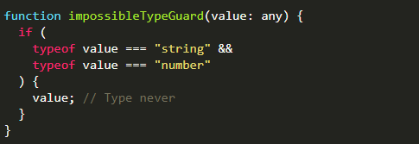

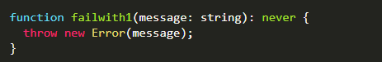

## Q) Partial

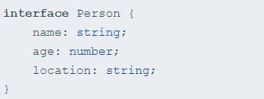

A partial version of it would be:

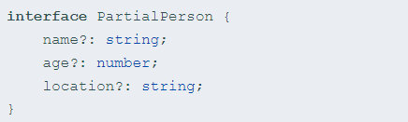

With Mapped types, PartialPerson can be written as a generalized transformation on the type Person as:

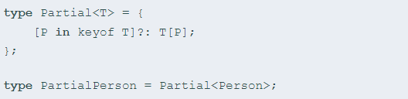

## Q) Underscore

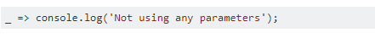

variable _ means don't care/not used but since it is the only variable is there any reason to prefer the use of _ over:



## Q) Readonly

Properties marked with readonly can only be assigned to during initialization or from within a constructor of the same class. All other assignments are disallowed.

The readonly modifier is part of TypeScript's type system. It's only used by the compiler to check for illegal property assignments. Once the TypeScript code has been compiled to JavaScript, all notions of readonly are gone.

Because readonly is only a compile-time artifact, there's no protection against property assignments at runtime whatsoever. That said, it's another feature of the type system that helps you write correct code by having the compiler check for unintended property assignments from within your TypeScript code base.

## Q) get/set

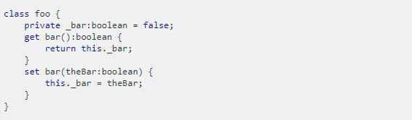

That will produce this Javascript, using the Ecmascript 5 Object.defineProperty() feature.

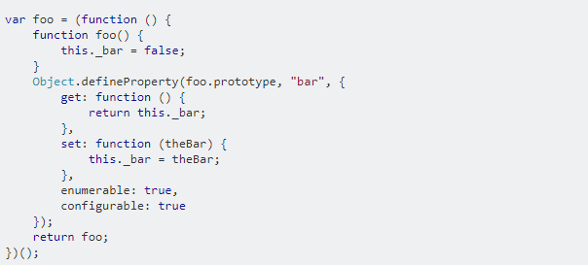

So to use it,

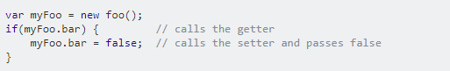

However, in order to use it at all, you must make sure the TypeScript compiler targets ECMAScript5. If you are running the command line compiler, use --target flag like this;

tsc --target ES5

## Promise

### Q) Promise syntax

A promise is a placeholder for a future value.

It serves the same function as callbacks but has a nicer syntax and makes it easier to handle errors.

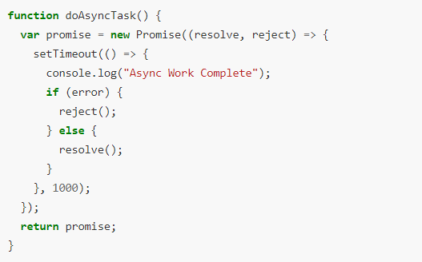

We can get notified when a promise resolves by attaching a *success* handler to its then function, the second argument is an *error* handler that gets called if the promise is rejected.

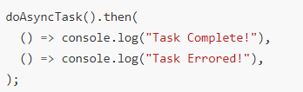

### Q) Immediate Resolution or Rejection

We can create an immediately *resolved* Promise by using the Promise.resolve() method

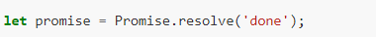

And an immediately *rejected* Promise by using the Promise.reject() method, like so



One of the nice things about Promises is that if we add a then handler **after** the promise resolves or rejects the handler **still** gets called.

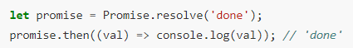

### Q) Chaining

We can also connect a series of then handlers together in a chain, like so:

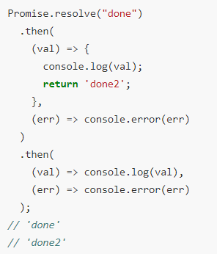

### Q) Error handling

If we throw an exception from our promise function or one of the success handlers, the promise gets rejected and the error handler is called, like so:

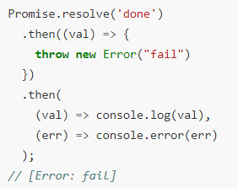

The catch function works exactly the same way as the then error handler, it’s just clearer and more explicitly describes our intent to handle errors.

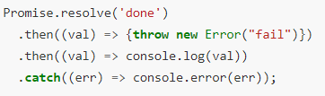

### Q) Async + Await

The async keyword within a TypeScript program lets us define an *asynchronous function*.

It allows us to utilize the await keyword in front of an express that will return a promise and pause the execution of the function until the await-ed promise resolves with a result.

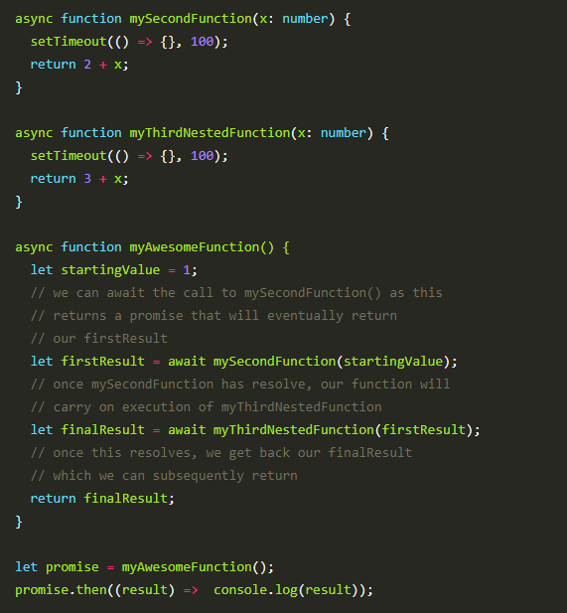

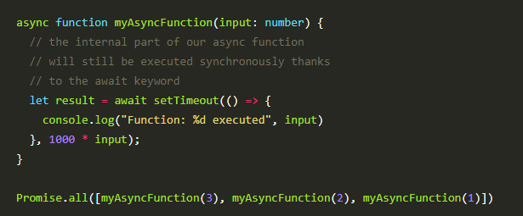

# Angular

## Angular CLI

### Q) tsconfig.json

The presence of a tsconfig.json file in a directory indicates that the directory is the root of a TypeScript project. The tsconfig.json file specifies the root files and the compiler options required to compile the project.

#### Q) [Imports Relatively](https://scotch.io/tutorials/reference-angular-imports-absolutely-for-easier-development#toc-referencing-imports-relatively)

Since TypeScript is what is in charge of transpiling our Angular apps, we'll make sure to configure our paths in tsconfig.json.

In the tsconfig.json, we'll do two things by using two of the [compiler options](https://www.typescriptlang.org/docs/handbook/compiler-options.html):

* baseUrl: Set the base folder as /src
* paths: Tell TypeScript to look for @app in the /src/app folder

baseUrl will be the base directory that is used to resolve non-relative module names.

paths is an array of mapping entries for module names to locations relative to the baseUrl.

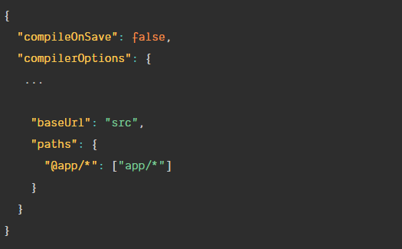



### Q) polyfills.ts

Polyfills in angular are few lines of code which make your application compatible for different browsers. The code we write is mostly in ES6 (New Features: Overview and Comparison) and is not compatible with IE or firefox and needs some environment setups before being able to be viewed or used in these browsers.

### Q) tslint.ts

TSLint is a static code analysis tool used in software development for checking Typescript code quality, if TypeScript source code complies with coding rules.

TSLint checks your TypeScript code for readability, maintainability, and functionality errors.

### Q) angular.json

Angular CLI workspace file (angular.json)

The schema is <https://github.com/angular/angular-cli/wiki/angular-workspace>

#### Q) Change default node port number

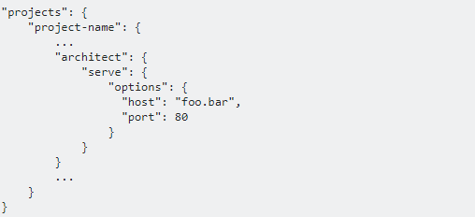

### Q) proxy.config.json

Using the proxying support in webpack's dev server we can highjack certain URLs and send them to a backend server. We do this by passing a file to --proxy-config

Proxy [options](https://github.com/nodejitsu/node-http-proxy#options) provided in this package is from underlying [node-http-proxy](https://webpack.js.org/configuration/dev-server/#devserver-proxy)

We create a file next to our project's package.json called proxy.conf.json with the content.

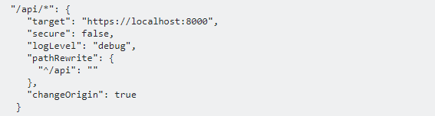

* "api/*":  
  All requests made to /api/ from within your application will be forwarded to target": "https://localhost:8000/api
* "secure": false,:  
  A backend server running on HTTPS with an invalid certificate will not be accepted by default. If you want to, you need to set secure: false.
* "logLevel": "debug"  
  To help debug whether or not your proxy is working properly, you can also add the logLevel option as follows: Possible options for logLevel include debug, info, warn, error, and silent (default is info).
* "pathRewrite": { "^/api": "" }, pathRewrite setting says that if the path matches ^/api (i.e. if it starts with /api) then rewrite that portion with the empty string (i.e. remove it from the path), so all the request to https://localhost:8000/api will go to https://localhost:8000
* "changeOrigin": true: If you need to access a backend that is not on localhost or when you’re using some virtual proxies (such as configured with Apache2) on your backend set it to true.
* `target:

The target url.

We can then add the proxyConfig option to the serve target:

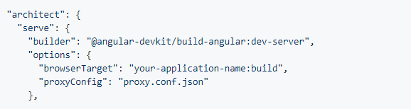

Or

ng serve --proxy-config proxy.config.json

### Q) proxy.conf.js

**Multiple entries**

If you need to proxy multiple entries to the same target define the configuration in proxy.conf.js instead of proxy.conf.json

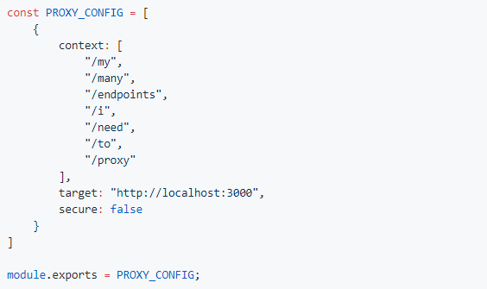

**Bypass the Proxy**

If you need to optionally bypass the proxy, or dynamically change the request before it's sent, define the configuration in proxy.conf.js

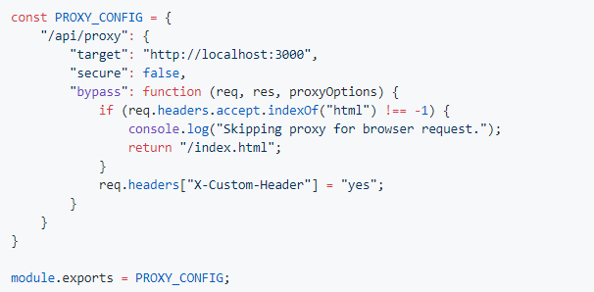

Make sure to point to the right file (.js instead of .json):

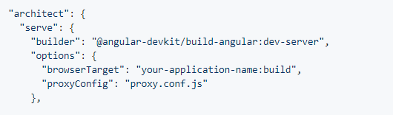

### Q) CLI commands

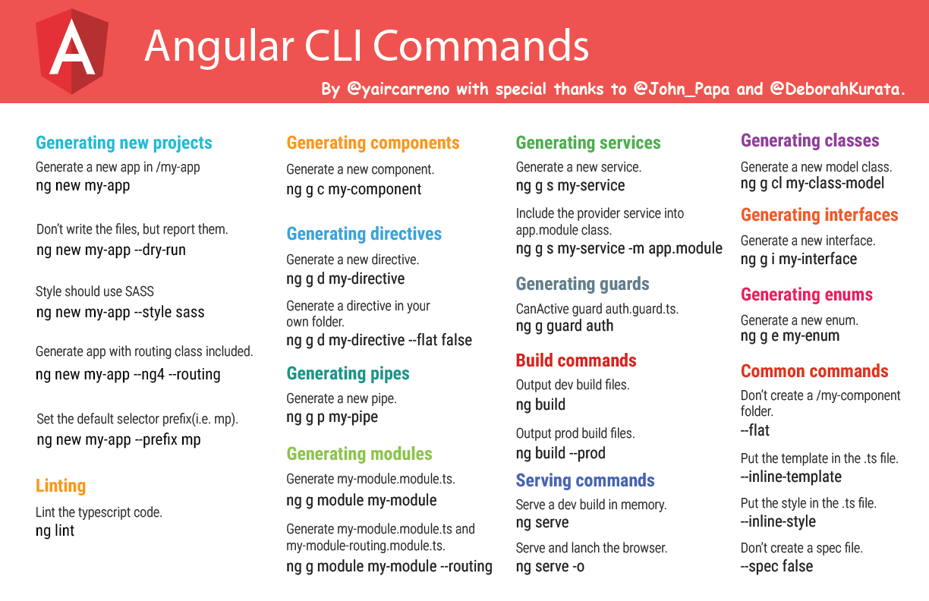

## Build

### Q) --e=prod flag

The file contents for the current environment will overwrite these during build.

The build system defaults to the dev environment which uses `environment.ts`, but if you do

`ng build --env=prod` then `environment.prod.ts` will be used instead.

--environment=prod

--e=dev

The list of which env maps to which file can be found in `angular-cli.json`.

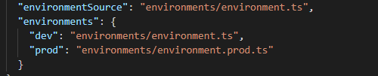

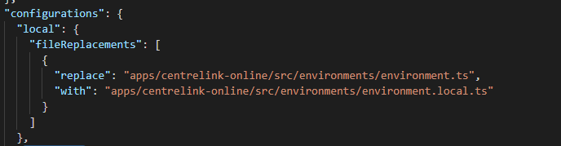

### Q) --prod flag

The --prod meta-flag engages the following optimization features.

* [Ahead-of-Time (AOT) Compilation](https://angular.io/guide/aot-compiler): pre-compiles Angular component templates.
* [Production mode](https://angular.io/guide/deployment#enable-prod-mode): deploys the production environment which enables production mode.
* Bundling: concatenates your many application and library files into a few bundles.
* Minification: removes excess whitespace, comments, and optional tokens.
* Uglification: rewrites code to use short, cryptic variable and function names.
* Dead code elimination: removes unreferenced modules and much unused code.

--target=production

--dev

### Q) Difference between ng build --prod and ng build --env=prod

* ng build --env=prod only set environment settings inside environment.prod.ts, whereas
* ng build --prod runs the --env=prod and does AOT, bundle, Minification Uglification, Dead code elimination

### Q)--configuration/-c flag

A named configuration environment, as specified in the "configurations" section of angular.json.

Aliases: -c

## Module

### Q) NgModule

**The purpose of NgModule is to declare each thing you create in Angular, and group them together** (like Java packages or PHP / C# namespaces).

* They are essential for template parsing, both in the Just In Time or Ahead Of Time Compilation scenarios.
* they are also very useful simply as documentation for grouping related functionality
* They can be used to clarify which components and directives are meant to be used publicly vs internal implementation details.

### Q) Metadata

NgModule metadata does the following:

* **Declarations**: Declares which components, directives, and pipes belong to the module.
* **Exports**: Makes some of those components, directives, and pipes public so that other module's component templates can use them when they get imported. Otherwise, these components stay module internal and cannot be accessed from the outside.
* **Imports**: Imports other modules with the components, directives, and pipes that components in the current module need.
* **Providers**: Provides services that the other application components can use.

### Q) What is a *declarable*?

**Declarable are the class types—components, directives, and pipes—that you can add to a module's**[**declarations**](https://angular.io/api/core/NgModule#declarations)**list.** They're the only classes that you can add to [declarations](https://angular.io/api/core/NgModule#declarations).

Do not declare the following:

* A class that's already declared in another module, whether an app module, @NgModule, or third-party module.
* An array of directives imported from another module. For example, don't declare FORMS_DIRECTIVES from @angular/forms because the [FormsModule](https://angular.io/api/forms/FormsModule) already declares it.
* Module classes.
* Service classes.
* Non-Angular classes and objects, such as strings, numbers, functions, entity models, configurations, business logic, and helper classes.

### Q) AppModule

Every Angular app has at least one module, the root module. You bootstrap that module to launch the application.

Several things identify this as being a root module:

* The root module has the conventional name of AppModule.
* The root module in the case of web applications imports the BrowserModule, which for example provides Browser specific renderers, and installs core directives like ngIf, ngFor, etc.
* The bootstrap property is used, providing a list of components that should be used as bootstrap entry points for the application. There is usually only one element in this array: the root component of the application

### Q) [BrowserModule](https://angular.io/api/platform-browser/BrowserModule) or [CommonModule](https://angular.io/api/common/CommonModule)?

The root application module, AppModule, of almost every browser application should import [BrowserModule](https://angular.io/api/platform-browser/BrowserModule)from @angular/platform-browser.

[BrowserModule](https://angular.io/api/platform-browser/BrowserModule) provides services that are essential to launch and run a browser app.

[BrowserModule](https://angular.io/api/platform-browser/BrowserModule) also re-exports [CommonModule](https://angular.io/api/common/CommonModule) from @angular/common, which means that components in the AppModule module also have access to the Angular directives every app needs, such as [NgIf](https://angular.io/api/common/NgIf) and NgFor.

Do not import BrowserModule in any other module. *Feature modules* and *lazy-loaded modules* should import CommonModule instead. They need the common directives. They don't need to re-install the app-wide providers.

Importing [CommonModule](https://angular.io/api/common/CommonModule) also frees feature modules for use on *any* target platform, not just browsers.

### Q) RouterModule

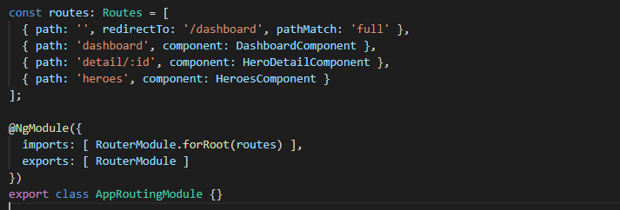

If you add AppRoutingModule to AppModule you also implicitly import RouterModule this way. Otherwise you would need to import it explicitly

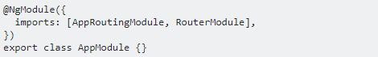

For example to be able to use <router-outlet> or RouterLink in components declared in AppModule.

### Q) Using spread operator to make module more readable

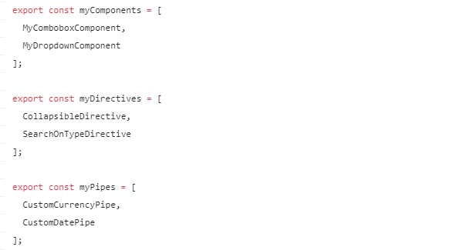

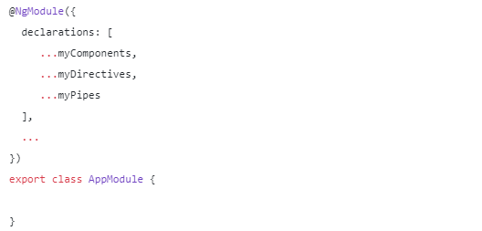

### Q) NgModule Scope

The confusion starts with components and services not having the same scope / visibility:

* declarations / components are in local scope (private visibility),
* Providers / services are (generally) in global scope (public visibility).

**It means the components you declared are only usable in the current module. If you need to use them outside, in other modules, you’ll have to export them:**

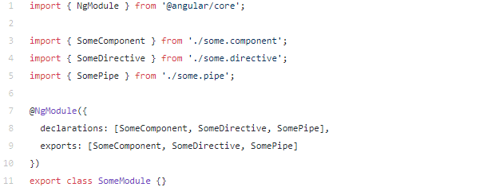

On the contrary, **services you provided will generally be available / injectable anywhere in your app**, in all modules.

### Q) Injectable in directly imported module.

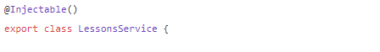

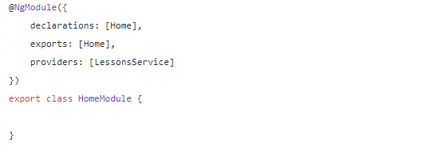

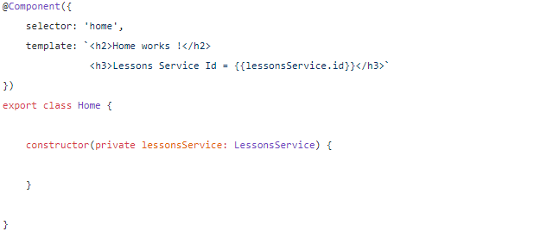

That a new module will **not** create its own separate dependency injection context! The lessons service will actually be added to the global dependency injection context.

This means that LessonsService is available for injection anywhere in the application.

Why isn't a separate DI context created by default?

This happens by design: Modules that are directly imported are usually meant to enrich the global application and the injectable received are in most of the cases meant as application-wide singletons.

The goal is usually not to create almost a small separate sub-application inside the main application.

So the behaviour of not creating a nested DI context is meant to help with the most common use case: importing application-wide singletons.

This helps prevent the following error situations:

* we import a module and are trying to use its injectables but we start getting errors saying that the injectable is not available
* we run into subtle bugs caused by the presence of multiple instances of an injectable

### Q) Injectable in lazy loading module

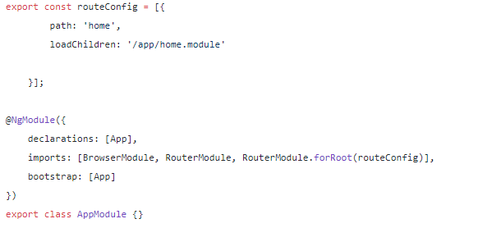

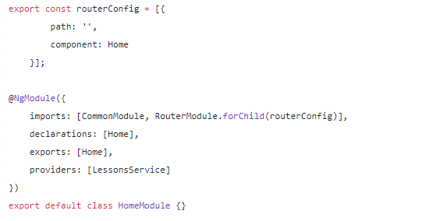

**When lazy loading a module is that Angular will create a child dependency injection context.** This Home DI context will contain the LessonsService, but this service will not be visible to the rest of the application.

The service will be visible to the Homecomponent, but if we now try to inject this into for example the main App component, we will get an error:



### Q) Injectable in shared module

The shared module BlockingProgressModule is made to be used across multiple modules. Let’s import the BlockingProgressModule into every module that uses it. Now we have a new challenge: As we import the module multiple times (AppModule + child modules) multiple instances of our service are being created at runtime making the service pretty much useless.

We need another mechanism for a shared module to make its injectables available to both the root module and lazy loaded modules in a safe way. What we want is a way to do the following:

* create an service instance when adding it to the root module
* this instance will automatically by visible to any child DI contexts
* prevent the creation of a second instance of the service, by removing the providers declaration

To solve this issue we can simply use the .forRoot() method as described [here](https://medium.com/@chrishouse/when-to-use-angulars-forroot-method-400094a0ebb7?source=post_page---------------------------) to create a singleton instance of our module’s services. To make this work we need to provide our BlockingProgressService different using the static forRoot() method:

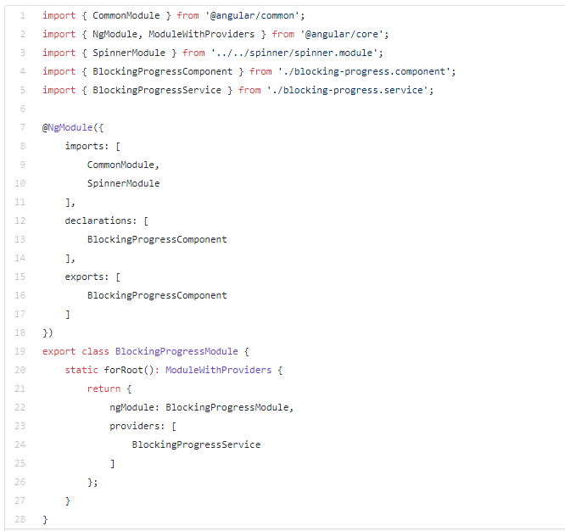

Then import the module in our AppModule using the forRoot() method:

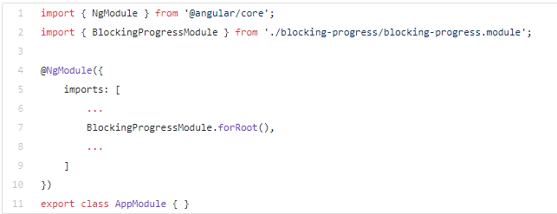

All child/feature modules will import the BlockingProgressModule the standard way like so:

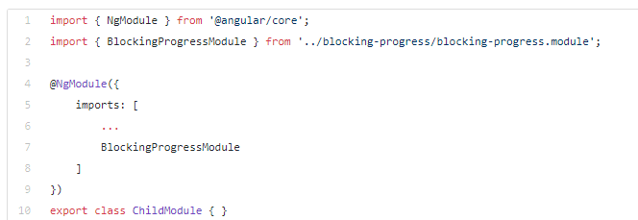

### Q) Pitfalls of module

Modules are very useful, but beware of the following pitfalls:

* do not redeclare a component, directive, etc. in more than one module
* modules do not create their own DI context, so injectables are available also outside the module
* unless the module is lazy loaded, in that case a separate DI context is created by the router to avoid accidental injectable overrides and prevent hard to troubleshoot bugs
* if you have a shared module that needs to be added to a lazy loaded module, make sure that it does not have providers, because that would create duplicate service instances

## Component

### Q) Data binding

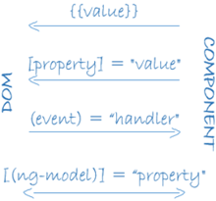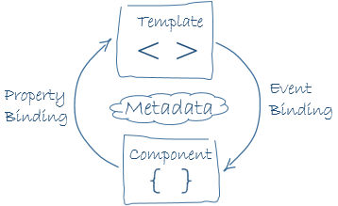

Angular processes all data bindings once for each JavaScript event cycle, from the root of the application component tree through all child components.

### Q) Understanding the Expression Context

When Angular evaluates an expression, it does so in the context of the template’s component, which is how the template is able to access methods and properties without any kind of prefix

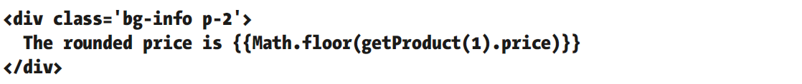

When Angular processes the template, it will produce the following error.

EXCEPTION: TypeError: Cannot read property 'floor' of undefined

The error message doesn’t specifically mention the global namespace. Instead, Angular has tried to evaluate the expression using the component as the context and failed to find a Math property.

If you want to access functionality in the global namespace, then it must be provided by the component, acting as on behalf of the template.

### Q) Communication between parent and child components

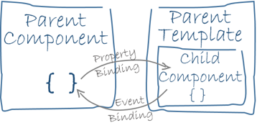

#### Q) Pass data from parent to child with input binding

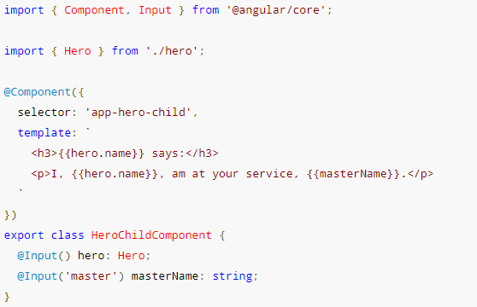

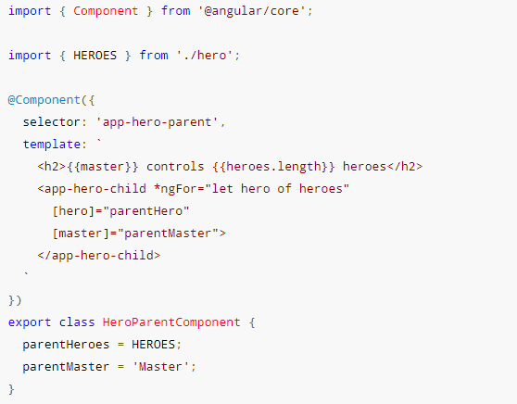

#### Q) Parent listens for child event

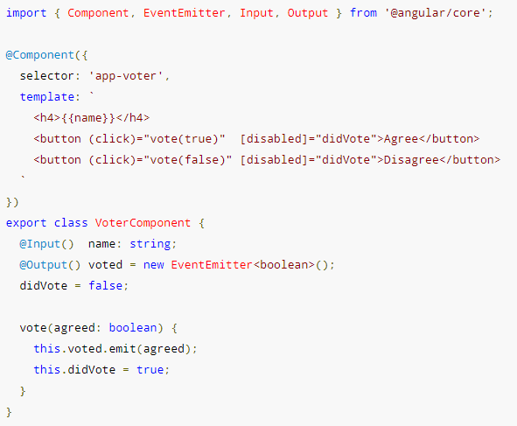

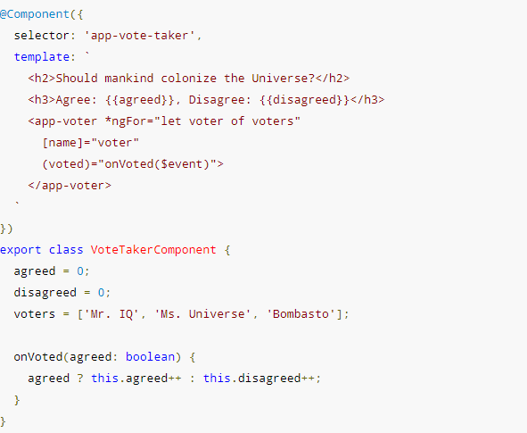

#### Q) Parent interacts with child via local variable

A parent component cannot use data binding to read child properties or invoke child methods. You can do both by creating a template reference variable for the child element and then reference that variable within the parent template as seen in the following example.

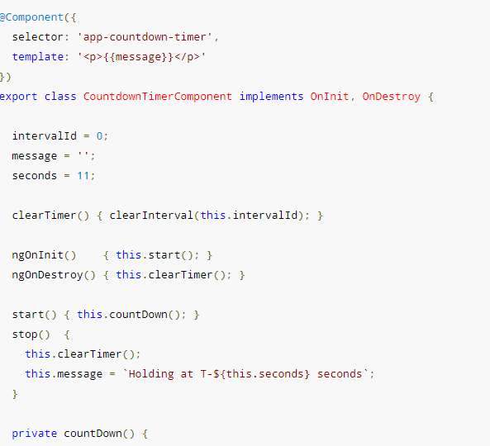

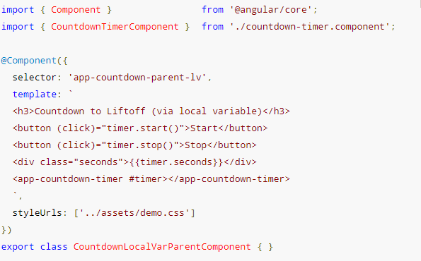

You can place a local variable, #timer, on the tag <countdown-timer> representing the child component. That gives you a reference to the child component and the ability to access any of its properties or methods from within the parent template.

#### Q) Parent calls an @ViewChild()

 Inject the child component into the parent as a ViewChild.

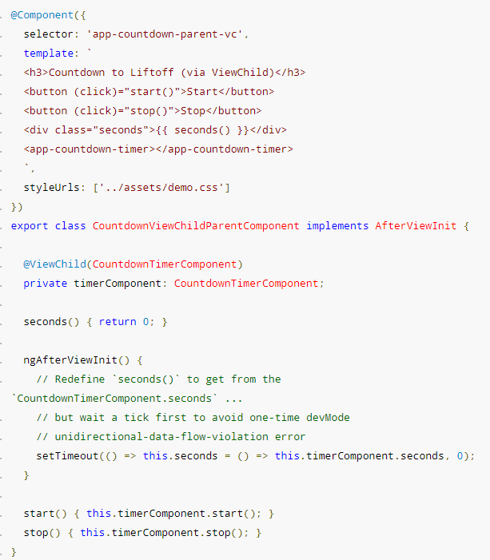

#### Q) Parent and children communicate via a service

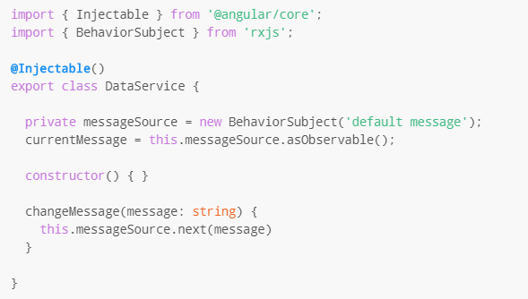

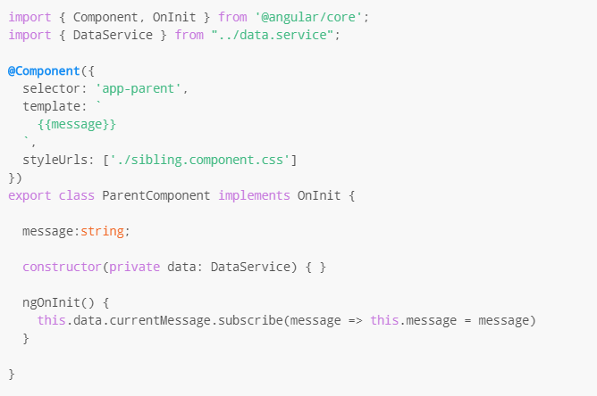

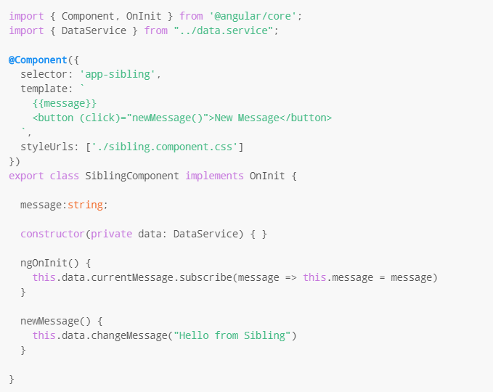

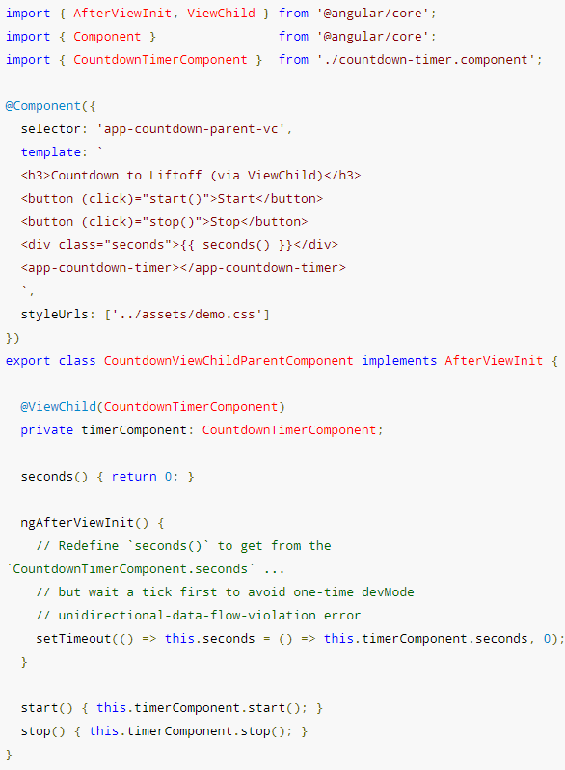

### Q) Template reference variable

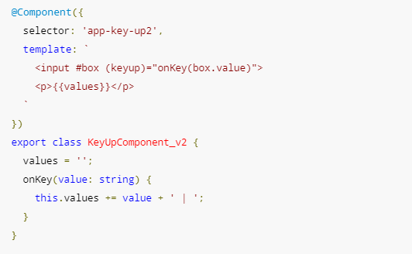

The template reference variable named box, declared on the <input> element, refers to the <input>element itself.

### Q) Lifecycle

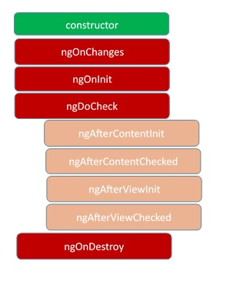

These stages are mainly divided into two phases – one is linked to the component itself and another is linked to the children of that component.

**ngOnChanges**– This event executes every time when a value of an input control within the component has been changed. Actually, this event is fired first when a value of a bound property has been changed. It always receives a change data map, containing the current and previous value of the bound property wrapped in a SimpleChange.

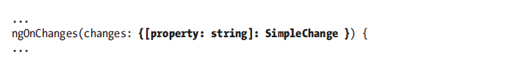

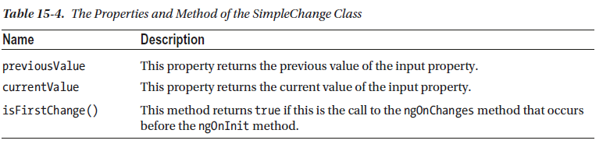

**ngOnInit** – This event initializes after Angular first displays the data-bound properties or when the component has been initialized. This event is basically called only after the ngOnChanges()events. This event is mainly used for the initialize data in a component.

**ngDoCheck**– This event is triggered every time the input properties of a component are checked. We can use this hook method to implement the check with our own logic check. Basically, this method allows us to implement our own custom change detection logic or algorithm for any component.

**ngAfterContentInit**–  This lifecycle method is executed when Angular performs any content projection within the component views. This method executes when all the bindings of the component need to be checked for the first time. This event executes just after the ngDoCheck() method. This method is basically linked with the child component initializations.

**ngAfterContentChecked** – This lifecycle hook method executes every time the content of the component has been checked by the change detection mechanism of Angular. This method is called after the ngAfterContentInit() method. This method is also called on every subsequent execution of ngDoCheck(). This method is also mainly linked with the child component initializations.

**ngAfterViewInit** – This lifecycle hook method executes when the component’s view has been fully initialized. This method is initialized after Angular initializes the component’s view and child views. It is called after ngAfterContentChecked(). This lifecycle hook method only applies to components.

**ngAfterViewChecked**– This method is called after the ngAterViewInit() method. It is executed every time the view of the given component has been checked by the change detection algorithm of Angular. This method executes after every subsequent execution of the ngAfterContentChecked(). This method also executes when any binding of the children directives has been changed. So this method is very useful when the component waits for some value which is coming from its child components.

**ngOnDestroy** – This method will be executed just before Angular destroys the components. This method is very useful for unsubscribing from the observables and detaching the event handlers to avoid memory leaks. Actually, it is called just before the instance of the component is finally destroyed. This method is called just before the component is removed from the DOM.

## Pipe

### Q) What is pipe

Pipes are small fragments of code that transform data values so they can be displayed to the user in templates. Pipes allow transformation logic to be defined in self-contained classes so that it can be applied consistently throughout an application.

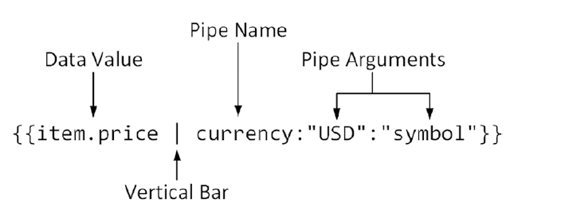

### Q) Pure pipe

A pure pipe is only called when Angular detects a change in the value or the parameters passed to a pipe.

An impure pipe is called for every change detection cycle no matter whether the value or parameters changes.

This is relevant for changes that are not detected by Angular

* when you pass an array or object that got the content changed (but is still the same instance)
* When the pipe injects a service to get access to other values, Angular doesn't recognize if they have changed.

In these cases you probably still want the pipe to be executed.

You should be aware that impure pipes are prone to be inefficient. For example when an array is passed into the pipe to filter, sort, ... then this work might be done every time change detection runs (which is quite often especially with the default ChangeDetectionStrategy setting) event though the array might not even have changed. Your pipe should try to recognize this and for example return cached results.

### Q) Async pipe

The [async](https://angular.io/api/core/testing/async) pipe subscribes to an Observable or Promise and returns the latest value it has emitted. When a new value is emitted, the [async](https://angular.io/api/core/testing/async) pipe marks the component to be checked for changes. When the component gets destroyed, the [async](https://angular.io/api/core/testing/async) pipe unsubscribes automatically to avoid potential memory leaks.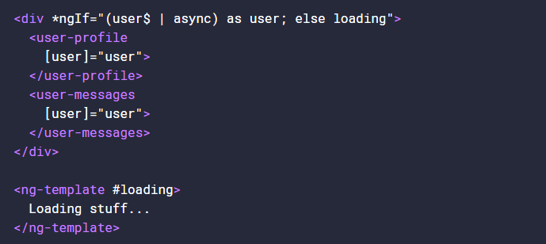

What “as user” will do is wait until user$ | async has evaluated, and bind the result to the value of user.

**Problems**

Every time we use the async pipe, we create a subscription. If you’re going to subscribe directly to Observables that initiate data transfer, it’s likely you’ve come across unwanted issues such as duplicate Http requests.

## Directives

### Q) ngif

The ngIf directive adds and removes elements from the HTML document, rather than just showing or hiding them.

If you want to leave elements in place and control their visibility, either by setting the hidden element property to true or by setting the display style property to none.

Some directives, such as ngFor, ngIf, and the nested directives used with ngSwitch are prefixed with an asterisk, as in *ngFor, *ngIf, and *ngSwitch. **The asterisk is shorthand for using directives that rely on content provided as part of the template, known as a micro-template**. Directives that use microtemplates are known as structural directives.

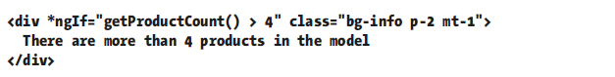

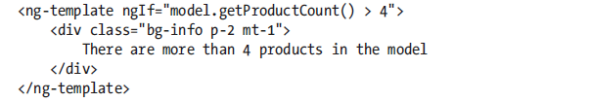

### Q) ngSwitch

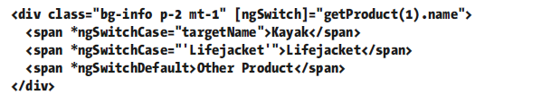

"targetName" assigned to the ngSwitchCase directives are also expressions.

"'Lifejacket'" is literal string.

### Q) ngFor

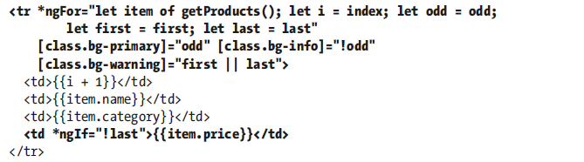

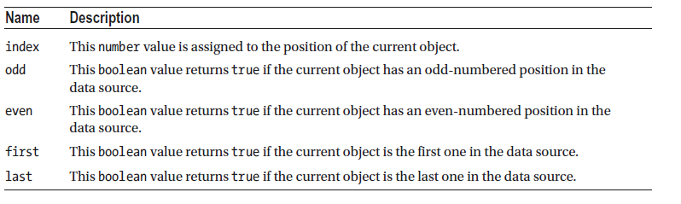

### Q) ngTemplateOutlet

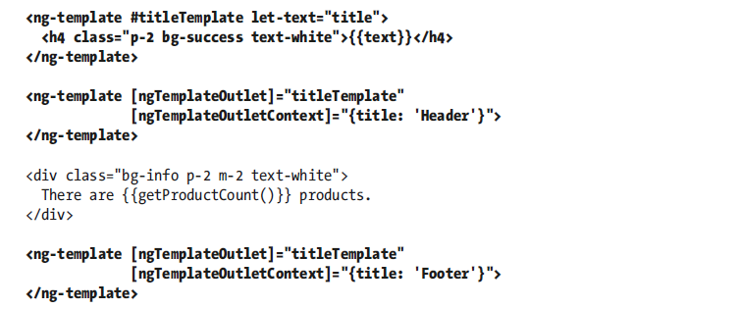

### Attribute directive

#### Q) @Directive

Directives are classes to which the @Directive decorator has been applied. The decorator requires the selector property, which is used to specify how the directive is applied to elements, expressed using a standard CSS style selector

The directive constructor defines a single ElementRef parameter, which Angular provides when it creates a new instance of the directive and which represents the host element. The ElementRef class defines a single property, nativeElement, which returns the object used by the browser to represent the element in the Domain Object Model.

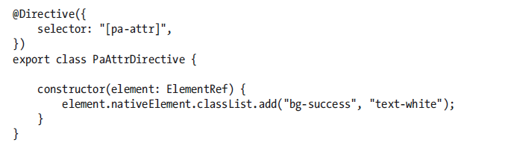

#### Accessing Application Data in a Directive

##### Q) Reading Host Element Attributes



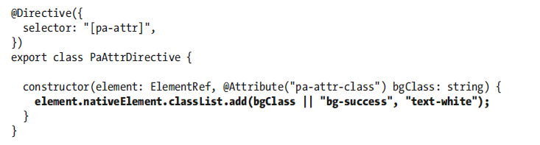

To receive the value of the pa-attr-class attribute, I added a new constructor parameter called bgClass, to which the @Attribute decorator has been applied, it specifies the name of the attribute that should be used to provide a value for the constructor parameter when a new instance of the directive class is created. Angular creates a new instance of the decorator for each element that matches the selector and uses that element’s attributes to provide the values for the directive constructor arguments that have been decorated with @Attribute.

##### Q) Creating Data-Bound Input Properties

The main limitation of reading attributes with @Attribute is that values are static. The real power in Angular directives comes through support for expressions that are updated to reflect changes in the application state and that can respond by changing the host element.

Directives receive expressions using data-bound input properties, also known as input properties

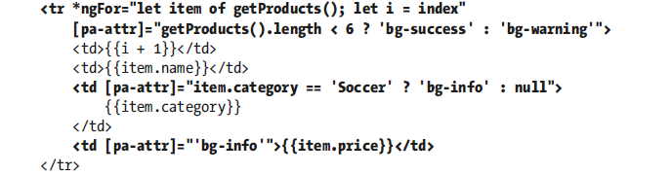

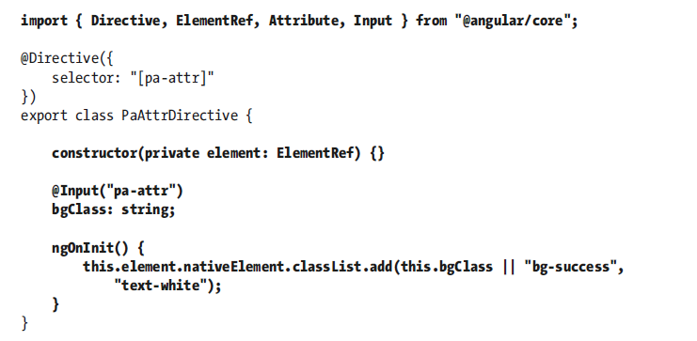

When Angular creates a new instance of a directive class, the constructor is invoked to create a new directive object and only then is the value of the input property set. This means that the constructor cannot access the input property value because its value will not be set by Angular until after the constructor has completed and the new directive object has been produced. To address this, directives can implement lifecycle hook methods.

##### Q) Responding to Input Property Changes

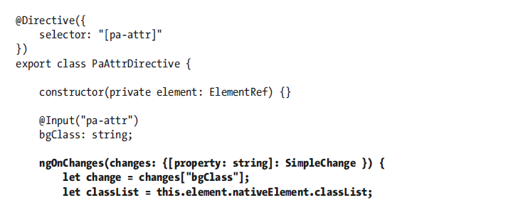

The ngOnChanges method is called once before the ngOnInit method and then called again each time there are changes to any of a directive’s input properties. The ngOnChanges parameter is an object whose property names refer to each changed input property and whose values are SimpleChange objects.

#### Creating Custom Events

Output properties are the Angular feature that allows directives to add custom events to their host elements, through which details of important changes can be sent to the rest of the application. Output properties are defined using the @Output decorator.

## DI

### Q) Angular DI

The DI framework in Angular consists of 4 concepts working together:

1. Token

This uniquely identifies something that we want injected. A dependency of our code.

1. Dependency

The actual code we want injected.

1. Provider

This is a map between a token and a list of dependencies.

1. Injector

This is a function which when passed a token returns a dependency (or a list of dependencies)

We configure injectors with providers, Angular then uses these injectors to resolve dependencies using tokens and injecting them into constructors as arguments.

There are 4 types of providers, a class provider, a value provider, a factory function provider and an alias provider.

If we want a dependency to be shared across our entire application we would configure it on our NgModule.

If we want a separate instance of a dependency to be shared across each instance of a component and it’s children we configure it on the components providers’ property.

If we want a separate instance of a dependency to be shared across each instance of a component and only its view children we configure it on the components viewProviders property.

### Q) Inject()

We use the @Inject parameter decorator to instruct Angular we want to resolve a token and inject a dependency into a constructor.

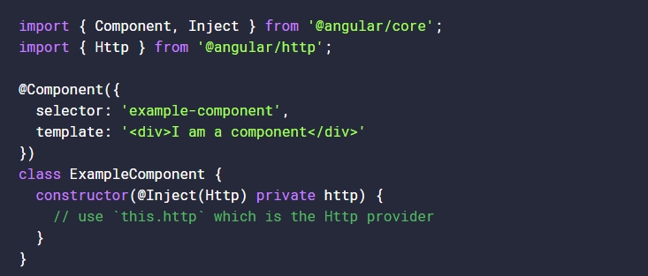

@Inject is a manual way of specifying this lookup token, followed by the lowercase http argument to tell Angular what to assign it against.

This could (and will) get very messy when a component or service requires a lot of dependencies. As Angular supports resolving dependencies from the emitted metadata, there’s no need to use @Inject most of the time.

The only time we’d need to use @Inject is alongside something like an [OpaqueToken](https://angular.io/docs/ts/latest/api/core/index/OpaqueToken-class.html) - which creates a unique blank token to be used as a dependency injection provider.

The reason we use @Inject is because we cannot use an OpaqueToken as the *type* of a parameter, for instance this will not work:

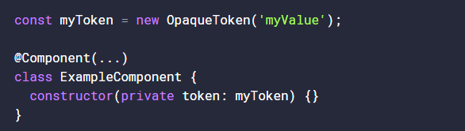

Here, myToken is not a Type, it’s a value - which means TypeScript cannot compile it. However, when we introduce @Inject alongside an OpaqueToken, things will work out nicely:

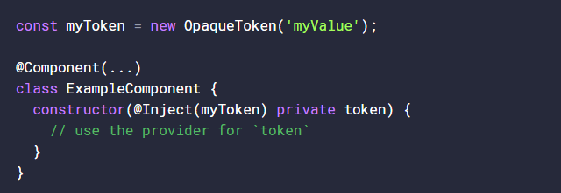

### Q) Injectable()

Decorating all our constructor arguments with @Inject can be tiresome however so instead we can decorate our *entire* class with @Injectable

@Injectable is actually a shortcut for having to decorate every parameter in your constructor with @Inject.

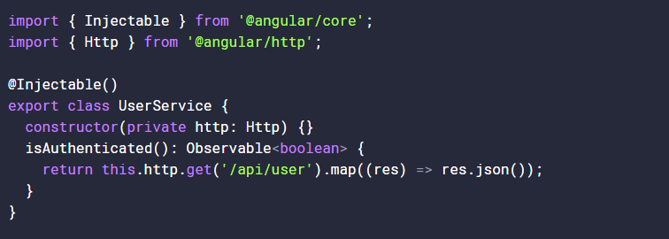

At this point, Angular is aware of the Http token and can supply it to http.

### Q) Decorator is essential to include dependency for $injector to work.

We *only* need to use @Injectable on classes which don’t already use one of the other Angular decorators. That’s because the other decorators in Angular, such as @Component and @Directive, already perform the same function as @Injectable.

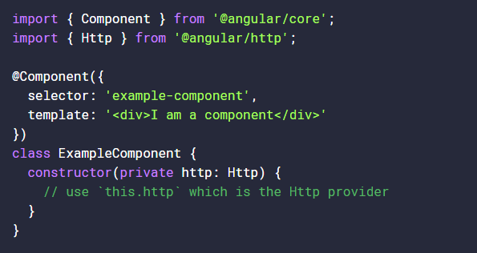

Inside our tsconfig.json files we’ll likely have emitDecoratorMetadata set to true. This emits metadata about the type of the parameter into a decorator in our compiled JavaScript output.

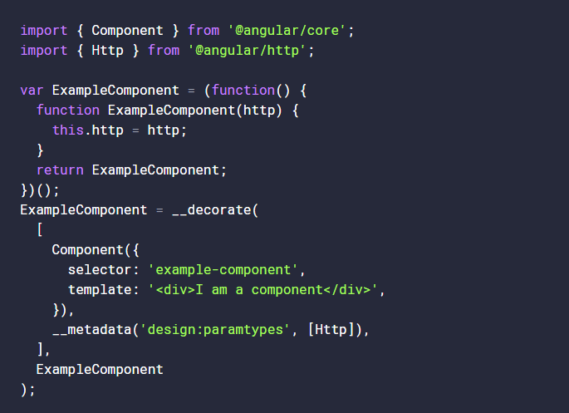

From here, we can see the compiled code knows about http being equal to the Http service provided by @angular/http - it’s added as a decorator for our class here:

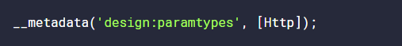

So essentially, the @Component decorator is transformed into plain ES5, and some additional metadata is supplied through the __decorate assignment. Which in turn tells Angular to lookup the Http token and supply it as a first parameter to the Component’s constructor - assigning it to this.http

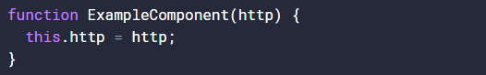

<https://toddmotto.com/angular-dependency-injection>

### Q) Providers

We configure these injectors with providers by adding the configuration to either the providers’ property on the NgModule, Component and Directive decorators or to the viewProviders property on the Component decorator.

The provide property is the token and can either be a type, a string or an instance of something called an InjectionToken.

**useClass**

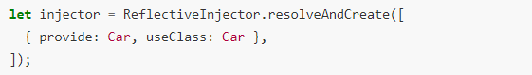

**useExisting**

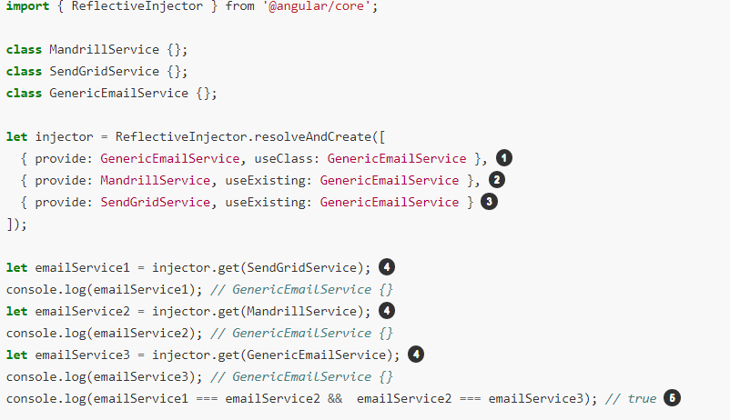

**useValue**

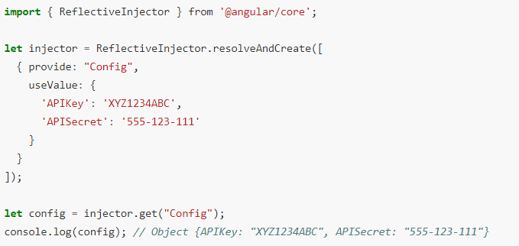

**useFactory**

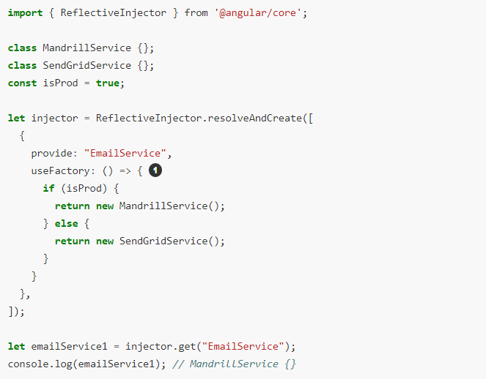

### Q) Token

A *token* can be either a string, a class or an instance of InjectionToken.

String tokens can cause name clashes so we prefer to use *InjectionTokens* instead.

**String token**

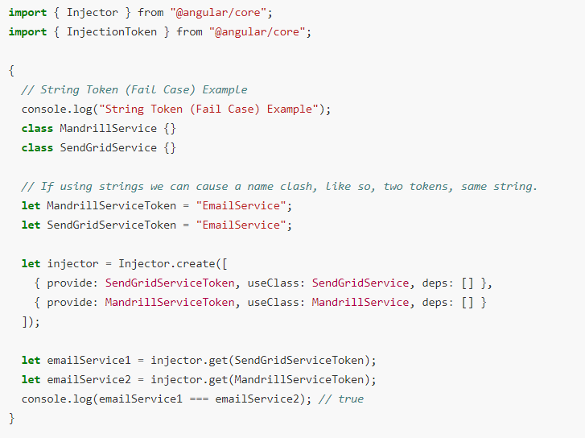

When configuring an injector with the *same* token multiple times, the last provider just *overwrites* the previous providers.

**Injection token**

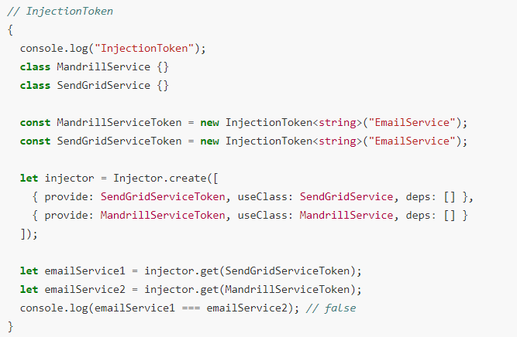

InjectionToken is unique even if the same descriptive string was passed in.

**Type token**

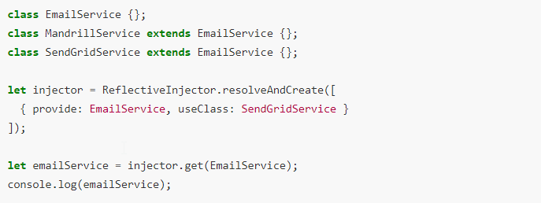

### Q) Injectors

* We configure injectors with providers.
* We pass to injectors a token and then resolve this into a dependency.
* Injectors cache dependencies, so multiple calls result in the same instance being returned.
* Different injectors hold different caches, so resolving the same token from a different injector will return a different instance.
* We create child injectors from parent injectors.
* A child injector will forward a request to their parent if it can’t resolve the token itself.

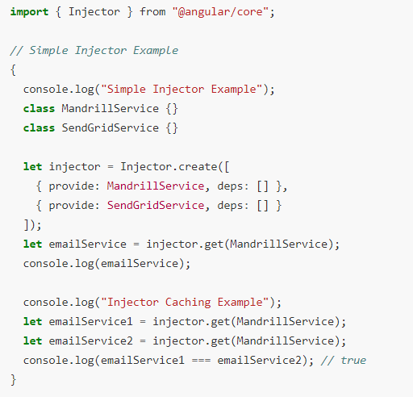

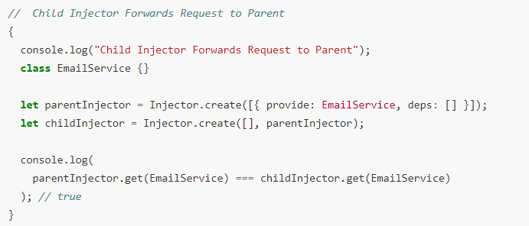

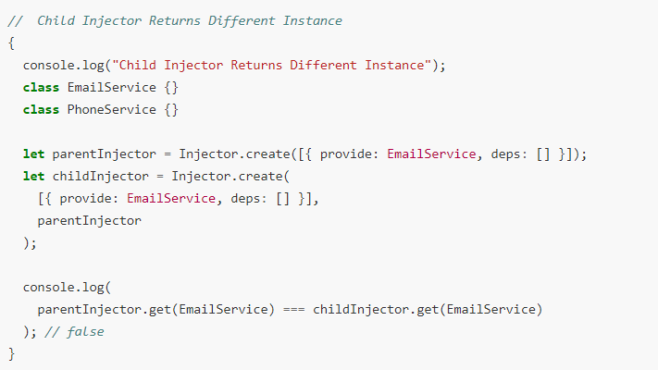

### Q) Hierarchical Dependency Injectors

The Angular dependency injection system is hierarchical. The choices you make about where to configure providers lead to differences in the final bundle size, service scope, and service lifetime.

Services are singletons within the scope of an injector. That is, there is at most one instance of a service in a given injector.

We can configure injectors in Angular by:

* providers on NgModule.
* providers on Components and Directives.
* viewProviders on Components.

**NgModule level**

NgModule-level providers can be specified with @[NgModule](https://angular.io/api/core/NgModule)() providers metadata option, or in the @[Injectable](https://angular.io/api/core/Injectable)() [providedIn](https://angular.io/api/core/Injectable" \l "providedIn) option

Use the @[NgModule](https://angular.io/api/core/NgModule)() provides option if a module is [lazy loaded](https://angular.io/guide/lazy-loading-ngmodules). The module's own injector is configured with the provider when that module is loaded, and Angular can inject the corresponding services in any class it creates in that module.

If you use the @[Injectable](https://angular.io/api/core/Injectable)() option [providedIn](https://angular.io/api/core/Injectable" \l "providedIn): MyLazyloadModule, the provider could be shaken out at compile time, if it is not used anywhere else in the app.

When you use [providedIn](https://angular.io/api/core/Injectable" \l "providedIn):'root', you are configuring the root injector for the app, which is the injector for AppModule.

For both root-level and module-level injectors, a service instance lives for the life of the app or module, and Angular injects this one service instance in every class that needs it.

**Components level**

*Component-level* providers configure each component instance's own injector. Angular can only inject the corresponding services in that component instance or one of its descendant component instances.

A component-provided service may have a limited lifetime. Each new instance of the component gets its own instance of the service. When the component instance is destroyed, so is that service instance.

Child modules and component injectors are independent of each other, and create their own separate instances of the provided services

**Two places to do the injection**

**@Injectable**

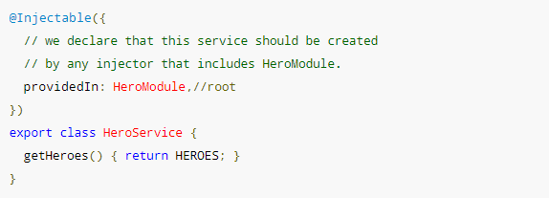

**Module/Component/Directive metadata providers**

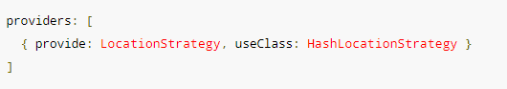

<https://codecraft.tv/courses/angular/dependency-injection-and-providers/ngmodule-providers-vs-component-providers-vs-component-viewproviders/>

**Injector scope**

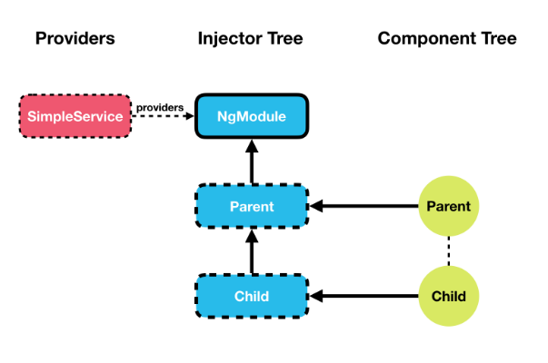

Since we only have one injector which is resolving the dependency, every-time we request an instance of SimpleService to be injected into one of our components it’s *always* going to inject the *same* instance.

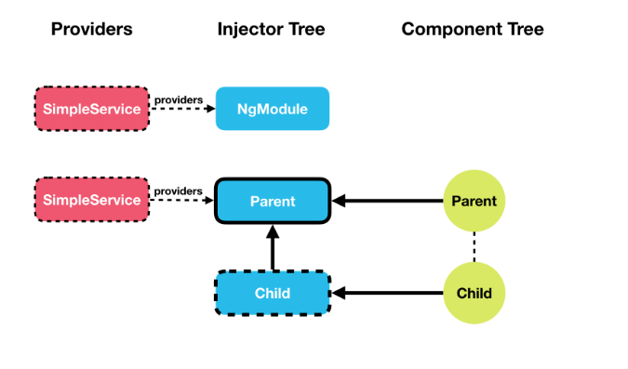

Each instance of ParentComponent now has its *own* instance of SimpleService, so state is not shared globally but only between a ParentComponent and its child components.

That’s because each instance of ParentComponent has its own child injector with SimpleServiceconfigured as a provider and it won’t use model level one.

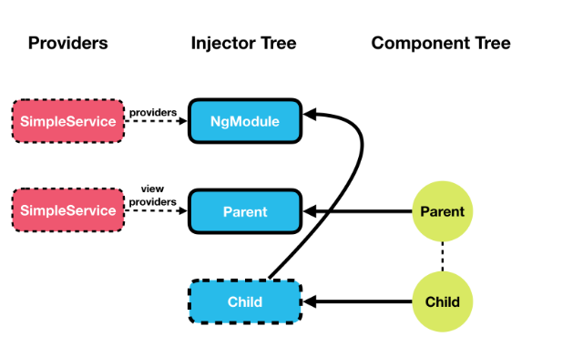

When using viewProviders the component creates an injector which is **only** used by the *current component* and any *view children*.

If you are a *content child*, as our child component now is, then it uses the injector in NgModule to resolve the dependency.

### Looking for dependency

#### Q) Default

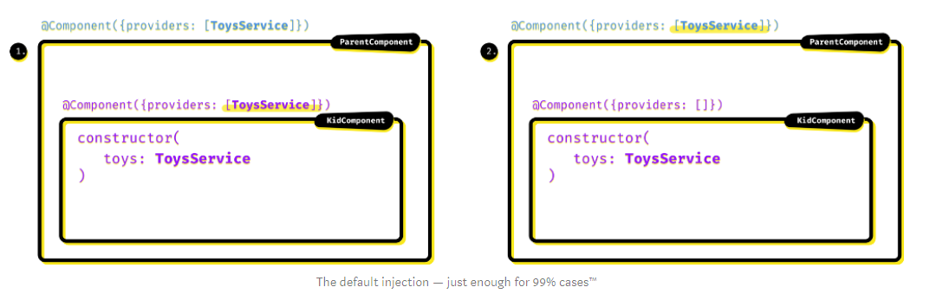

By default Angular will first check if the component defines a dependency injector in its decorator. If it does (1.), the component (specifically: each of its instances) will receive its own instance of the service. If it doesn’t find in on the component, it will look for a parent injector (e.g. the parent component (2.), its ancestors etc.), up the injectors’ tree and in the end it will stop on the application-wide instance of the service defined on a one of our NgModules. Unless it’s not even there, in which case we will get a “

No provider” error.

#### Q) @Self()

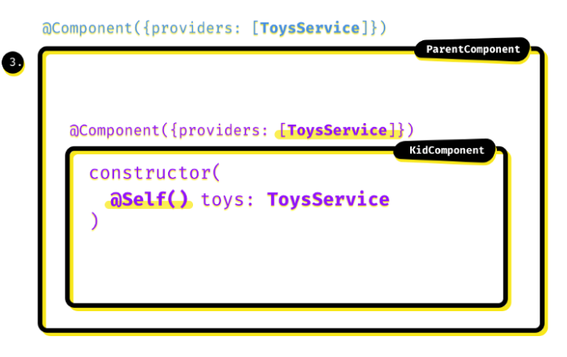

If we decorate the parameter with @Self(), it’s like there was only the first step of the previously discussed default behaviour. The only place allowed to find the injector is the component itself (**3.**)

#### Q) @Optional()

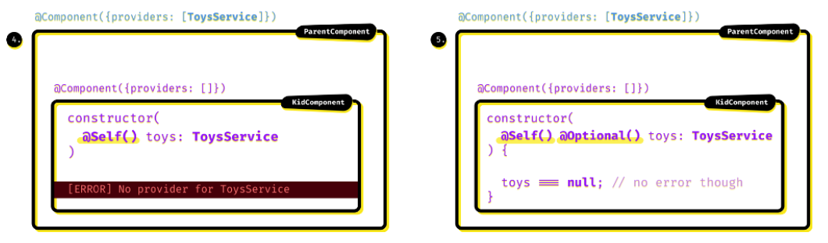

If it isn’t defined there, that would be an error, right? Yes, definitely *(4.)*, but also not necessarily: if your component doesn’t absolutely need that service, you can decorate a parameter with the @Optional() decorator and in such case of no provider found, no error will occur. Instead Angular will set the value for our service to null*(5.)*

#### Q) @SkipSelf()

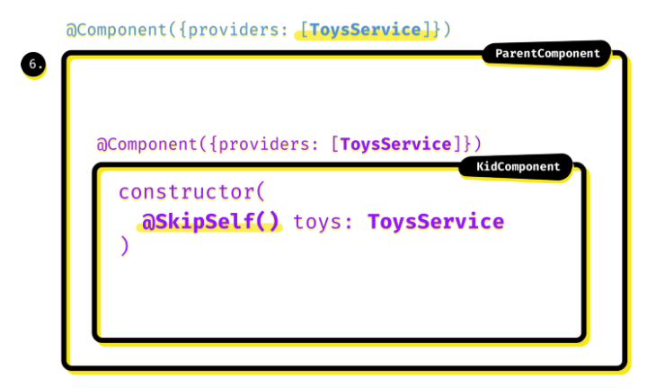

At this point, @SkipSelf() decorator should be, forgive the bad pun, self-explanatory. The behaviour is like the default — we’re looking up the injectors hierarchy, but this time skipping the first step of looking for a possible injector in the requesting component *(6.)*

#### Q) @Host

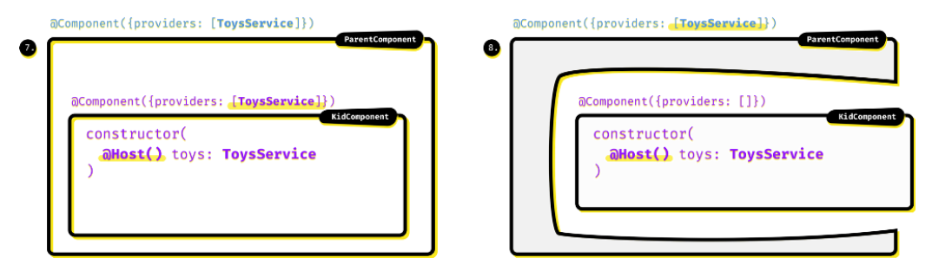

@Host() decorator makes Angular to look for the injector on the component itself, so in that regard it may look similar to the @Self() decorator *(7.)*. But that’s actually not the end: if the injector is not found there, it looks for the injector *up to its host component.*

There are two common scenarios where said host component is something different than our current class.

* We’ve been looking at a Component as our example, but we may just as well have a Directive here instead. In that case it can be used on a Component that defines its injector and that component would be the directive’s host.
* Or we can have our KidComponent projected into ParentComponent(by that <ng-content></ng-content> thingy). Then we also say that our component is being hosted by ParentComponent — and if ParentComponent provides ToyService and KidComponent does not, the @Host() decorator of that inner component would still get that service’s instance (8.)

## Router

### Q) Router Configuration

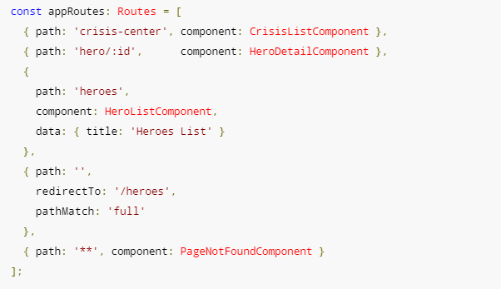

The order of the routes in the configuration matters and this is by design. The router uses a first-match wins strategy when matching routes, so more specific routes should be placed above less specific routes.

#### Q) **PathMatch**

**pathMatch** is used to specify the matching strategy **full** or **prefix**. **full** means that the whole URL's path needs to match by the matching algorithm. **prefix** means the first route where path matches the start of the URL will be chosen. In the case of empty path if we don't set the **full** matching strategy then we won't get the desired behaviour as any path starts with an empty path.

#### Q) Data

The data property in the third route is a place to store arbitrary data associated with this specific route. The data property is accessible within each activated route. Use it to store items such as page titles, breadcrumb text, and other read-only, *static* data

#### Q) Route Resolver

Route resolves are nothing more than a way to pre-fetch the data a component needs before it is initialized. A resolver is a function that returns either Observable<any>, Promise<any> or just data.

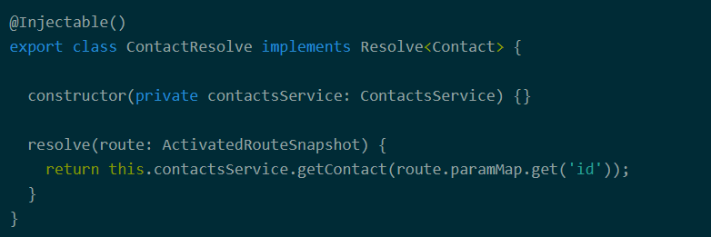

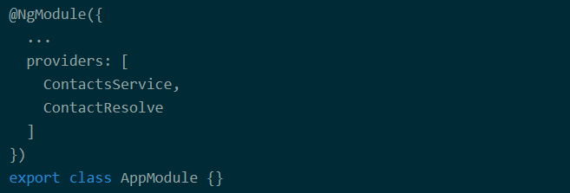

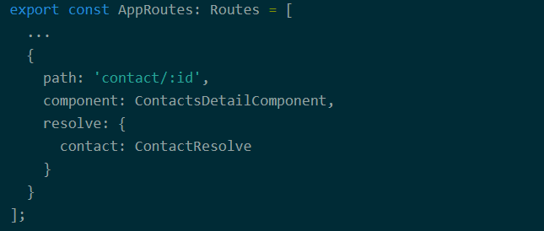

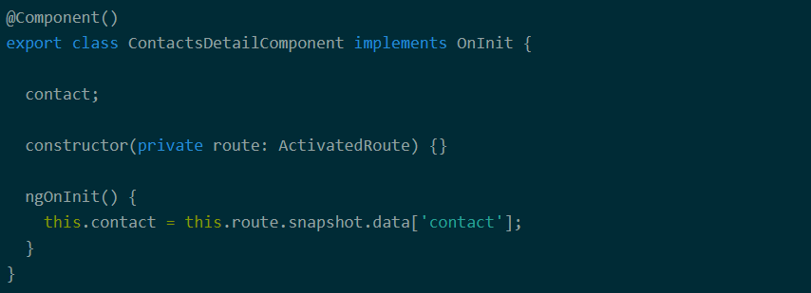

https://www.callibrity.com/blog/angular-2-route-resolves

#### Q) Guard types

First, it runs the following [guards](https://angular.io/guide/router#milestone-5-route-guards) from the deepest child route to the top:

**CanDeactivate**

**CanActivateChild**

Then it runs the following guard from the top route to the deepest child route:

**CanActivate**

If the new router state requires a module to be lazy loaded, the following guard is also run:

**CanLoad**

A guard must return a boolean or a promise/observable that resolves to a boolean value.

Guards can be implemented in different ways, but after all it really boils down to a function that returns either Observable<boolean>, Promise<boolean> or boolean. In addition, guards are registered using providers, so they can be injected by Angular when needed.

### Q) RouterOutlet

It acts as a placeholder that marks the spot in the template where the router should display the components for that outlet.

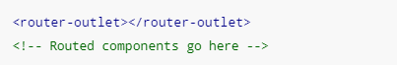

Notice that the router-outlet directive has no name attribute. Internally, this default outlet is known as the [PRIMARY_OUTLET](https://github.com/angular/angular/blob/master/packages/router/src/shared.ts?source=post_page---------------------------#L20), and it is where all routed content will go.

However, it’s possible that you want multiple outlets for displaying different routable content in different parts of your application.

<router-outlet name="sidebar"></router-outlet>

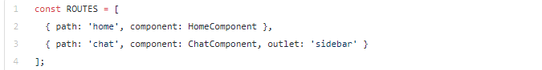



A router outlet will emit an activate event any time a new component is being instantiated, and a deactivate event when it is being destroyed.

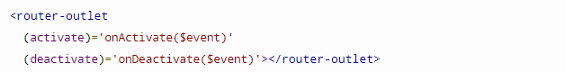

### Q) RouterLink

routerLink: this directive is used instead of *href* in the <a> tags, routerLinkActive: this directive is used to add a CSS class to an element when the link's route becomes active.

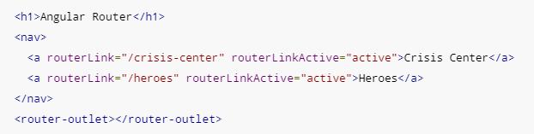

### Q) Lazy loading

Code splitting is, and Webpack allows us to do it super easily with a loader for Angular. In a nut shell, your application becomes lots of small applications, which we typically call “chunks”. These chunks can be loaded on demand.

Lazy loading is the process in taking already “code split” chunks of our application, and simply loading them on demand. With Angular, the router is what allows us to lazy load. We call it “lazy” because it’s not “eagerly” loading – which would mean loading assets upfront. Lazy loading helps boost performance – as we’re only downloading a fraction of our app’s bundle instead of the entire bundle. Instead, we can code split per @NgModule with Angular, and we can serve them lazily via the router. Only when a specific route is matched, Angular’s router will load the code split module.

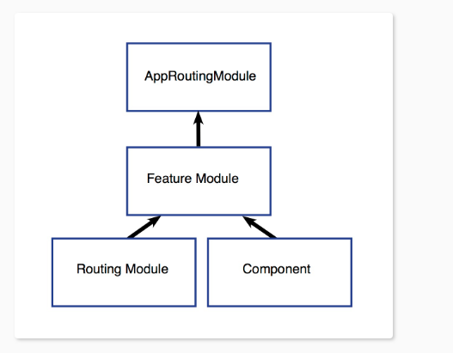

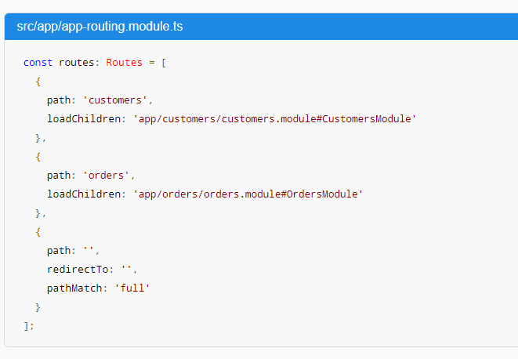

Routes at the top level

The first two paths are the routes to the CustomersModule and the OrdersModulerespectively. Notice that the lazy loading syntax uses [loadChildren](https://angular.io/api/router/Route" \l "loadChildren) followed by a string that is the path to the module, a hash mark or #, and the module’s class name.

Routes at the feature module level.

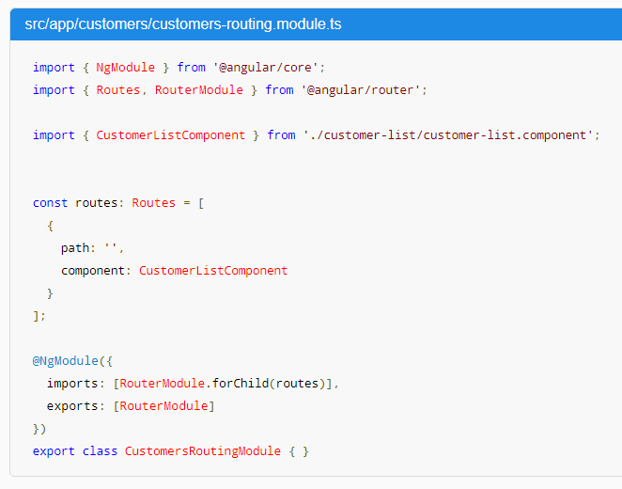

### Q) forRoot vs forChild

You might have noticed that the CLI adds RouterModule.forRoot(routes) to the app-routing.module.ts imports array. This lets Angular know that this module, AppRoutingModule, is a routing module and [forRoot()](https://angular.io/api/router/RouterModule" \l "forRoot) specifies that this is the root routing module. It configures all the routes you pass to it, gives you access to the router directives, and registers the RouterService. Use [forRoot()](https://angular.io/api/router/RouterModule" \l "forRoot) in the AppRoutingModule—that is, one time in the app at the root level.

The CLI also adds RouterModule.forChild(routes) to feature routing modules. This way, Angular knows that the route list is only responsible for providing additional routes and is intended for feature modules. You can use [forChild()](https://angular.io/api/router/RouterModule" \l "forChild) in multiple modules.

[forRoot()](https://angular.io/api/router/RouterModule#forRoot) contains injector configuration which is global; such as configuring the Router. [forChild()](https://angular.io/api/router/RouterModule" \l "forChild) has no injector configuration, only directives such as [RouterOutlet](https://angular.io/api/router/RouterOutlet) and [RouterLink](https://angular.io/api/router/RouterLink).

### Q) Two ways to grab route parameters

* The Snapshot Way: The router provides us with a snapshot of the current route
* The Observable/Stream Way: Since Angular employs Observables heavily, the router also returns an Observable that we can listen to.

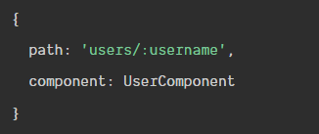



#### Q) The snapshot way

We'll inject the ActivatedRoute into this component via the constructor. Next we'll use the ActivatedRoute to grab the username route parameter in ngOnInit()

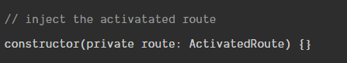

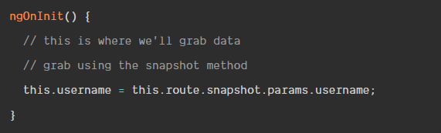

A scenario where the snapshot method wouldn't work is when we are on one profile and click a link to second profile. The snapshot method only runs one time when the component is initiated. The component wouldn't update if we travelled from (/users/chris) to another profile (/users/nick).

#### Q) the observe way

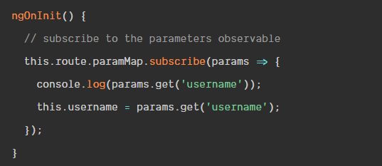

### Q) URL

**Since URLs are serializations of router state, which can be complex, the router needs a more sophisticated structure for representing URLs internally**.

To parse the URL, Angular uses the following conventions:

* /: slashes divide URL segments
* (): parentheses specify [**secondary routes**](https://angular.io/guide/router#secondary-routes)
* :: a colon specifies a [**named router outlet**](https://angular.io/guide/router#displaying-multiple-routes-in-named-outlets)
* ;: a semicolon specifies a [**matrix parameter**](https://angular.io/guide/router#heroes-list-optionally-selecting-a-hero)
* ?: a question mark separates the [**query string parameters**](https://angular.io/guide/router#query-parameters-and-fragments)
* #: a hashtag specifies the [**fragment**](https://angular.io/guide/router#query-parameters-and-fragments)
* //: a double slash separates multiple secondary routes



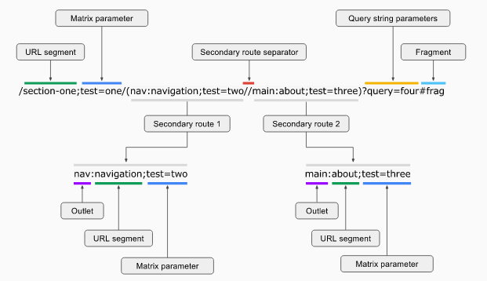

### Q) Router

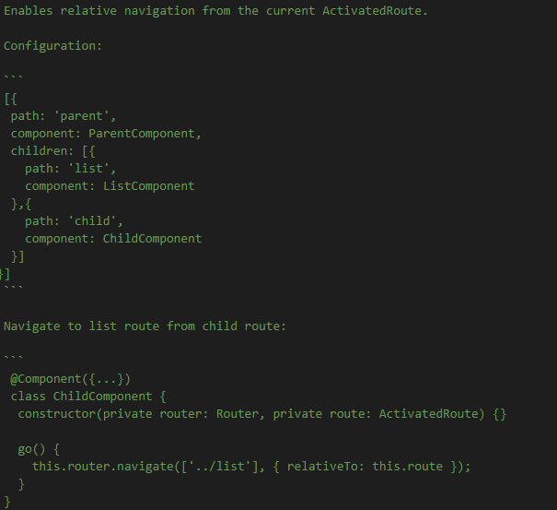

### Q) Router State

Represents the state of the router as a tree of activated routes. The routerState has two properties of interest to us; snapshot, and root.

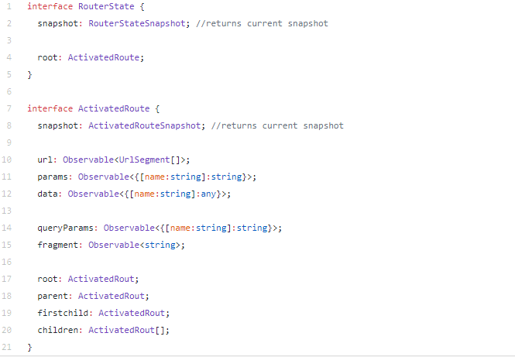

Every node in the route tree is an ActivatedRoute instance that knows about the "consumed" URL segments, the extracted parameters, and the resolved data. Use the ActivatedRoute properties to traverse the tree from any node.

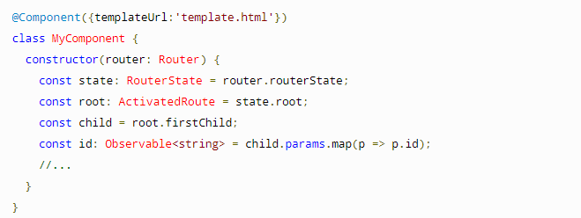

### Q) ActivatedRoute

It contains the information about a route associated with a component loaded in an outlet. An ActivatedRoute can also be used to traverse the router state tree.

**ActivatedRoute provides access to the url, params, data, queryParams, and fragment observables.**

Any component instantiated by the router can inject its ActivatedRoute.

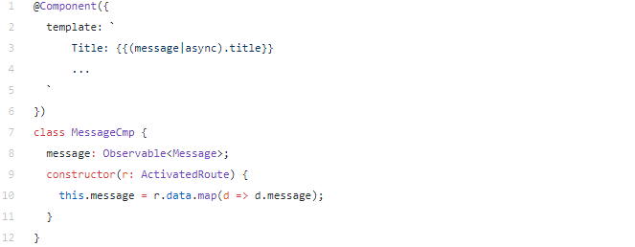

If we navigate from “/inbox/33/messages/44” to “/inbox/33/messages/45”, the data observable will emit a new set of data with the new message object, and the component will display Message 45.

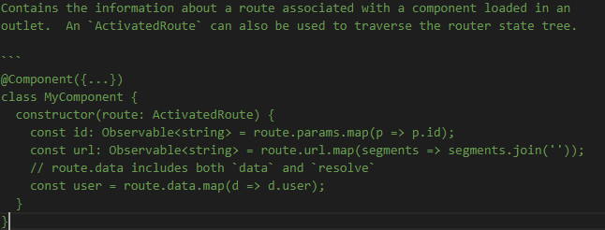

### Q) RouterStateSnapshot

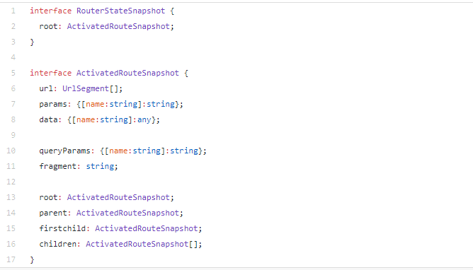

It contains the information about a route associated with a component loaded in an outlet at a particular moment in time. ActivatedRouteSnapshot can also be used to traverse the router state tree.

RouterStateSnapshot is a tree of activated route snapshots. Every node in this tree knows about the “consumed” URL segments, the extracted parameters, and the resolved data.

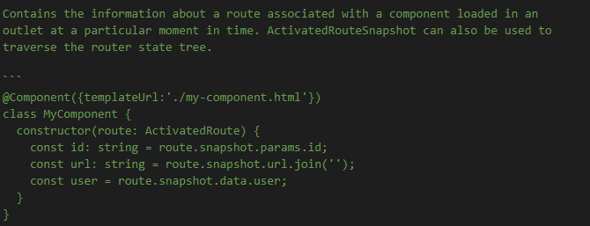

### Q) ActivatedRoute vs ActivatedRouteSnapshot

* Since ActivatedRoute can be reused, ActivatedRouteSnapshot is an immutable object representing a particular version of ActivatedRoute. It exposes all the same properties as ActivatedRoute as plain values, while ActivatedRoute exposes them as observables.
* ActivatedRoute requires that you subscribe. Which requires that you unsubscribe. Which requires that you implement OnDestroy. This is a lot of overhead for a static route.
* If you use ActivatedRouteSnapshot and have a parameter in your route definition like product/:id, then you will not get any new ID if the user changes them or your page does. Snapshot means that it was when OnInit ran, this was the state it was in at that point in time. So, any changes will be ignored.
* ActivatedRouteSnapshot is an immutable data structure.
* ActivatedRouteSnapshot is representing the state of the router at a particular moment in time.
* ActivatedRoute is similar to ActivatedRouteSnapshot, except that it represents the state of the router changing over time.
* Every node in ActivatedRouteSnapshot tree knows about the "consumed" URL segments, the extracted parameters, and the resolved data.
* When using snapshot - doesn't show the right ID when clicking. So your statement here is incorrect.
* Use the Snapshot if you only need the initial value of the parameter once during the component's initialization, and don't expect the URL to change while the user is still on that same component.

### Q) The 7-step routing process

Every time a link is clicked or the browser URL changes, Angular router makes sure your application reacts accordingly.

To accomplish that, Angular router performs the following 7 steps in order:

**Parse**: it parses the browser URL the user wants to navigate to

**Redirect**: it applies a URL redirect (if one is defined)

**Identify**: it identifies which router state corresponds to the URL

**Guard**: it runs the guards that are defined in the router state

**Resolve**: it resolves the required data for the router state

**Activate**: it activates the Angular components to display the page

**Manage**: it manages navigation and repeats the process when a new URL is requested

#### Q) Step 1 - Parse the browser URL

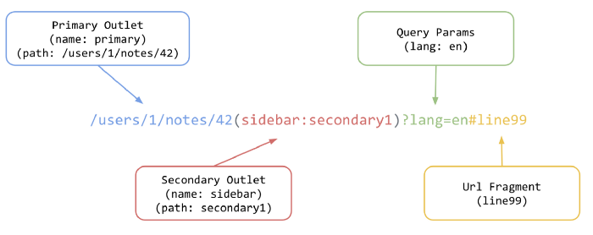

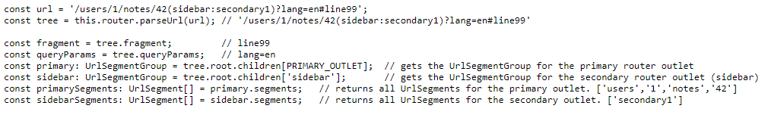

Calling router.parseUrl(url) on line 2 will convert the URL string into the following tree structure:

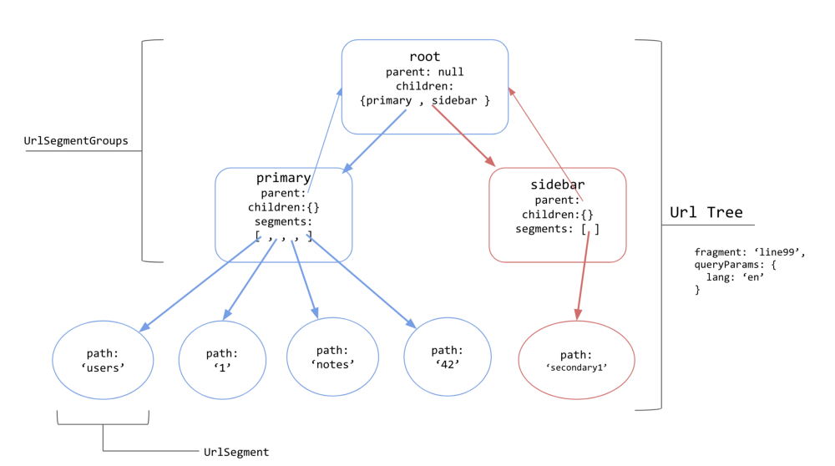

Tree structure generated from the url ‘/users/1/notes/42(sidebar:secondary1)?lang=en#line99’. Some properties of objects have been omitted for brevity. Primary outlet is in blue, secondary sidebar outlet is in red.

1. The entire URL is represented as an [UrlTree](https://github.com/angular/angular/blob/master/packages/router/src/url_tree.ts?source=post_page---------------------------#L105).
2. Interior nodes of the tree (those which have child nodes of UrlSegments) are represented as [UrlSegmentGroups](https://github.com/angular/angular/blob/master/packages/router/src/url_tree.ts?source=post_page---------------------------" \l "L139). These are usually associated with a specific router outlet, such as primary and sidebar in the example above.
3. Leaf nodes (those with no children) are represented as [UrlSegments](https://github.com/angular/angular/blob/master/packages/router/src/url_tree.ts?source=post_page---------------------------#L193). An UrlSegment is any part of a URL occurring between two slashes, for instance /users/1/notes/42 has four segments, users, 1, notes and 42. **These are what will be matched to path properties in the router configurations in ROUTES.** UrlSegments can also contain *matrix parameters*, which are data specific to a segment. Matrix parameters are separated by semicolons, such as name and type in the example/users;name=nate;type=admin/.
4. The root node has a child UrlSegmentGroup for each outlet. In this case, it has two; one for the default outlet (primary), and one for the secondary outlet (sidebar). Internally, the router serializes secondary outlets in the URL within parenthesis, such as (secondary_outlet_name:secondary_path_name), and matches them to configuration objects which have a matching outlet property, such as {path: ‘secondary_path_name’, outlet: ‘secondary_outlet_name'}.
5. Fragments and query params live as properties on the UrlTree.

A new UrlTree is generated each time the URL changes. UrlTree creation happens synchronously, and independently from the task of matching the URL to something in the ROUTES configuration tree. **This is an important distinction because matching may be asynchronous.** For instance, matching might require a router configuration from a lazily-loaded module to be loaded asynchronously.

#### Q) Step 2 - Redirect

Before Angular router uses the URL tree to create a router state, it checks to see if any redirects should be applied. The first thing the router does is apply any redirects defined for each segment of the URL.

There are 2 kinds of [redirects](https://angular.io/guide/router#redirecting-routes):

**local redirect**:

* when redirectTo does not start with a slash
* replaces a single URL segment
* Example: { path: 'one', redirectTo: 'two' }

**absolute redirect**:

* when redirectTo starts with a slash
* replaces the entire URL
* Example: { path: 'one', redirectTo: '/two' }

Angular router walks through the router configuration. As soon as it finds a matching redirect, the redirect is applied and the router continues to step 3.

**Only one redirect is applied!**

If route 1 redirects to route 2, which in turn redirects to route 3, then the second redirect to route 3 is **not** performed and route 2 is activated.

Redirects simply replace a URL segment with something else (or in the case of an absolute redirect, they replace the entire URL). Internally, a new UrlTree will be created, which reflects the redirect. You can define a redirect in a route configuration by specifying {redirectTo: 'some_path'}.

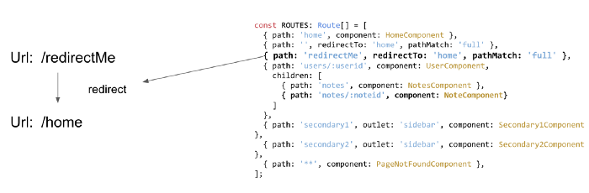

Redirect transformations are applied to a URL before it is matched against a router state, which means that **redirects are very useful for normalizing URLs or performing refactors.**

Internally, the router uses a function called [applyRedirects](https://github.com/angular/angular/blob/master/packages/router/src/apply_redirects.ts?source=post_page---------------------------" \l "L56) to process redirects.

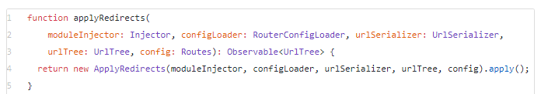

**configLoader:**An instance of [RouterConfigLoader](https://github.com/angular/angular/blob/ce63dc6f954bcacd86f7ee0c401c1824f519b794/packages/router/src/router_config_loader.ts?source=post_page---------------------------" \l "L24). This is used for compiling and loading any lazily loaded modules encountered along the way. **You never know, the URL we are trying to match might take us to a module we haven’t loaded yet.** The loader will bring in the lazy module’s router config (have a look at its [load function](https://github.com/angular/angular/blob/ce63dc6f954bcacd86f7ee0c401c1824f519b794/packages/router/src/router_config_loader.ts?source=post_page---------------------------#L44)).

**urlSerializer:**We’ve met this before. Used for transforming URL strings to UrlTrees and back again.

**urlTree:**Thetree structure representing our URL.

**config:**This is the ROUTES array that we passed into forRoot. It is what the router will compare URL segments against.

Once a redirect is applied, a new UrlTree is generated to match against the router config.

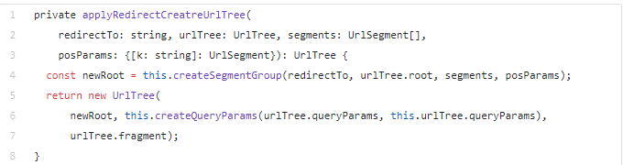

#### Q) Step 3 - Identify the router state

At this point, Angular router has a URL tree with a potential redirect applied.

Angular router traverses the URL tree and matches the URL segments against the paths configured in the router configuration.

If a URL segment matches the path of a route, the route's child routes are matched against the remaining URL segments until all URL segments are matched.

If no complete match is found, the router backtracks to find a match in the next sibling route.

At the heart of the router lies a powerful URL matching engine. Internally, Angular uses an instance of the [Recognizer](https://github.com/angular/angular/blob/ce63dc6f954bcacd86f7ee0c401c1824f519b794/packages/router/src/recognize.ts?source=post_page---------------------------#L31) class to perform url-to-path matching.

#### Q) Step 4 - Guard - run guards

Now that Angular router knows which router state to navigate to, it runs the associated guards to check whether navigation to the new router state is allowed.

As soon as any guard returns a false value, the navigation is cancelled.

If none of the guards return a false value, Angular router continues to step 5.

#### Q) Step 5 - Resolve - run resolvers

Because Angular router knows that the new router state can be activated, it runs the associated [resolvers](https://angular.io/guide/router#resolve-pre-fetching-component-data).

During configuration, you can attach static data to a route using the route's data property:

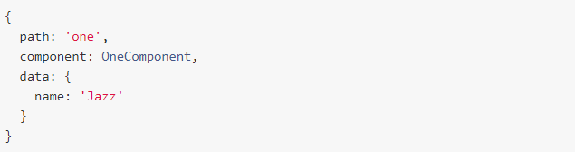

Resolvers allow you to dynamically resolve data at runtime. The newly resolved data is then merged into the existing static data in the data property:

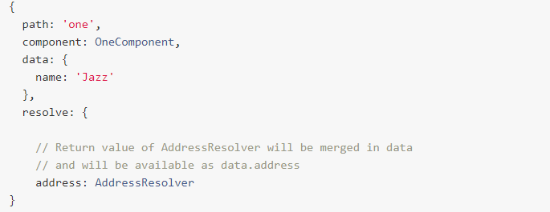

A resolver is a function or a class with a resolve method that returns a value, a promise or an observable. If a resolver returns a promise or an observable, Angular router waits until it completes before it continues to step 6.

Once all resolvers have completed, their return values are merged in the route's data property and Angular router continues to step 6.

#### Q) Step 6 - Activate components

At this point, Angular router instantiates the required components and places them right next to the corresponding [**<router-outlet>**](https://angular.io/guide/router#router-outlet) elements in the DOM.

If a component was already instantiated in the previous router state and only route parameters changed, the component is not re-instantiated but reactivated and the new route parameters are available via an observable in ActivatedRoute.

When all components are instantiated or reactivated, Angular router updates the URL in the browser's URL.

#### Q) Step 7 - Manage navigation

Finally, when the new router state has been displayed to the screen, Angular router listens for URL changes and state changes.

As soon as one of the following happens:

* the user changes the browser URL
* the user clicks a link (using routerLink)
* an imperative navigation command is performed (using router.navigate)

Angular router repeats the entire process.

### Q) Navigation event

A great way to see the navigation cycle is by subscribing to the Router service’s events observable:

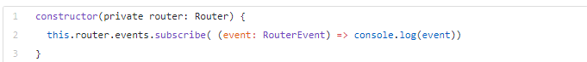

During development, you can also pass along an option of enableTracing: true in the router configuration.

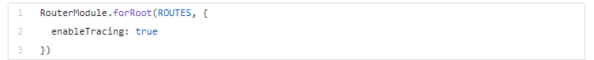

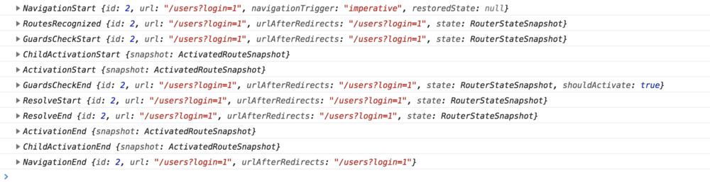

#### Q) Navigation Start

*events: NavigationStart*



Whenever the router detects a click on a router link directive, it starts the navigation cycle. There are imperative means of starting a navigation as well, such as the Router Service’s navigate and navigateByUrl methods.

#### Q) URL Matching, and Redirects

*events: RoutesRecognized*

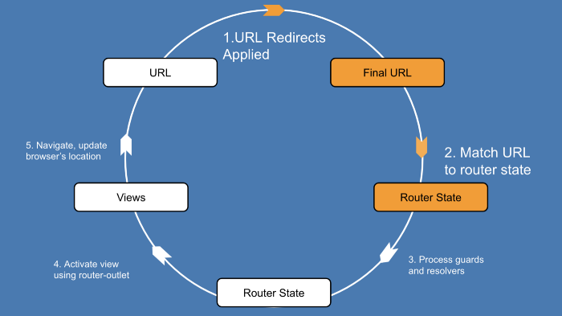

The router starts by doing a depth-first search through the array of router configurations, and trying to match the URL /users to one of the path properties in the router configurations, while applying any redirects along the way.

If the matched path requires a lazy loaded module, it will be loaded at this point.

The router emits a RoutesRecognized event to signal that it has found a match for the URL, and a component to navigate to (UsersComponent).

But not so fast, the router has to make sure that it is allowed to navigate to this new component.

Enter route guards.

#### Q) Route Guards

*events: GuardsCheckStart, GuardsCheckEnd*

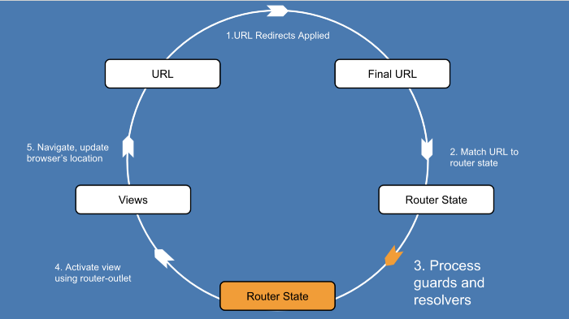

Route guards are boolean functions that the router uses to determine if it can perform a navigation. As developers, we use guards to control whether a navigation can occur or not.

**The canActivate guard is run before any data is fetched for the route, since there is no reason to fetch data for a route that shouldn’t be activated.**

ther guards include [canLoad](https://angular.io/api/router/CanLoad?source=post_page---------------------------) (should a module be lazily-loaded or not), [canActivateChild](https://angular.io/api/router/CanActivateChild?source=post_page---------------------------), and [canDeactivate](https://angular.io/api/router/CanDeactivate?source=post_page---------------------------) (which is useful for preventing a user from navigating away from a page, for instance, when filling out a form)

#### Q) Route Resolvers

*events: ResolveStart, ResolveEnd*



Route resolvers are functions that we can use to prefetch data during navigation, before the router has rendered anything.

#### Q) Activating Routes

*events: ActivationStart, ActivationEnd, ChildActivationStart, ChildActivationEnd*

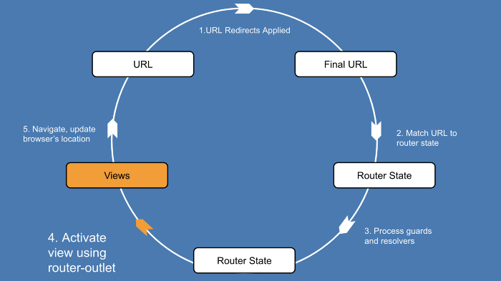

Now it’s time to activate the components, and display them using a<router-outlet>. The router can extract the information it needs about the component from the tree of ActivatedRouteSnapshots that it built during the previous steps of the navigation cycle.

The router will render a component on the screen. If the rendered component has any nested <router-outlet> elements, the router will go through and render those as well.

#### Q) Updating the URL

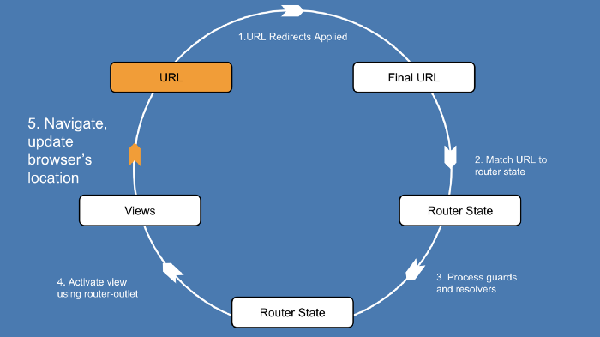

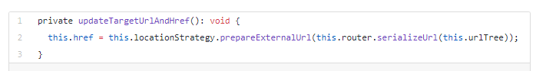

The router is now ready to listen for another URL change, and start the cycle all over again.

## Form

### Reactive From

#### Q) Form Controls

FormControl: it tracks the value and validity status of an angular form control. It matches to a HTML form control like an input.

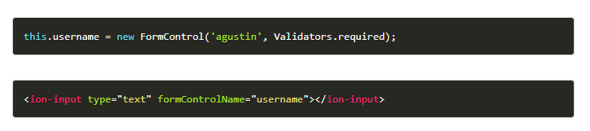

FormGroup: it tracks the value and validity state of a FormBuilder instance group. It aggregates the values of each child FormControl into one object, using the name of each form control as the key. It calculates its status by reducing the statuses of its children. If one of the controls inside a group is invalid, the entire group becomes invalid.

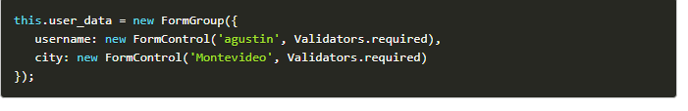

FormArray: is a variation of FormGroup. The main difference is that its data gets serialized as an array, as opposed to being serialized as an object in case of FormGroup. This might be especially useful when you don’t know how many controls will be present within the group, like in dynamic forms.

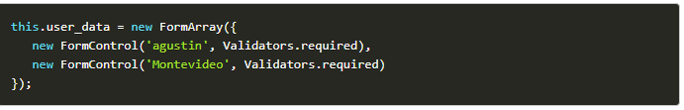

FormBuilder: is a helper class that creates FormGroup, FormControl and FormArray instances for us. It basically reduces the repetition and clutter by handling details of form control creation for you.

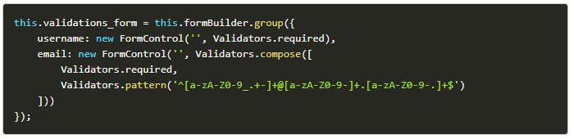

All of them should be imported from the @angular/forms module.



#### Q) Form Array

Let’s imagine we want our users to include multiple phone numbers on their account dynamically. Harding coding a nested object would impossible to maintain, but we can allow the user to push multiple groups to a FormArray.

Rather than define the form groups one-by-one, we let the user click a button that will push a new group to the FormArray. Each group in this array has an index, so we can modify and delete these forms based on their index position.

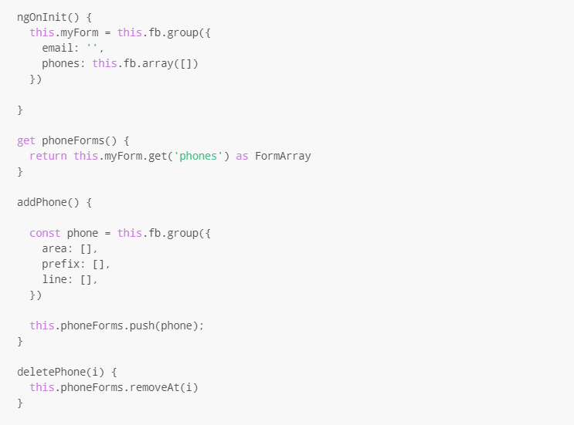

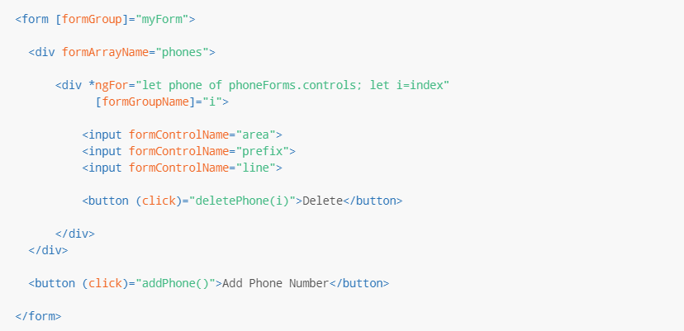

#### Q) Form Validation

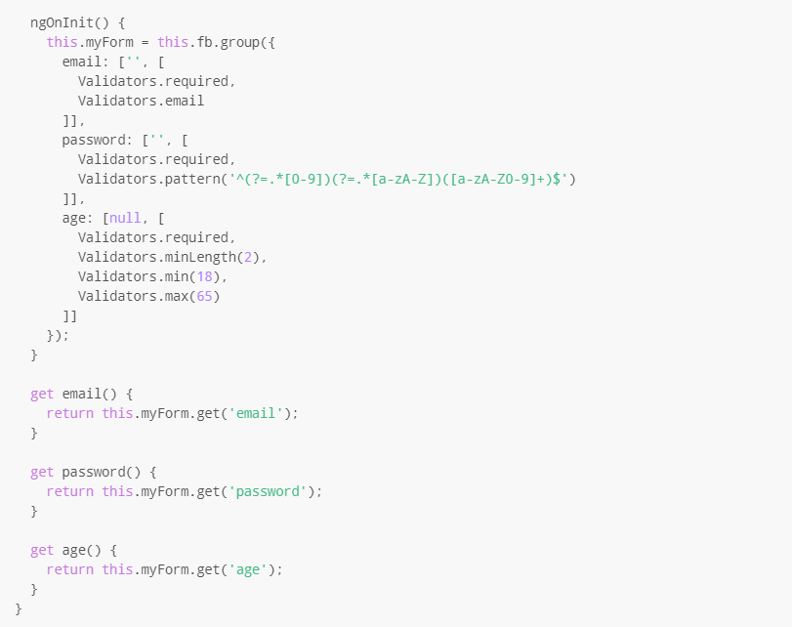

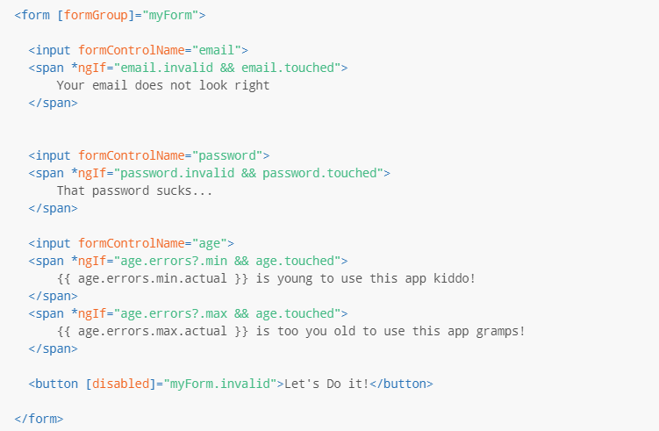

#### Q) Submit the form



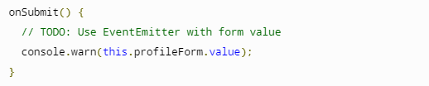



#### Q) Update form value

There are two ways to update the model value:

Use the setValue() method to set a new value for an individual control. The setValue() method strictly adheres to the structure of the form group and replaces the entire value for the control.

Use the patchValue() method to replace any properties defined in the object that have changed in the form model.

The strict checks of the setValue() method help catch nesting errors in complex forms, while patchValue() fails silently on those errors. PatchValue() only updates properties that the form model defines.

#### Q) Form Status

When you add a required field to the form control, its initial status is invalid. This invalid status propagates to the parent form group element, making its status invalid. Access the current status of the form group instance through its status property.

### Template-Driven Form

#### Q) novalidate

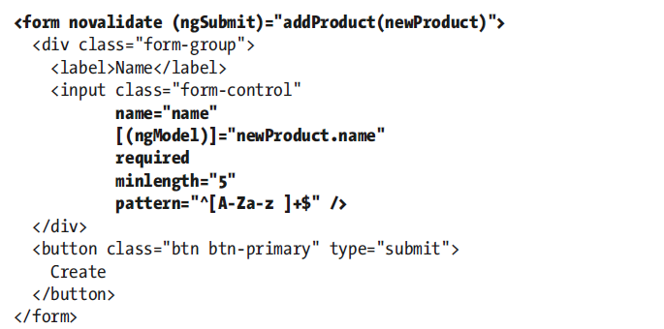

The validation attributes that Angular uses are the same ones used by the HTML 5 specification, so

I have added the novalidate attribute to the form element, which tells the browser not to use its native validation features, which are inconsistently implemented by different browsers and generally get in the way. Since Angular will be providing the validation, the browser’s own implementation of these features is not required.

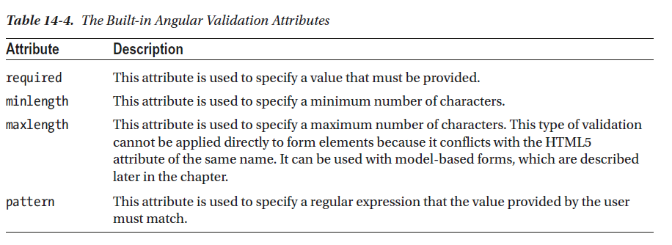

### Q) The Angular Form Validation Classes

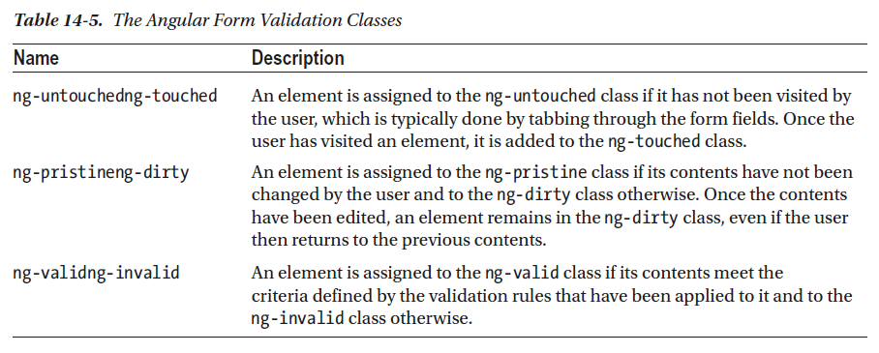

## Features

### HMR

First, we need to set up the environment.

Create a file src/environments/environment.hmr.ts with the following contents:

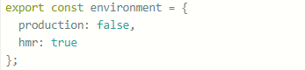

Update src/environments/environment.prod.ts and add the hmr: false flag to the environment:

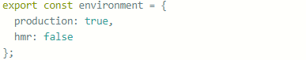Then update src/environments/environment.ts and add the hmr: false flag to the environment there as well:

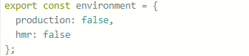

Next in the angular.json file, update this part:

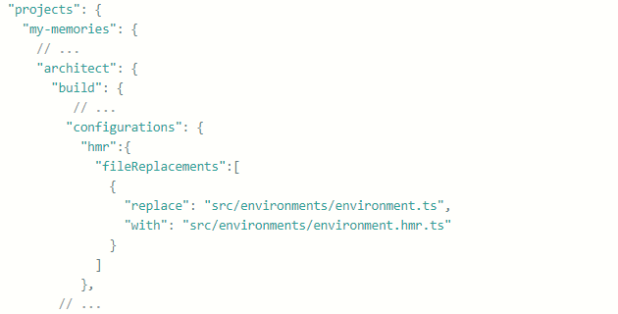

And under projects → my-memories → architect → serve → configurations:

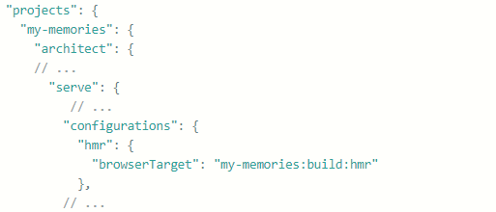

Now update tsconfig.app.json to include the necessary types (well, type) by adding this under compilerOptions:

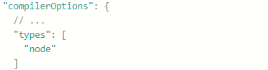

Next, we’ll install the @angularclass/hmr module as a development dependency:



Then configure it by creating a file src/hmr.ts:

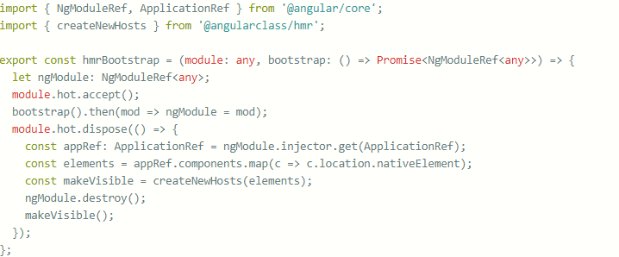

Next, update src/main.ts to use the above function:

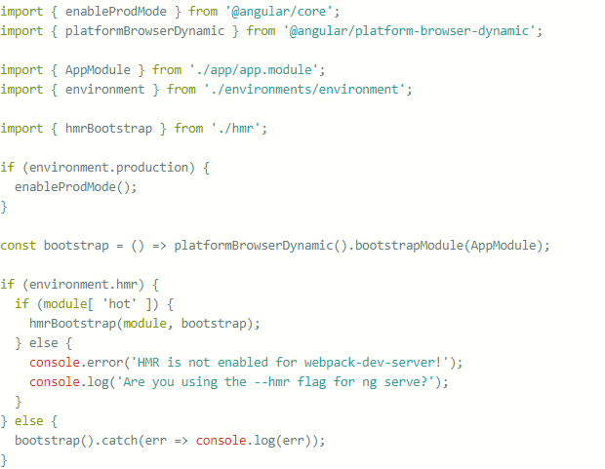

What we are doing here is making bootstrap call an anonymous function, and next asking whether the environment.hmr flag is true. If it is, we call the previously defined function from hmr.ts which enabled hot module replacement; otherwise, we bootstrap it as we used to.

Now, when we run ng serve --hmr --configuration=hmr, we’ll be invoking the hmr configuration, and when we make changes to files, we’ll get updates without a full refresh. The first --hmr is for webpack, and --configuration=hmr is for Angular to use the hmr environment.

# RxJS

## Q) Players

1. Producers
2. Consumers
3. Data pipeline
4. Time

### Q) Producer

Producers are the sources of your data. A stream must always have a producer of data, which will be the starting point for any logic that you’ll perform in RxJS. In practice, a producer is created from something that generates events independently (anything from a single value, an array, mouse clicks, to a stream of bytes read from a file). In RxJS, we call them *observables*, as in something that’s *able to be observed*.

Observables are in charge of pushing notifications, so we refer to this behaviour as fire-and-forget, which means that we’ll never expect the producer to be involved in the *processing* of events, only the emission of them.

### Q) Consumer

Consumer to accept events from the producer and process them in some specific way. When the consumer begins listening to the producer for events to consume, you now have a stream, and it’s at this point that the stream begins to push events; we’ll refer to a consumer as an *observer*.

### Q) Data Pipeline

One advantage of RxJS is that you can manipulate or edit the data as it passes from the producer to the consumer. This is where the list of methods (known as observable operators) comes into play. Manipulating data en route means that you can adapt the output of the producer to match the expectations of the consumer.

### Q) Time

The time need not always run at normal speed, and you can build streams that run slower or faster depending on your requirements.

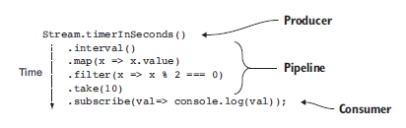

## Q) Observable

### Q) Type of data source

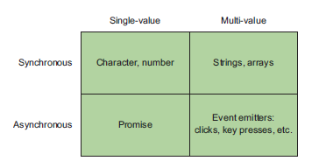

#### SINGLE-VALUE, SYNCHRONOUS

The simplest case is that you have only a single piece of data. In programming, you know there are operations that return a single value for each invocation. This is the category of any function that returns a single object. You can use the Rx.Observable.of() function to wrap a single, synchronous value. As soon as the subscriber is attached, the value is emitted.



#### MULTI-VALUE, SYNCHRONOUS

You can also group single items together to form collections of data, mainly for arrays. In order to apply the same operation that you used on the single item on all of the items, you would traditionally iterate over the collection and repeatedly apply the same operation to each item in the collection.

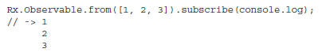

Both of these groups operate synchronously, which means each subsequent block of code must wait for the previous block to complete before executing. In the multi value example, each item will be processed serially (one by one) until the collection is exhausted.

#### SINGLE-VALUE, ASYNCHRONOUS

Like with the first dimension, you also have a single-value case, where the result of a task will result in a single return value. This kind of operation is usually used to load some remote resource via an AJAX call or wait on the result of some non-local calculation wrapped in a Promise, without blocking the application. In either case, after the operation is initiated, it will expect a single return value or an error.

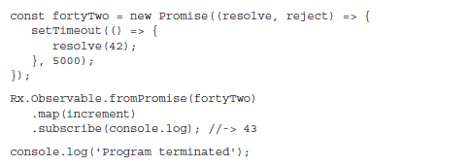

**Promises are single-value and immutable, they’re never run again.**

#### MULTI-VALUE, ASYNCHRONOUS

An event emitter doesn’t stop after a single event; instead, it can continue to invoke the registered call-backs for each event that arrives, creating a practically infinite stream of events. The emitter will fulfil both of your criteria for handling multi-value, asynchronous events.

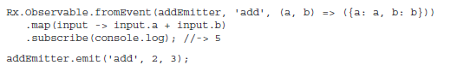

### Q) O**bservables Constructors**

RxJS offers multiple ways of creating an observable depending on the type of the data producer.

* Observable.of(1,2,3) – turns the sequence of numbers into an Observable
* Observable.create(myObserver) – returns an Observable that can invoke  methods on myObserver that you will create and supply as an argument.
* Observable.from(myArray) – converts an array represented by the variable myArray into an Observable. You can also use any an iterable data collection or a generator function as an argument of from().
* Observable.fromEvent(myInput, ‘keyup’) – converts the keyup event from some HTML element represented by myInput into an Observable
* Observable.interval(1000) – emits a sequential integer (0,1,2,3…) every second

### Q) Data push pattern

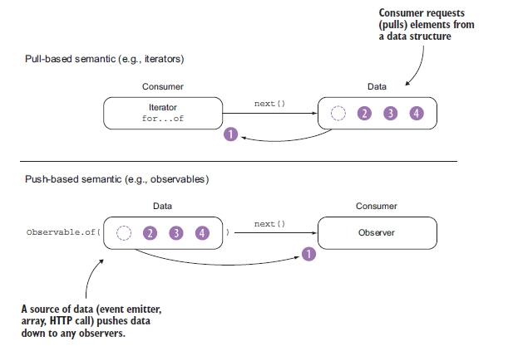

Iterators use a pull*-*based semantic. This means that the consumer of the iterator is responsible for requesting the next item from the iterator.

RxJS observables use push-based notifications, which means they don’t request data; rather, data is pushed onto them so that they can react to it. Push notifications bring the reactive paradigm to life.

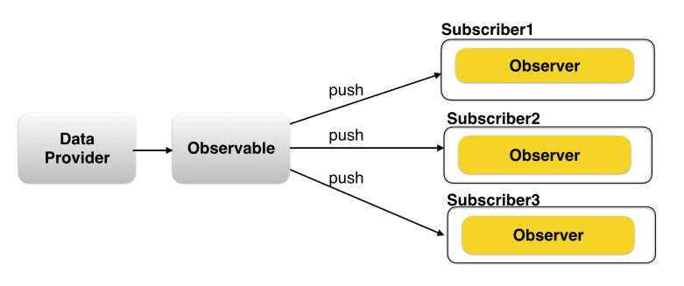

### Q) Observable vs Function

Observables are like functions with zero arguments, but generalize those to allow multiple values. Subscribing to an Observable is analogous to calling a Function. Observables are able to deliver values either synchronously or asynchronously.

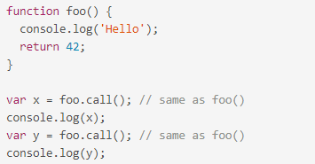

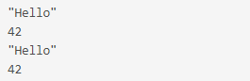

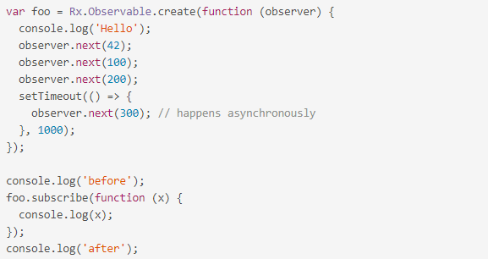

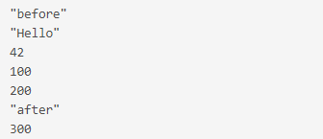

Conclusion:

* func.call() means "give me one value synchronously"
* observable.subscribe() means "give me any amount of values, either synchronously or asynchronously"

### Q) Rx.Observable.create()

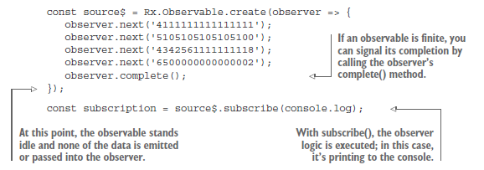

The code inside Observable.create(function subscribe(observer) {...}) represents an "Observable execution", a lazy computation that only happens for each Observer that subscribes. The execution produces multiple values over time, either synchronously or asynchronously.

There are three types of values an Observable Execution can deliver:

* "Next" notification: sends a value such as a Number, a String, an Object, etc.
* "Error" notification: sends a JavaScript Error or exception.
* "Complete" notification: does not send a value.

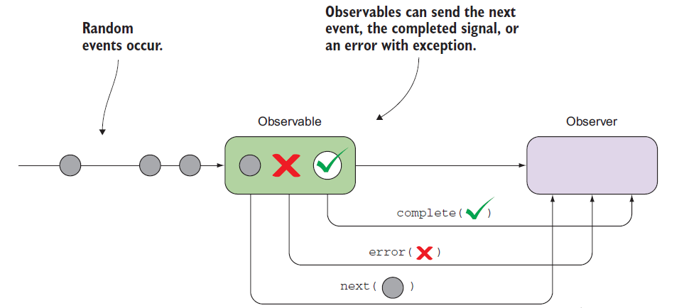

Next notifications are the most important and most common type: they represent actual data being delivered to an Observer. Error and Complete notifications may happen only once during the Observable Execution, and there can only be either one of them. In an Observable Execution, zero to infinite Next notifications may be delivered. If either an Error or Complete notification is delivered, then nothing else can be delivered afterwards.



### Q) Observable merge

1. *Interleave events by merging streams*

This strategy is useful for forwarding events from multiple streams and is ideal for handling different types of user interaction events like mouse or touch.

1. *Preserve order of events by concatenating streams*

This one is used when the order of the events emitted by multiple streams needs to be preserved.

1. *Switch to the latest stream data*

This is used when one type of event kicks off another, such as a button click initiating a remote HTTP call or beginning a timer.

#### Q) Interleave events by merging streams

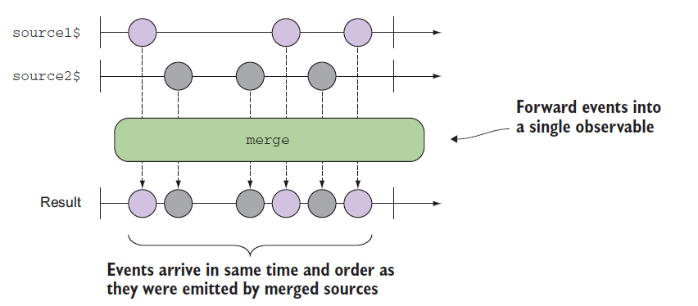

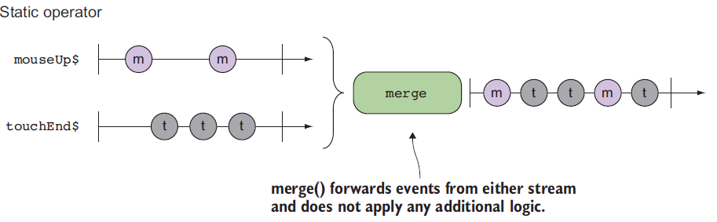



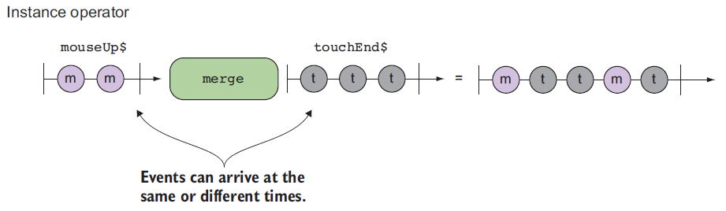



Two ways to handle stream

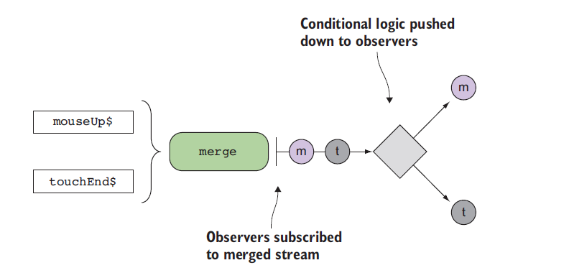

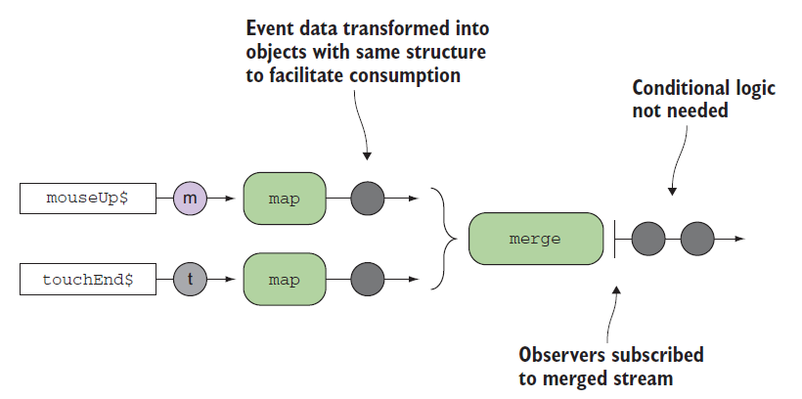

#### Q) Preserve order of events by concatenating streams

### Q) Hot and Cold Observables

#### Q) Cold observable

A cold observable is one that doesn’t begin emitting all of its values until an observer subscribes to it. The declaration of a cold observable frequently begins with static operators such as of() or from(), and timing observables interval() and timer()also behave coldly.

Being cold means that each new subscription is creating a new independent stream with a new starting point for that stream. This means that subscribers will independently receive the exact same set of events always, from the beginning.

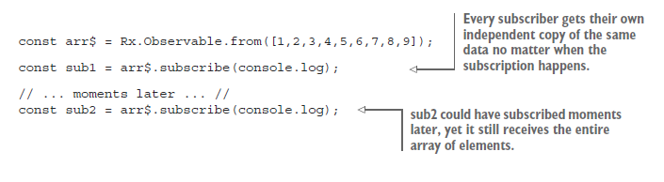

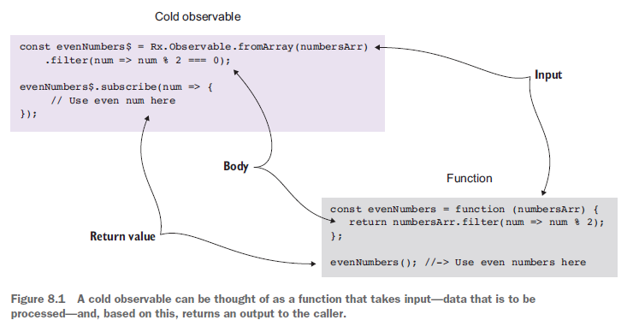

#### Q) Hot observables

Hot observables are those that produce events regardless of the presence of subscribers they are active. In the real world, hot observables are used to model events like clicks, mouse movement, touch, or any other events exposed via event emitters. This means that, unlike the cold counterpart where each subscription triggers a new stream, subscribers to hot observables tend to receive only the events that are emitted after the subscription is created.

## Q) Observer

Observers are created within the context of a subscription, which means that the result of calling subscribe() on an observable source is a Subscription object. Because observables operate synchronously or asynchronously, the consumer of an observable must in some way support the inversion of control **that also happens with call**-backs. This is consistent with its push-based mechanism.

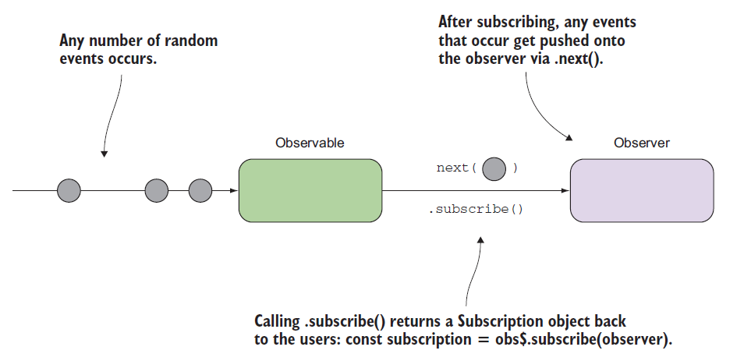

A handler for receiving observable notifications implements the Observer interface. It is an object that defines callback methods to handle the three types of notifications that an observable can send:

* next() - here's a new value from the stream
* error() - here's an error happened in the stream
* complete() - the stream's over

## Q) Subscription

Because Observable Executions may be infinite, and it's common for an Observer to want to abort execution in finite time, we need an API for cancelling an execution. Since each execution is exclusive to one Observer only, once the Observer is done receiving values, it has to have a way to stop the execution, in order to avoid wasting computation power or memory resources.

When you subscribe, you get back a Subscription, which represents the ongoing execution. Just call unsubscribe() to cancel the execution.

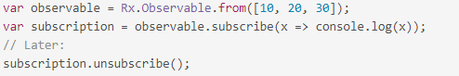

Each Observable must define how to dispose resources of that execution when we create the Observable using create(). You can do that by returning a custom unsubscribe function from within function subscribe().

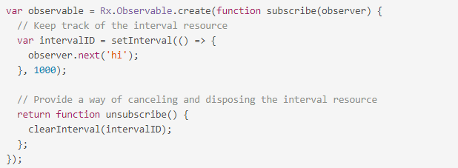

Just like observable.subscribe resembles Observable.create(function subscribe() {...}), the unsubscribe we return from subscribe is conceptually equal to subscription.unsubscribe. In fact, if we remove the ReactiveX types surrounding these concepts, we're left with rather straightforward JavaScript.

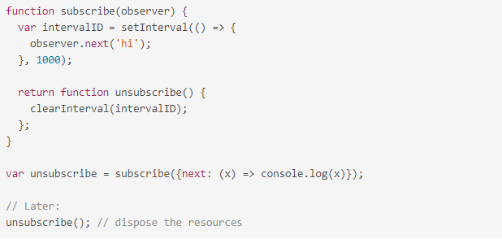

## Q) Unsubscribe

Manually unsubscribe from all custom Observables when a component/directive gets destroyed. The best place to unsubscribe is inside functions that handle the *OnDestroy* lifecycle hook. Some subscriptions like router and http don’t need manual unsubscribe, for the rest of them there are various solutions:

* execute unsubscribe over the subscription object
* using takeUntil operator
* using async pipe

#### Q) Unsubscribe

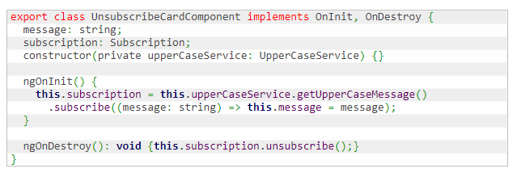

Subscription represents a disposable resource, it has an unsubscribe method that can be used to dispose the resource held by the subscription.

#### Q) TakeUntil

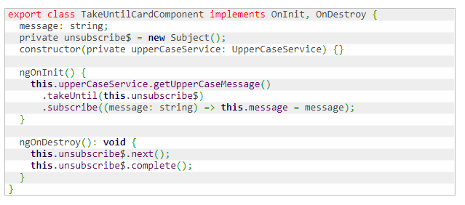

TakeUntil takes a second Observable as an argument, it monitors the second Observable and discard subscription after it emits a value or terminates.

#### Q) AsyncPipe

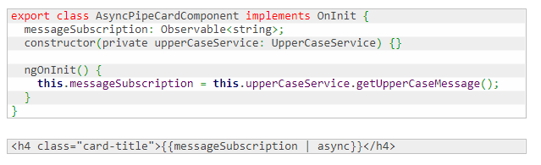

The async pipe subscribes to an Observable and returns the latest value it has emitted. When a component is destroyed, the async pipe unsubscribes automatically.

## Q) Subject

### **Q) What is a Subject?**

A Subject is a sort of bridge or proxy that is available in some implementations of ReactiveX that acts both as an observer and as an Observable. Because it is an observer, it can subscribe to one or more Observables, and because it is an Observable, it can pass through the items it observes by reemitting them, and it can also emit new items.

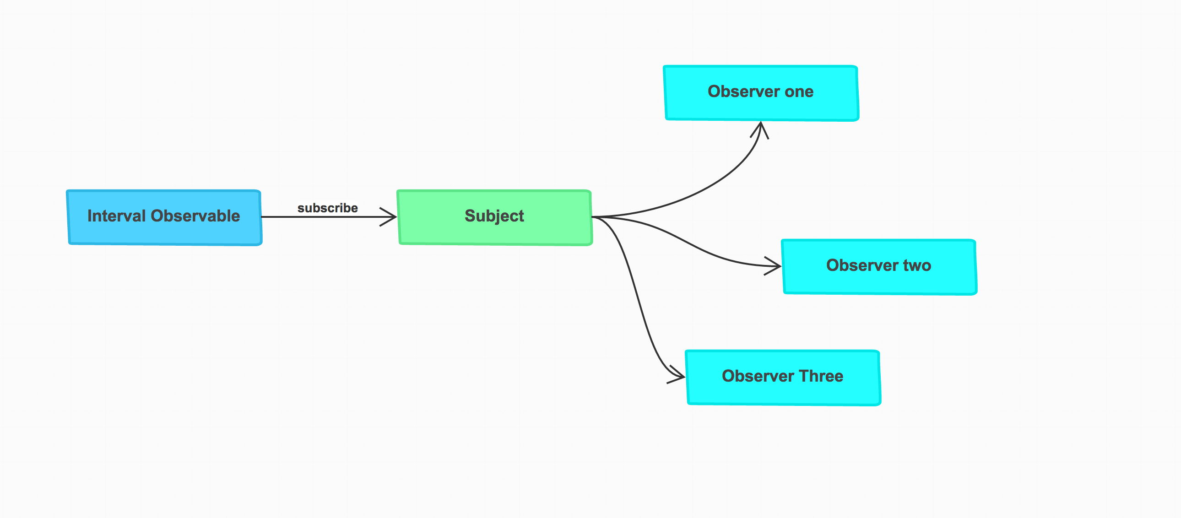

An RxJS Subject is a special type of Observable that allows values to be multicasted to many Observers. While plain Observables are unicast (each subscribed Observer owns an independent execution of the Observable), Subjects are multicast.

A Subject is like an Observable, but can multicast to many Observers.

Subjects are like EventEmitters: they maintain a registry of many listeners.

**Every Subject is an Observable.** It means he has all the operators (map, filter, etc. ) and you can subscribe to him.

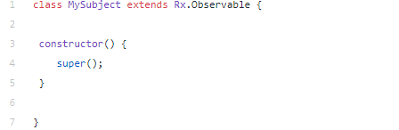

**Every Subject is an Observer.** It is an object with the methods next(v), error(e), and complete(). To feed a new value to the Subject, just call next(theValue), and it will be multicasted to the Observers registered to listen to the Subject.

When you call the subscribe() method you only push an observer into an array. The next(), error() and complete() methods will push the *same*value to each observer in the array.

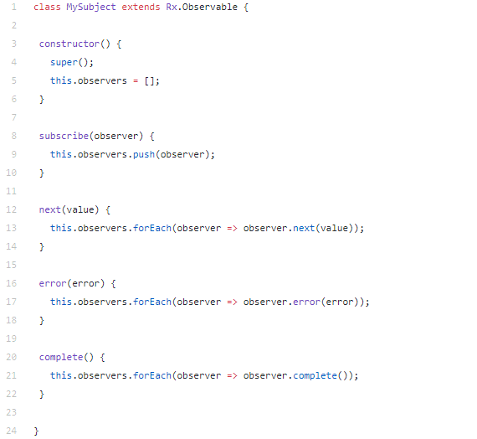

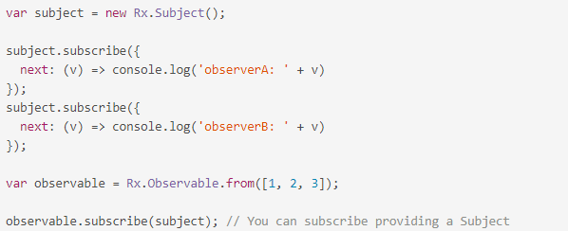

A multicasted Observable uses a Subject under the hood to make multiple Observers see the same Observable execution. Under the hood, this is how the multicast operator works: Observers subscribe to an underlying Subject, and the Subject subscribes to the source Observable.

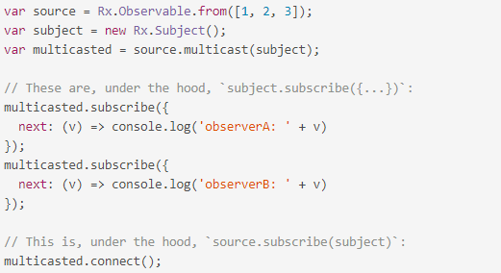

### Q) Subject types

* AsyncSubject: Subjects that will only emit the last item emitted by the source Observable when the source Observer completes the stream by calling onComplete()
* PublishSubject: The Subject only delivers to the Observers the events emitted after their subscription
* ReplaySubject: Emits all the events emitted by the source Observable, even those that were emitted before the subscription is made
* BehaviorSubject: Emits the last emitted item by the source Observable when the subscription is done, then continues to any other items emitted by the source observable

#### Q) BehaviorSubject

When an observer subscribes to a BehaviorSubject, it begins by emitting the item most recently emitted by the source Observable (or a seed/default value if none has yet been emitted) and then continues to emit any other items emitted later by the source Observable(s).

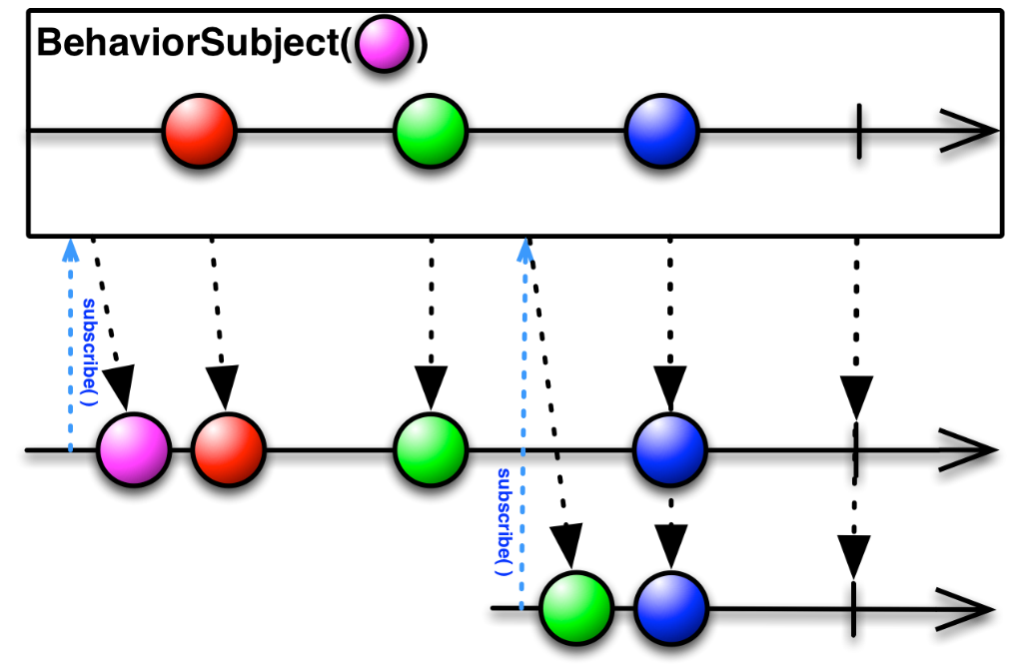

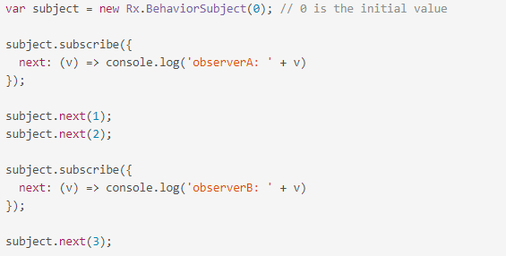

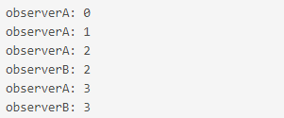

However, if the source Observable terminates with an error, the BehaviorSubject will not emit any items to subsequent observers, but will simply pass along the error notification from the source Observable.

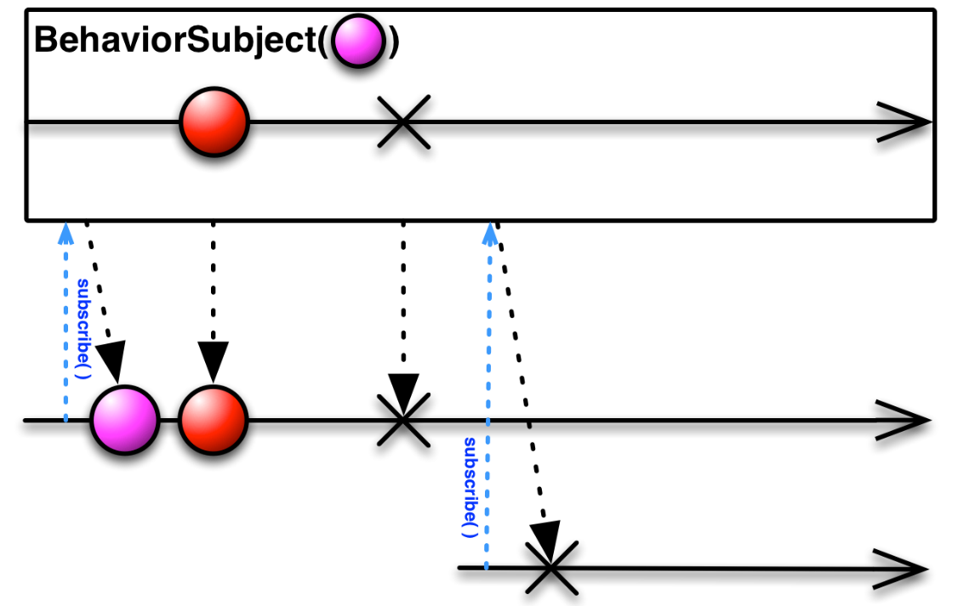

#### Q) ReplaySubject

A ReplaySubject records multiple values from the Observable execution and replays them to new subscribers.

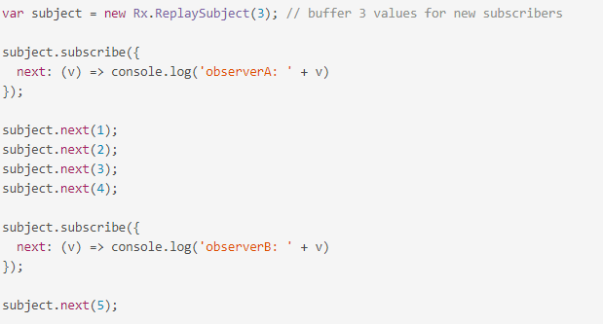

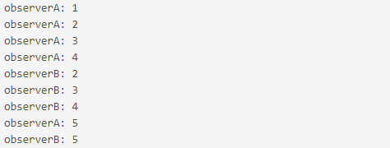

#### Q) AsyncSubject

The AsyncSubject is a variant where only the last value of the Observable execution is sent to its observers, and only when the execution completes.

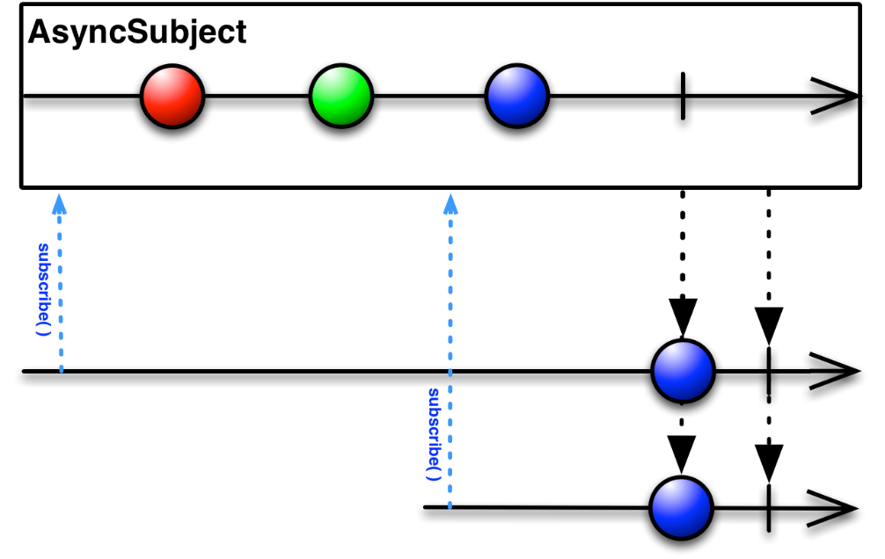

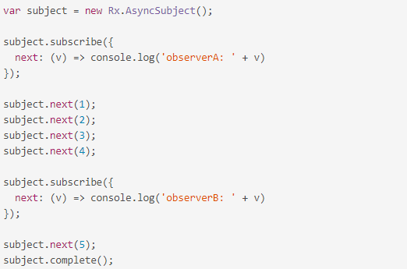

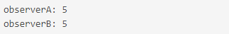

The AsyncSubject is similar to the [last()](http://reactivex.io/rxjs/class/es6/Observable.js~Observable.html#instance-method-last) operator, in that it waits for the complete notification in order to deliver a single value.

If the source Observable does not emit any values, the AsyncSubject also completes without emitting any values.

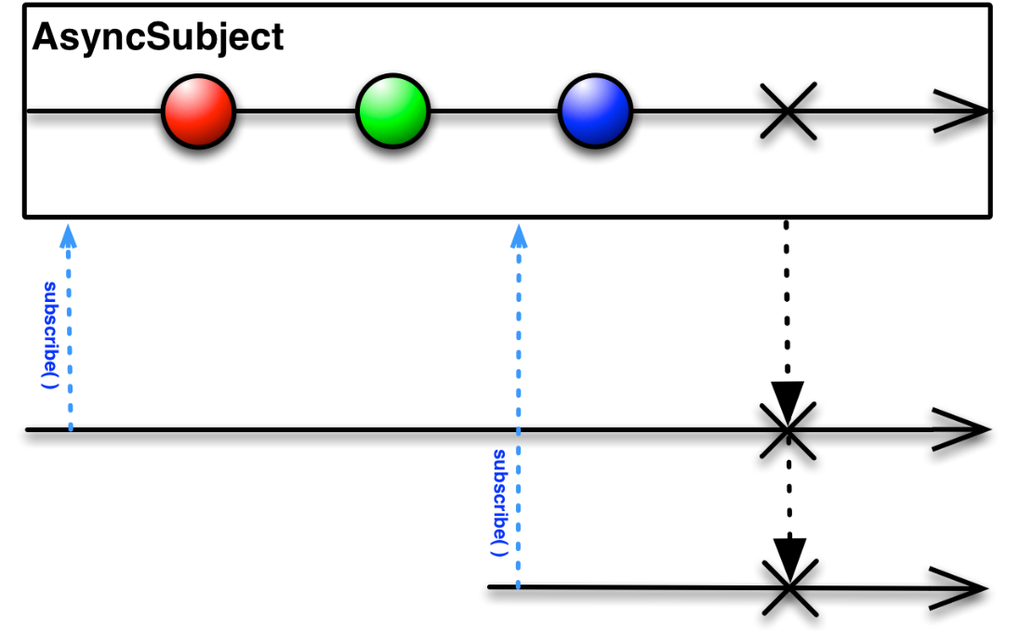

It will also emit this same final value to any subsequent observers. However, if the source Observable terminates with an error, the AsyncSubject will not emit any items, but will simply pass along the error notification from the source Observable.

#### Q) PublishSubject

PublishSubject emits to an observer only those items that are emitted by the source Observable(s) subsequent to the time of the subscription.

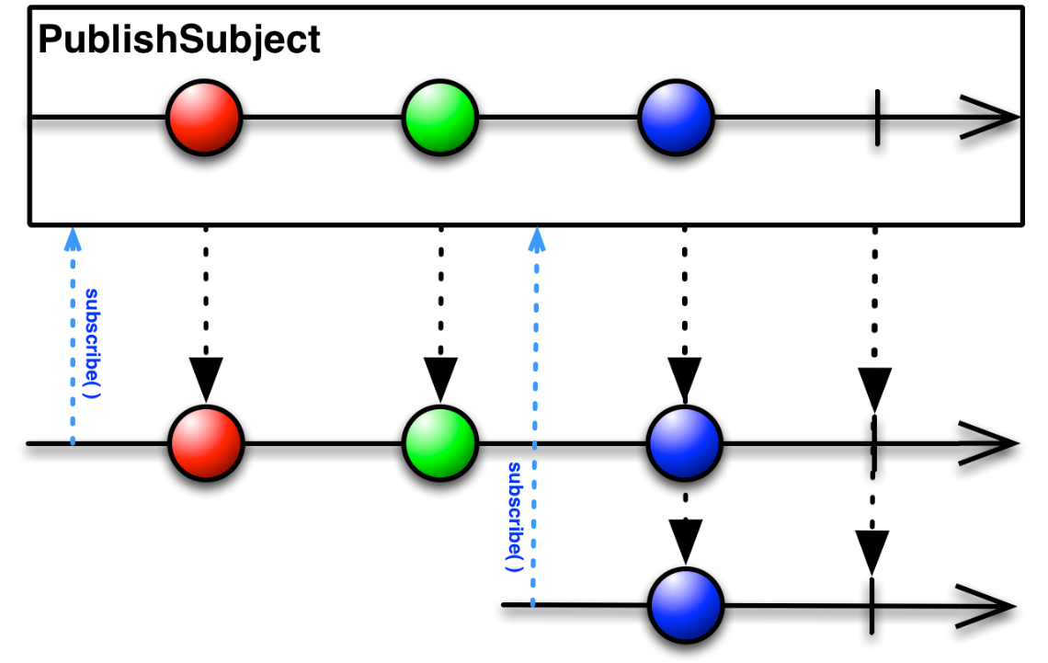

Note that a PublishSubject may begin emitting items immediately upon creation (unless you have taken steps to prevent this), and so there is a risk that one or more items may be lost between the time the Subject is created and the observer subscribes to it.

If the source Observable terminates with an error, the PublishSubject will not emit any items to subsequent observers, but will simply pass along the error notification from the source Observable.

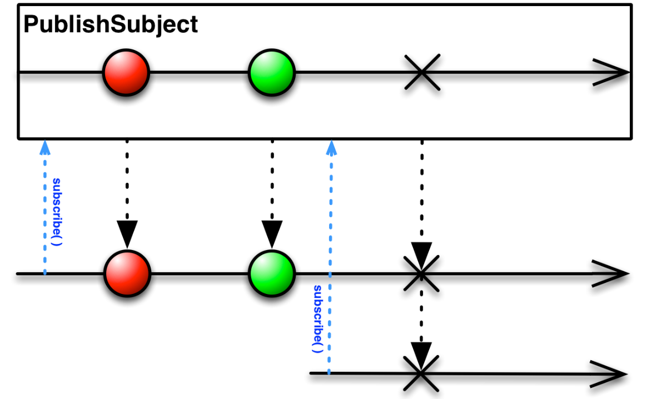

## Q) Schedulers

### Q) Calling order

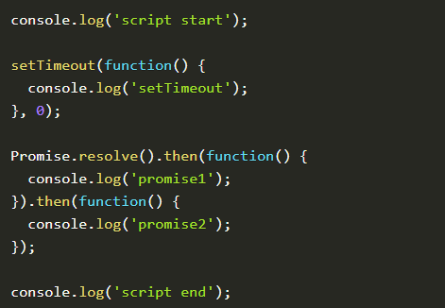

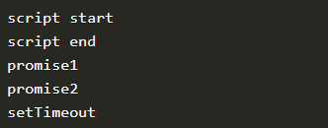

There are different queues. There is a microtask and a macrotask queue. A promise gets added to the microtask queue and a setTimeout to the macrotask queue. Whenever the call stack is cleared, the microtasks queue gets cleared first. Hence the ‘promise1’ is the next log statement we see.

When a microtask is finished, the rest of the microtasks queue gets executed until the microtask queue is empty. That’s the reason ‘promise2’ is logged next. So even if the second promise gets scheduled during the execution of the first, it still gets executed before the setTimeout.

Lastly, when the microtask queue is cleared, the next task is picked from the macrotask queue, and the ‘setTimeout’ is logged.

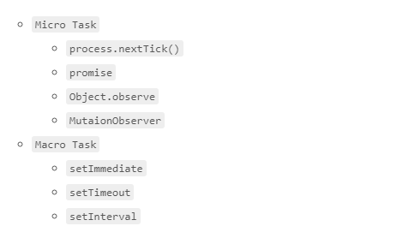

https://jakearchibald.com/2015/tasks-microtasks-queues-and-schedules/

### Q) What is a Scheduler?

A scheduler controls when a subscription starts and when notifications are delivered. It consists of three components.

* A Scheduler is a data structure. It knows how to store and queue tasks based on priority or other criteria.
* A Scheduler is an execution context. It denotes where and when the task is executed (e.g. immediately, or in another callback mechanism such as setTimeout or process.nextTick, or the animation frame).
* A Scheduler has a (virtual) clock. It provides a notion of "time" by a getter method now() on the scheduler. Tasks being scheduled on a particular scheduler will adhere only to the time denoted by that clock.

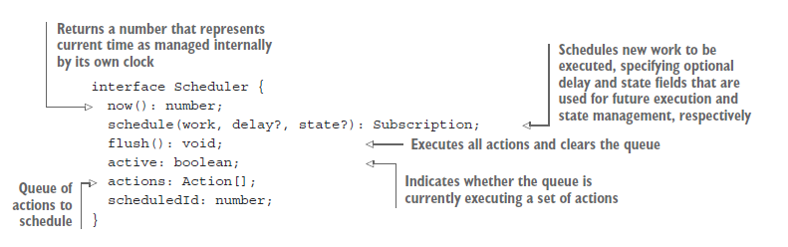

### Q) Schedulers

Schedulers influence the timing on which tasks get executed. You can change the default schedulers of some operators by passing in an extra scheduler argument.

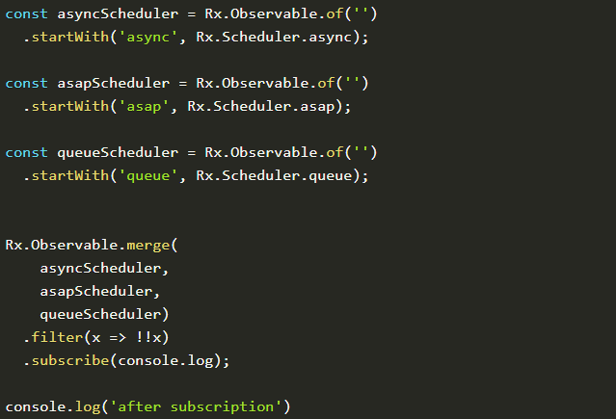

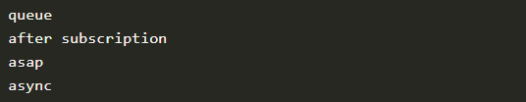

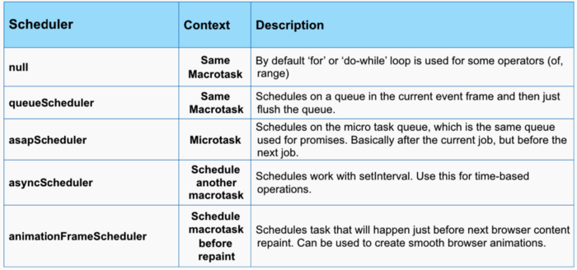

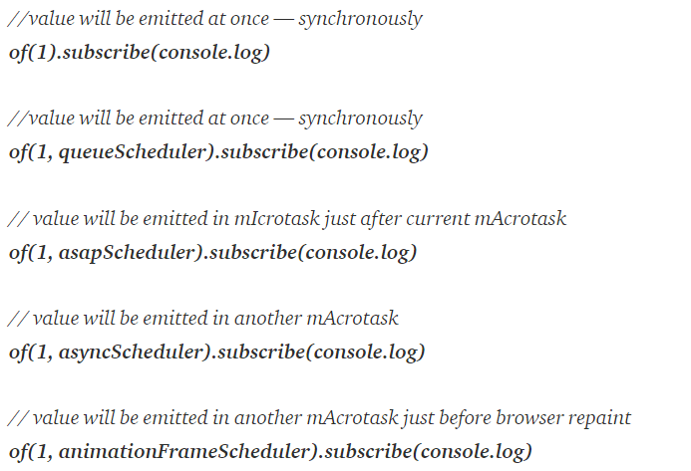

### Q) null vs queueScheduler

As you can see we have null and queueScheduler both emitting data in the same mAcrotask.

As you can see we have **null** and **queueScheduler** both emitting data in the same m**A**crotask. *So what is the difference between them?*

Some factory functions like **of** or **range** if no scheduler is defined just uses ‘for’ or ‘do-while’ loop to emit all the values synchronously. So they don’t use schedulers at all.

If we use queueScheduler — then rx.js just adds all values to scheduler queue and then flush it. It happens in the same macrotask on subscription event.

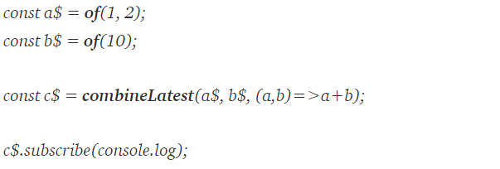

[**combineLatest**](https://rxjs-dev.firebaseapp.com/api/index/function/combineLatest?source=post_page---------------------------) combines multiple Observables to create an Observable whose values are calculated from the latest values of each of its input Observables. It starts emitting if argument observables (a$ and b$ in our case) have at least one value. If it has resultSelector function (here it is (a,b)=>a+b ) — then it will emit its output (a+b)

What we may expect, that **combineLatest** subscribes to **a$**, gets 1, then subscribes to **b$**, gets 10 and emits 1+10=11. And then a$ will produce 2, so combineLatest observable will emit 2+10=12.

But since no scheduler is fed to **‘of’**function so it works not as we may expect: **combineLatest** subscribes to **a$**andsince ‘**of’** works with ‘**for**’ loop — a$ emits 1 and 2 at once. Then **combineLatest** subscribes to **b$**and gets 10. Now it takes last values and feeds them to selectorFunction, so 2+10=12, so 12 is emitted.

It is called the depth-first approach but can we somehow make it breadth-first?

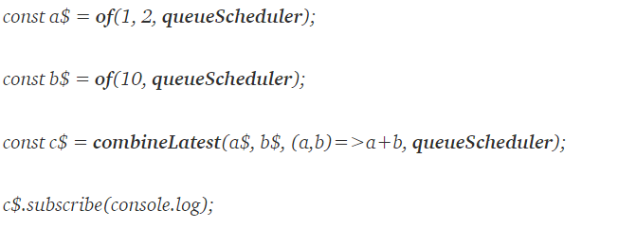

## Q) Error Handling

### Q) Errors propagated downstream to observers

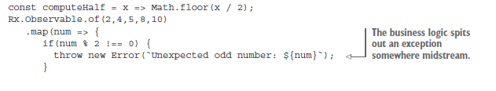

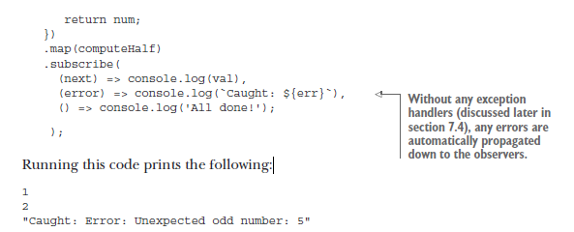

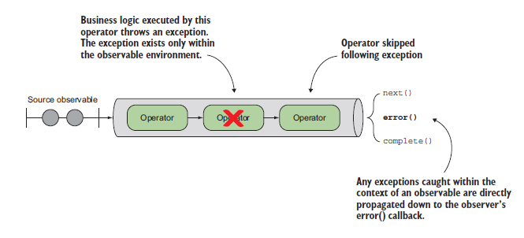

### Q) Catching and reacting to errors

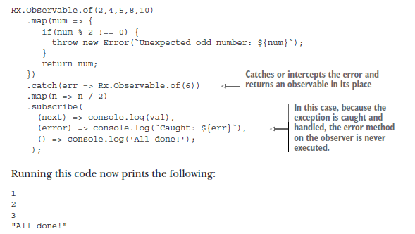

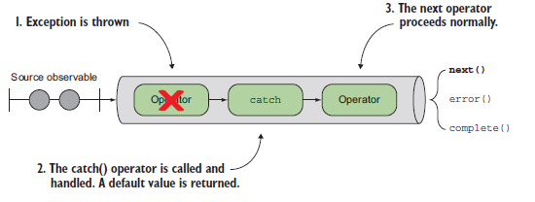

### Q) Retry failed observable

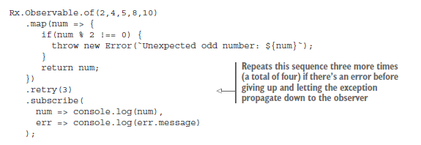

Running this code will print a sequence of numbers 2 and 4 a total of four times before printing “Unexpected odd number: 5.”

Q) Retry when

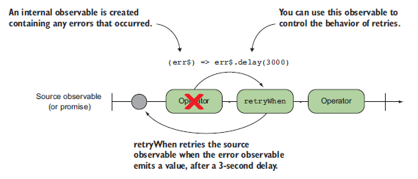

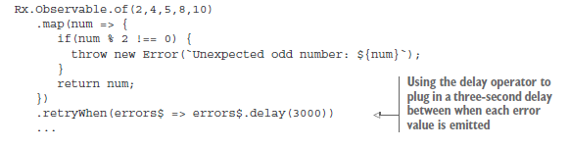

### Q) finally()

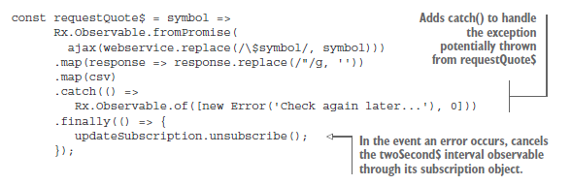

## Q) Operators

* Operators are functions that can transform the stream data between the moments when the Observable sent them and the function subscribe() received them.
* Each operator is a function that takes an Observable as an argument, transforms it and returns another Observable

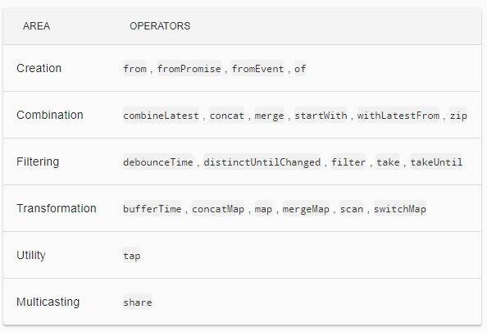

### **Q) map()**

The map() operator transforms one value to another. It takes a given value from the observable stream and applies the provided transforming function to it.

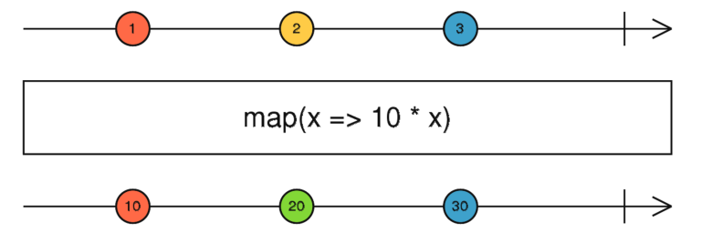

### **Q) filter()**

The filter() operator takes a function predicate as an argument, which returns true if the emitted value meets the criteria, or false otherwise. Only the values that meet the criteria will make it to the observer.

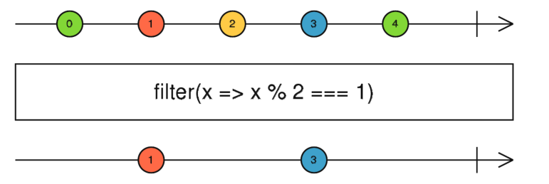

### **Q) reduce()**

The operator reduce() that allows you aggregate values emitted by an observable.

As you see from the above diagram, the accumulator function also has two arguments:

* acc stores the currently accumulated value, which is available for each emitted element
* curr stores the currently emitted value.

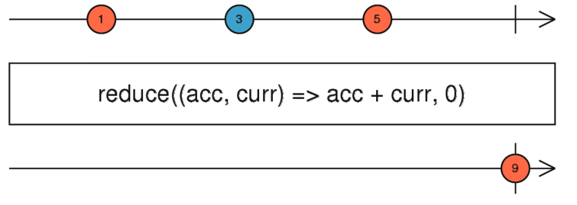

### Q) scan()

RxJS uses scan() to apply an accumulator function over an observable sequence (just like reduce()) but returns each intermediate result as the accumulation process is happening and not all at once.

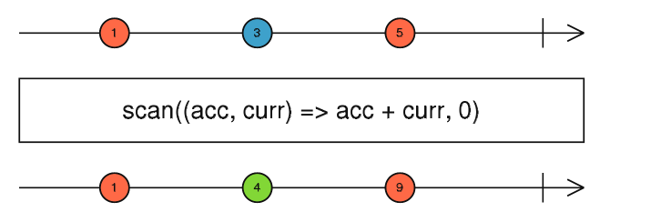

### Q) pluck()

Maps each source value (an object) to its specified nested property.

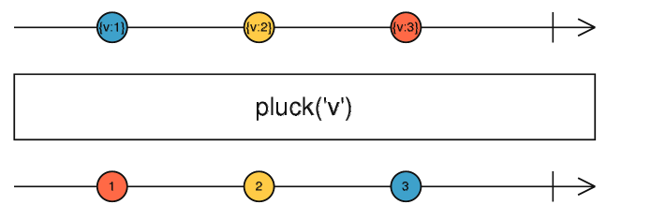

### Q) tap()

Returns a mirrored Observable of the source Observable, but modified so that the provided Observer is called to perform a side effect for every value, error, and completion emitted by the source. Any errors that are thrown in the aforementioned Observer or handlers are safely sent down the error path of the output Observable.

This operator is useful for debugging your Observables for the correct values or performing other side effects.

Note: this is different to a subscribe on the Observable. If the Observable returned by tap is not subscribed, the side effects specified by the Observer will never happen. tap therefore simply spies on existing execution, it does not trigger an execution to happen like subscribe does.

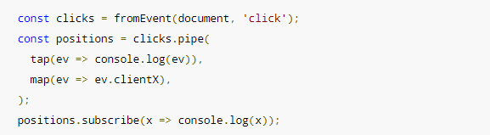

### **Q) pipe()**

You can use pipes to link operators together. Pipes let you combine multiple functions into a single function. The pipe() function takes as its arguments the functions you want to combine, and returns a new function that, when executed, runs the composed functions in sequence.

A set of operators applied to an observable is a recipe—that is, a set of instructions for producing the values you’re interested in. By itself, the recipe doesn’t do anything. You need to call subscribe() to produce a result through the recipe.

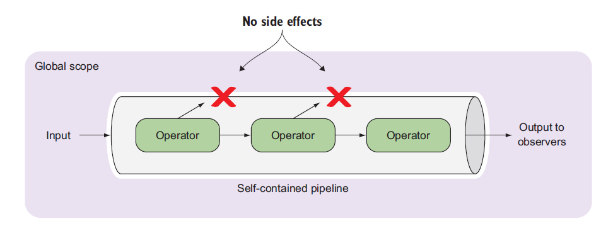

Problems with the patched operators for dot-chaining are:

1. Any library that imports a patch operator will augment the Observable.prototype for all consumers of that library, creating blind dependencies. If the library removes their usage, they unknowingly break everyone else. With pipeables, you have to import the operators you need into each file you use them in.
2. Operators patched directly onto the prototype are not "tree-shakeable" by tools like rollup or webpack. Pipeable operators will be as they are just functions pulled in from modules directly.
3. Unused operators that are being imported in apps cannot be detected reliably by any sort of build tooling or lint rule. That means that you might import scan, but stop using it, and it's still being added to your output bundle. With pipeable operators, if you're not using it, a lint rule can pick it up for you.
4. Functional composition is awesome. Building your own custom operators becomes much, much easier, and now they work and look just like all other operators from rxjs. You don't need to extend Observable or override lift anymore.

### Q) debouncetime()

Only emit an item from an Observable if a particular timespan has passed without it emitting another item

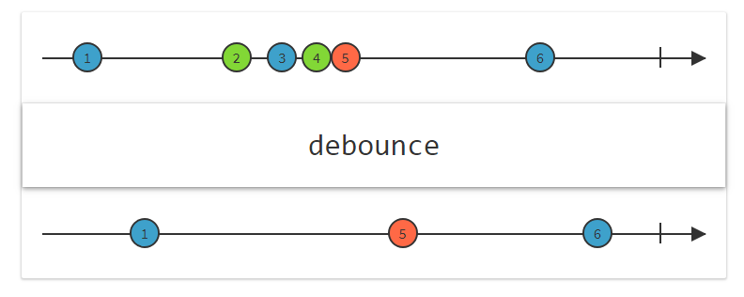

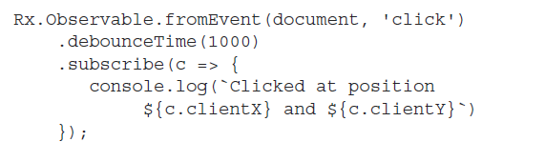

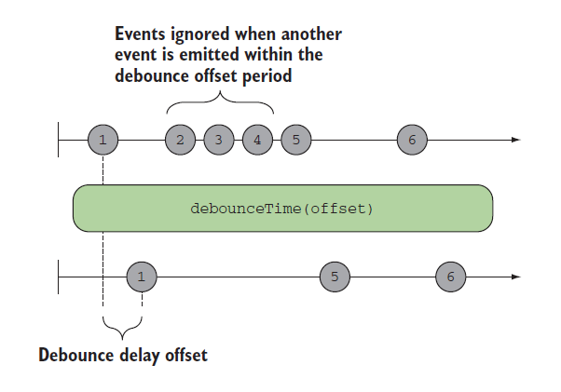

With this code, the user can generate a burst of click events, but only the last one will be emitted after a second of inactivity.

### Q) throttleTime()

Throttling ignores values from an observable sequence that are followed by another value before a certain time. In simple terms, this means “execute a function at most once every period.”

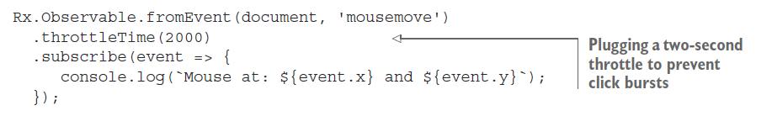

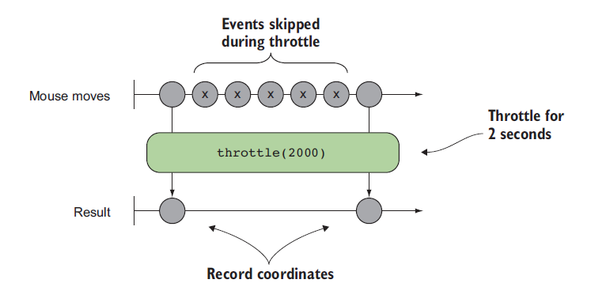

### Q) debounceTime vs throttleTime

debounceTime

* accepts 1 input stream, time period number
* Whenever an event is emitted, the time period of silence measured restarts from zero
* It waits for a time period of silence and then emits the latest value of the input stream
* returns a new stream of debounced values

throttleTime

* accepts 1 input stream, time period number
* It starts by emitting the first values of the input stream
* Then, it limits the rate of values to at most one per time period
* returns a new stream of throttled values

### Q) flatmap()

flatMap() is used to “transform the items emitted by an observable into observables, then flatten the emissions from those into a single observable”.

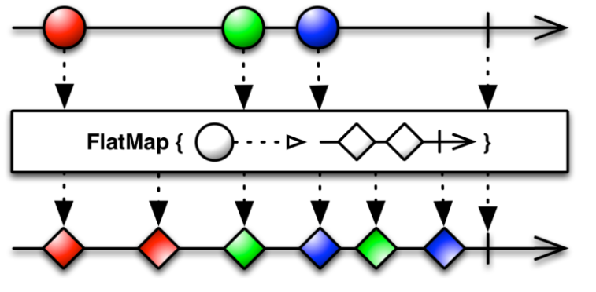

The flatMap() operator takes an emitted item from the outer observable (the circle) and unwraps its content (the inner observable of diamonds) into the flattened output observable stream. The flatMap() operator merges the emissions of the inner observables so their items may interleave.

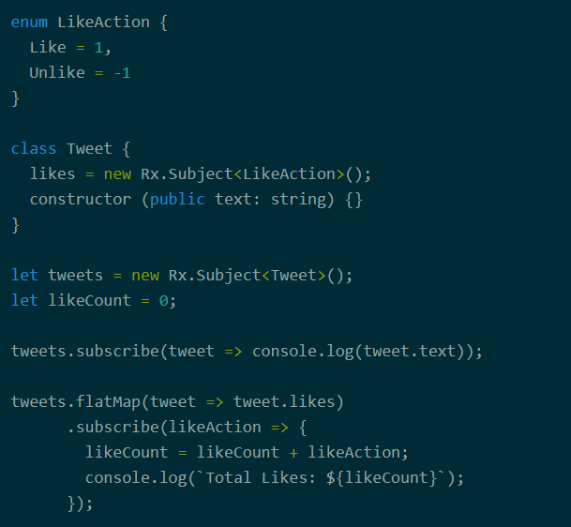

### Q) switchmap()

The main difference between switchMap and other flattening operators is the cancelling effect. On each emission the previous inner observable (the result of the function you supplied) is cancelled and the new observable is subscribed. You can remember this by the phrase switch to a new observable.

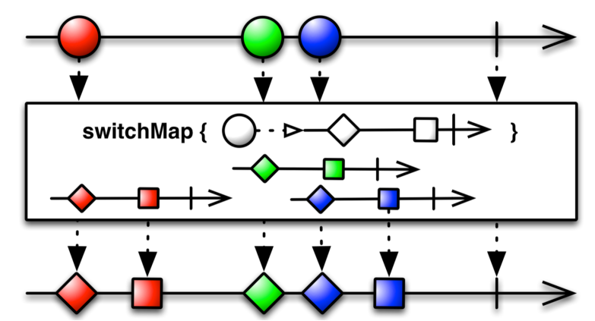

The outer observable emits the red circle, and switchMap() emits the item from the inner observable (red diamond and square) into the output stream. The red circle was processed without any interruptions because the green circle was emitted after the inner observable finished processing.

The situation is different with the green circle. The switchMap() managed to unwrap and emit the green diamond, but the blue circle arrived *before* the green square was processed. So the subscription to the green inner observable was cancelled, and the green square was never emitted into the output stream. In other words, the switchMap() operator *switched* from processing of the green inner observable to the blue one.

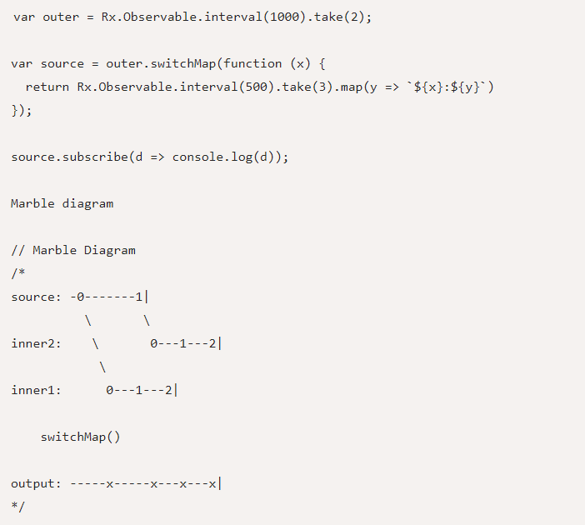

The moment the inner2 stream became available, the output no longer listens to data from inner1. switchMap effectively switches over to inner2 and unsubscribes from the previous one.

This also implies that even though the inner streams may be producing data concurrently in switchMap, the output is only determined by the latest observable that is still producing data.

### Q) combineLatest()

This operator is best used when you have multiple, long-lived observables that rely on each other for some calculation or determination. Be aware that combineLatest will not emit an initial value until each observable emits at least one value.

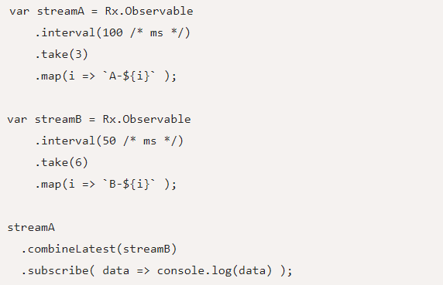

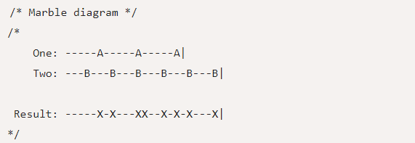

In the above example, since stream B emits faster than stream A, there is no output until stream A also starts emitting. Also notice that when both the streams emit data at the same time (as in the code example above), the result stream sees two immediate data points.

When using combineLatest, the data of both the streams have an equal weightage in terms of producing an output given that data is present on both the streams.

### Q) withLatestFrom ()

You use a primary stream to control when the data is emitted on the result.

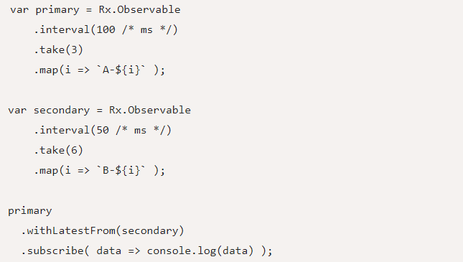

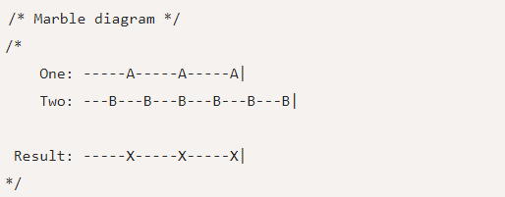

Notice how in this case, data is emitted only 3 times on the result stream because the primary observable only emitted 3 data points. As expected, it combines with the latest value of the secondary stream when emitting data on the result, just like combineLatest does.

# Redux

**Redux attempts to make state mutations predictable** by imposing certain restrictions on how and when updates can happen. These restrictions are reflected in the [three principles](https://redux.js.org/introduction/threeprinciples) of Redux.

## Q) [Three principles](https://redux.js.org/introduction/threeprinciples)

* Single source of truth

**The** [**state**](https://redux.js.org/glossary#state) **of your whole application is stored in an object tree within a single** [**store**](https://redux.js.org/glossary#store)**.**

* State is read-only

**The only way to change the state is to emit an** [**action**](https://redux.js.org/glossary#action)**, an object describing what happened.**

* Changes are made with pure functions

**To specify how the state tree is transformed by actions, you write pure** [**reducers**](https://redux.js.org/glossary#reducer)**.**

## **Q) Action**

Actions are payloads of information that send data from your application to your store. They are the only source of information for the store. You send them to the store using [store.dispatch()](https://redux.js.org/api/store#dispatch).

Actions are plain JavaScript objects. Actions must have a type property that indicates the type of action being performed. Types should typically be defined as string constants.

Other than type, the structure of an action object is really up to you.

## Q) Reducer

**Reducers** specify how the application's state changes in response to [actions](https://redux.js.org/basics/actions) sent to the store. Remember that actions only describe *what happened*, but don't describe how the application's state changes.

## Q) Store

We defined the [actions](https://redux.js.org/basics/actions) that represent the facts about “what happened” and the [reducers](https://redux.js.org/basics/reducers) that update the state according to those actions.

The Store is the object that brings them together. The store has the following responsibilities:

* Holds application state;
* Allows access to state via [getState()](https://redux.js.org/api/store#getState);
* Allows state to be updated via [dispatch(action)](https://redux.js.org/api/store#dispatch);
* Registers listeners via [subscribe(listener)](https://redux.js.org/api/store#subscribe);
* Handles unregistering of listeners via the function returned by [subscribe(listener)](https://redux.js.org/api/store#subscribe).

## Q) Data flow

Redux architecture revolves around a **strict unidirectional data flow.**

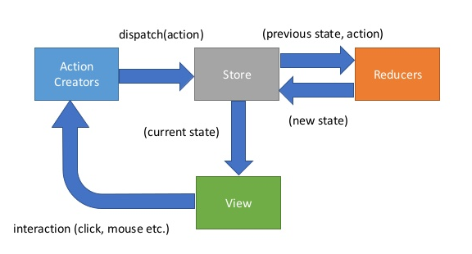

# NgRx

## Q) Advantages of Store

Throughout the overview we touched briefly on the advantages of utilizing Store over a typical, Angular 1 style approach but let's take a moment to recap. Why take the time to invest in this particular library, architecture pattern, and learning curve? The primary advantage to a Store-based application are **centralized state**, **performance**, **testability**, and **tooling**.

Centralized, Immutable State

All relevant application state exists in one location. This makes it easier to track down problems, as a snapshot of state at the time of an error can provide important insight and make it easy to recreate issues. This also makes notoriously hard problems such as undo/redo trivial in the context of a Store application and enables powerful tooling.

Performance

Since state is centralized at the top of your application, data updates can flow down through your components relying on slices of store. Angular 2 is built to optimize on such a data-flow arrangement, and can disable change detection in cases where components rely on Observables which have not emitted new values. In an optimal store solution this will be the vast majority of your components.

Testability

All state updates are handled in reducers, which are pure functions. Pure functions are extremely simple to test, as it is simply input in, assert against output. This enables the testing of the most crucial aspects of your application without mocks, spies, or other tricks that can make testing both complex and error prone.

Tooling and Ecosystem

A centralized, immutable state also enables powerful tooling. One such example is ngrx developer tools, which provides a history of actions and state changes, allowing for 8 time travel during development. The patterns provided by Store also allow for a rich ecosystem of easy to implement middleware. Because store provides an entry point both before and after dispatched actions hit application reducers, problems such as syncing slices of state to local storage, advanced logging, and implementing sagas are easily solved with a quick package include and a few lines of code. This ecosystem will only grow over the coming months.

## Q) Actions

Actions are objects that extend the NgRx Action class with a ‘type’ property.  They have an optional ‘payload’ property (naming is up to you but the standard is to name it ‘payload’) for sending in data to the effect/reducer and are dispatched by the store to either run an effect or change state in a reducer.

## Q) NgRx diagram

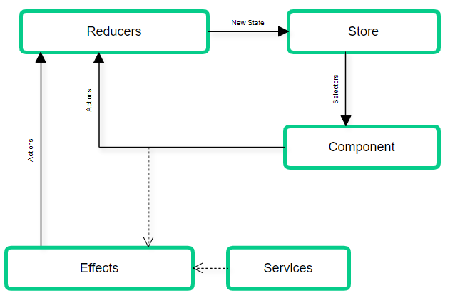

**1.** In the most common scenario, everything starts in the component view. Some interaction made by a user may cause the component to **dispatch an action**.

**2.1.** If this action doesn't trigger an effect then **a reducer is going to analyse the action** (usually using a switch statement) and return a new state that’s is going to be the result of merging the old state with the value that changed by calling the action.

**2.2.** **If an effect gets triggered by dispatching an action is because some side effects are going to happen before calling the reducer.** This can probably be something like calling an HTTP service to get data.

**2.2.1.** **After the effect is done (side effects are finished) a new “state-result” action gets fired by the effect** (it can be that the side effects succeeded or failed), and we are back to point 2.1.

**3.** Now the Store has a new state. The state can be a big object tree, so **ngrx introduces selectors to be able to use only the slices of the object that we need in a specific component**.

## Q) Reducers

Reducers are pure functions that are the only ones that can change state.  They aren’t really changing state but making a copy of existing state and changing one or more properties on the new state.

## Q) Effects

Effects allow us to handle asynchronous operations in NgRx.

* Most times this will be calling an API
* The resulting data should be stored in state by returning an action for the reducer
* Effects always return one or more actions (unless you decorate @Effect with {dispatch: false})
* You can inject services into your effects as well so if you need to access those in NgRx, effects are the place to do it

## Q) Selectors

Selectors are pure functions that take slices of state as arguments and return some state data that we can pass to our components.

To better understand what selectors are and what they do, it helps see ngrx state as a data structure - a tree that can be serialised to JSON. Data is added to the state tree by composing state in reducers - that’s the easy part. Now to get data out of the state tree, we have to traverse it to find our property of interest - and return it. That can become more complex, and is where selectors help us out.

### Q) Top level feature state

We register any feature state into feature modules by importing the StoreModule and invoking it with .forFeature():

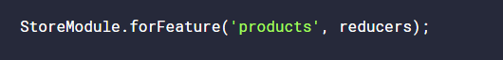

The first argument of .forFeature contains a string that represents the name of the feature state, and the second argument supplies our reducers which manage that feature state. The feature name plays a crucial role in creating a state selector for the feature state using a handy function provided by ngrx/store called createFeatureSelector.

createFeatureSelector allows us to get a top-level feature state property of the state tree simply by calling it out by its feature name:



Firstly, we pass it a string that represents the name used to register the feature state in the feature module. It uses this string to look up the feature state from within the root state object, such as state['products'].

It then returns a typed selector function that will return a reference to that specific slice of state.

### Q) State slice selector

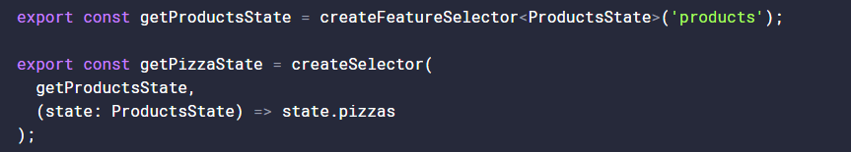

The createSelector function takes up to eight selector functions as arguments, each one referencing different slices of state. The last argumet to createSelector can be treated as our “projector function”.

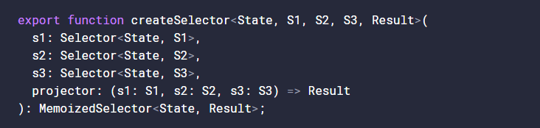

Notice how in the projector we are given s1, s2 and s3 as the function arguments - in the order in which we supplied them. The projector function is passed, as arguments, the returned values of the selectors listed before it in the order in which they were listed.

The role of the projector function is a powerful one. We can ask for various state properties, anywhere within our state tree, we can derive, transform or combine data from the state slices passed to it and return this modified data as a single object - typically for component consumption.

# Unit Testing

## Karma

### Q) Karma vs Protractor

* End-to-End Tests - These are the tests where you want to mimic an actual user that visits your website. Each test contains a series of simulated user events (ex. go to http://mysite.com/home and then click on the button with ID 'my-button') and expected results (ex. after 200ms a new window should appear that says "Thank You").
* Integration Tests - These tests will call directly into your code. For example, you can use an integration test to call an Angular service. Typically each test will focus on one function. The test calls the target function with a set of parameters and then checks to make sure the results match expected values.
* Unit Tests - These are the same as integration tests except you take extra steps to ensure that nothing is executed besides the one function you are testing. For example, when you test a service that uses $http to call a back end API, an integration test would include the API call. A unit test, however, would use a utility we will discuss later called $http Backend to replace $http so that the code executed by the test is restricted to just the target function.

Protractor is the tool you will use for end-to-end tests while Karma handles integration and unit testing.

### Q) What is Karma

Karma is a direct product of the AngularJS team from struggling to test their own framework features with existing tools. As a result of this, they made Karma and have transitioned it to Angular as the default test runner for applications created with the Angular CLI.

Karma also provides you options to replace Jasmine with other testing frameworks such as [Mocha](https://mochajs.org/) and [QUnit](https://qunitjs.com/) or integrate with various continuous integration services like [Jenkins](https://jenkins.io/), [TravisCI](https://travis-ci.org/), or [CircleCI](https://circleci.com/).

Unless you add some additional configuration your typical interaction with Karma will be to run ng test in a terminal window.

### Q) karma.conf.js





After installing Karma, we need to set up the karma.conf file. The karma.conf.js file is a partial karma configuration file. The CLI constructs the full runtime configuration in memory, based on application structure specified in the angular.json file, supplemented by karma.conf.js.

Note that most values in the karma.conf file can be overridden at the command line.



If you want the tests to display in a more readable format within your terminal, there's an npm package for this.



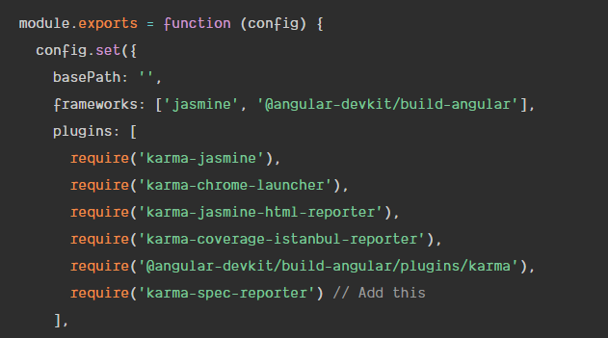

### Q) Run karma

The ng test command builds the app in *watch mode*, and launches the [karma test runner](https://karma-runner.github.io/).

ng test project Name

The ng test command builds the app in watch mode, and launches the Karma test runner.

Here’s what happens behind the scenes:

1. Angular CLI loads .angular-cli.json.
2. Angular CLI runs Karma with the configuration specified in .angular-cli.json. By default this is karma.conf.js located in the root directory of your application.
3. Karma opens the browser specified in the Karma configuration. By default the browser is set to [Google Chrome](https://www.google.com/chrome/).
4. Karma then instructs the browser (Chrome) to run src/test.ts using the testing framework specified in the Karma config. By default this is the [Jasmine framework](http://jasmine.github.io/). The file src/test.ts is automatically created when your application is created. It’s pre-configured to load and configure the code that’s needed to test your Angular application and run all spec files ending in .spec.ts in your src directory.
5. Karma reports the result of the test run to the console.
6. Karma watches the src file for changes and repeats step 4 and 5 when a file change is detected.

To end the process, you can press ctrl-c.

### Q) Run Single test case with Jasmin

Focusing specs will make it so that they are the only specs that run.

This can be achieved by renaming individual test cases or test suites from it() to iit() or describe() to ddescribe()

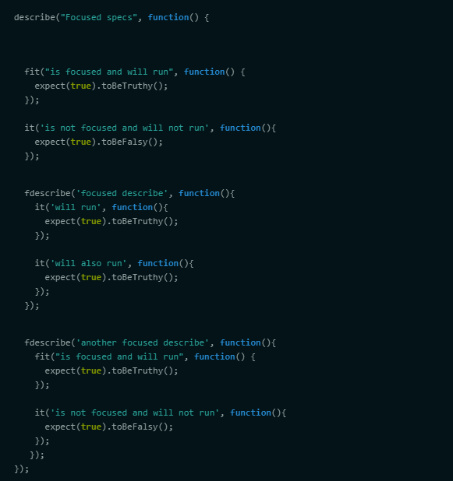

## Jasmine

Within Jasmine, this would begin with what's referred to as a "suite" which groups a related set of tests by calling the function describe.

Within Jasmine, these are referred to as "specs" which we create by calling the function it, passing it a string to describe the functionality that's being tested.

For each spec (it), the following actions are performed:

• Jasmine runs all setup functions (beforeEach) from the outside in

• Jasmine runs a spec code (it)

• Jasmine runs all the teardown functions (afterEach) from the inside out

## Jest

* Jest is a testing platform, widely adapted by many large companies and swiftly adopted by the React community.
* Sits on top of Jasmine, so the API is nearly identical.
* Has all of its API documented, along with guides, examples and helpful community on forums like Reactiflux and Stack Overflow.
* Focuses on Developer Experience (speed and ease of use is the first priority.)
* Provides meaningful error messages.
* Runs on Continuous Integration servers without extra tooling (abstracting the DOM with jsdom library.)
* Provides code coverage out of the box.
* Integrates with Babel and TypeScript seamlessly.

# Webpack

## Q) What is bundle

Webpack starts with the code in the main.ts file and loads all of the modules for which there are import statements to create a set of dependencies. This process is repeated for each of the modules that main.ts depends on, and webpack keeps working its way through the application until it has a complete set of dependencies for the entire application, which is then combined into a file known as a bundle.

## Q) Development HTTP Server

To simplify the development process, the project incorporates the webpack-dev-server package, which is an

HTTP server that is tightly integrated with webpack

## Q) Understanding Hot Model Replacement

The bundles that webpack creates include support for a feature called hot module replacement (HMR).

When you make a change to the application’s source or content files, the altered file is compiled, put into a bundle by webpack, and sent to the browser. In most cases, only a small change is sent to the browser, and the application is updated on the fly.

# Node

## Winston

[Winston](https://www.npmjs.com/package/winston), an extremely versatile logging library and the most popular logging solution available for [Node.js](https://nodejs.org/) applications,

* **level** - Level of messages to log.
* **filename** - The file to be used to write log data to.
* **handleExceptions** - Catch and log unhandled exceptions.
* **json** - Records log data in JSON format.
* **maxsize** - Max size of log file, in bytes, before a new file will be created.
* **maxFiles** - Limit the number of files created when the size of the logfile is exceeded.
* **colorize** - Colorize the output. This can be helpful when looking at console logs.

Logging levels indicate message priority and are denoted by an integer. Winston uses npm logging levels that are prioritized from 0 to 5 (highest to lowest):

* **0**: error
* **1**: warn
* **2**: info
* **3**: verbose
* **4**: debug
* **5**: silly

# JWT

## Q) What are JWTs?

A JSON Web Token (or JWT) is simply a JSON payload containing a particular claim. The key property of JWTs is that in order to confirm if they are valid we only need to look at the token itself.

We don't have to contact a third-party service or keep JWTs in-memory between requests to confirm that the claim they carry is valid - this is because they carry a Message Authentication Code or MAC.

A JWT is made of 3 parts: the Header, the Payload and the Signature.

## Q) How JWT works

* The user submits the username and password to an Authentication server, which might be our Application server, but it's typically a separate server
* the Authentication server validates the username and password combination and creates a JWT token with a payload containing the user technical identifier and an expiration timestamp
* the Authentication server then takes a secret key, and uses it to sign the Header plus Payload and sends it back to the user browser
* the browser takes the signed JWT and starts sending it with each HTTP request to our Application server
* The signed JWT acts effectively as a temporary user credential, that replaces the permanent credential wich is the username and password combination

And from there, here is what our Application server does with the JWT token:

* Application server checks the JWT signature and confirms that indeed someone in possession of the secret key signed this particular Payload
* The Payload identifies a particular user via a technical identifier
* Only the Authentication server is in possession of the private key, and the Authentication server only gives out tokens to users that submit the correct password
* therefore our Application server can safely be sure that this token was indeed given to this particular user by the Authentication server, meaning that it's indeed the user as it had the right password
* The server proceeds with processing the HTTP request assuming that it indeed it belongs to that user

## Q) Stateless authentication

The key benefit of JWTs is that the Authentication server that issued the JWT and the Application server that validates the JWT can be two completely separate servers.

This means that there is only the need for some minimal Authentication logic at the level of the application server - we only need to check the JWT!

It would be possible for a complete cluster of applications to delegate login/signup to a single Authentication server.

This means that the Applications servers are simpler and safer, as a lot of the Authentication functionality is concentrated on the Authentication server and reused across applications.

# Express

## Q) Middleware

Express is a routing and middleware web framework that has minimal functionality of its own: An Express application is essentially a series of middleware function calls.

Middleware functions are functions that have access to the request object (req), the response object (res), and the next middleware function in the application’s request-response cycle. The next middleware function is commonly denoted by a variable named next.

Middleware functions can perform the following tasks:

* Execute any code.
* Make changes to the request and the response objects.
* End the request-response cycle.
* Call the next middleware function in the stack.

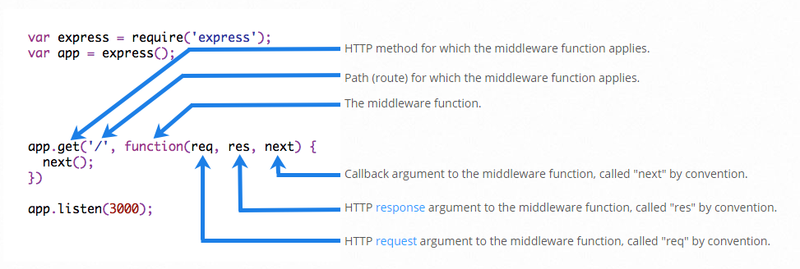

An Express application can use the following types of middleware:

* Application-level middleware
* Router-level middleware
* Error-handling middleware
* Built-in middleware
* Third-party middleware

## Q) Override a middleware

The decorator @OverrideMiddleware gives you the ability to override some internal Ts.ED middlewares

